To Whom it may Concern:

Regarding: Senate Finance Committee: HB 166

My Name is J.T. Diamond, I implore you to please Vote for the passage of HB 166.

Having the Cleveland Film Commission bring films, commercials, documentaries is so important to our community. It not only brings work to people and companies in the film industry but brings so much More! to our community, Jobs for so many other industries. Hotels, and caterers, rental companies, gas station, and clean up companies like mine. But it also brings National and World recognition to our Community, Our State.

It brings in JOBS!

And with recognition and skilled workers it brings in new Infrastructure, Collage classes, Sound stages, and so much more.

Please VOTE for HB 166.

JT Diamond

Diamond Services Inc.
2241 Augusta Ct.
Westlake Ohio 44145
(216) 956-5243

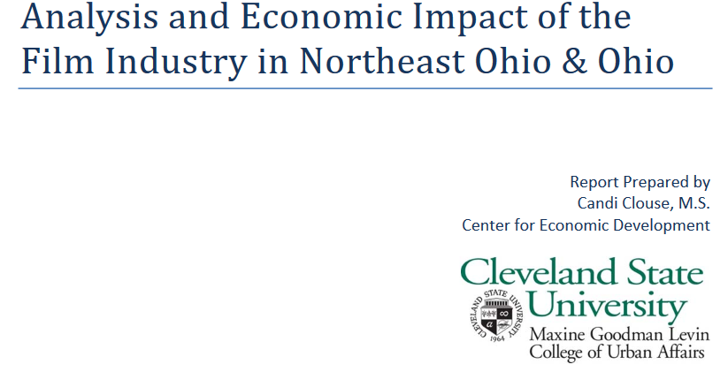

What Others Have Said About Us:
The Greater Cleveland Ohio Film Commission—2011 when we were just getting going,
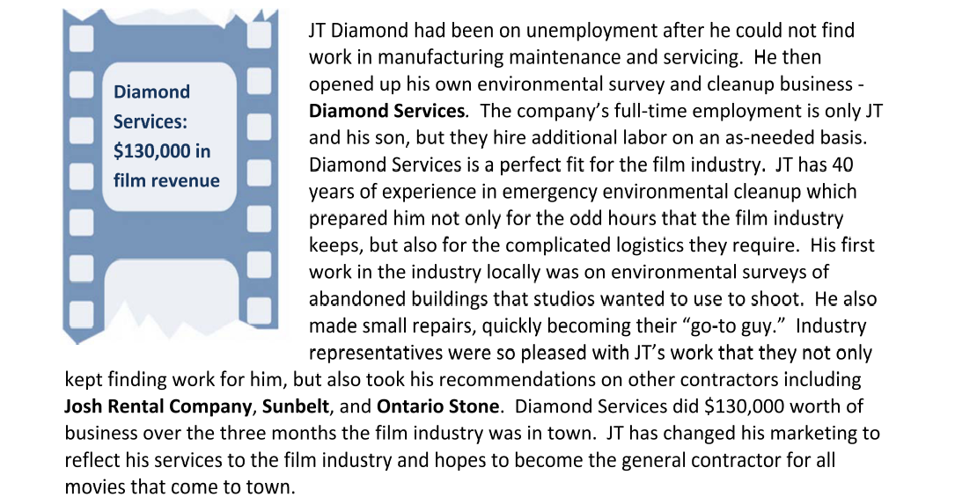
David Rumble—Location Manager “The Avengers”
“Diamond Services Inc., provided many services last year while I was working on a major feature film in Cleveland, Ohio. These services included environmental testing, abatement, building ramps and staircases, general cleaning, power washing among several other tasks that required special equipment. I was able to reach Mr. Diamond at all hours of the day and many times on the weekend. He always was prompt to meet and get a crew together to get a job done fast and thorough. They were able to meet delivery on every task they were assigned. I would definitely use Diamond Services Inc. in the future and would recommend them to anyone.”

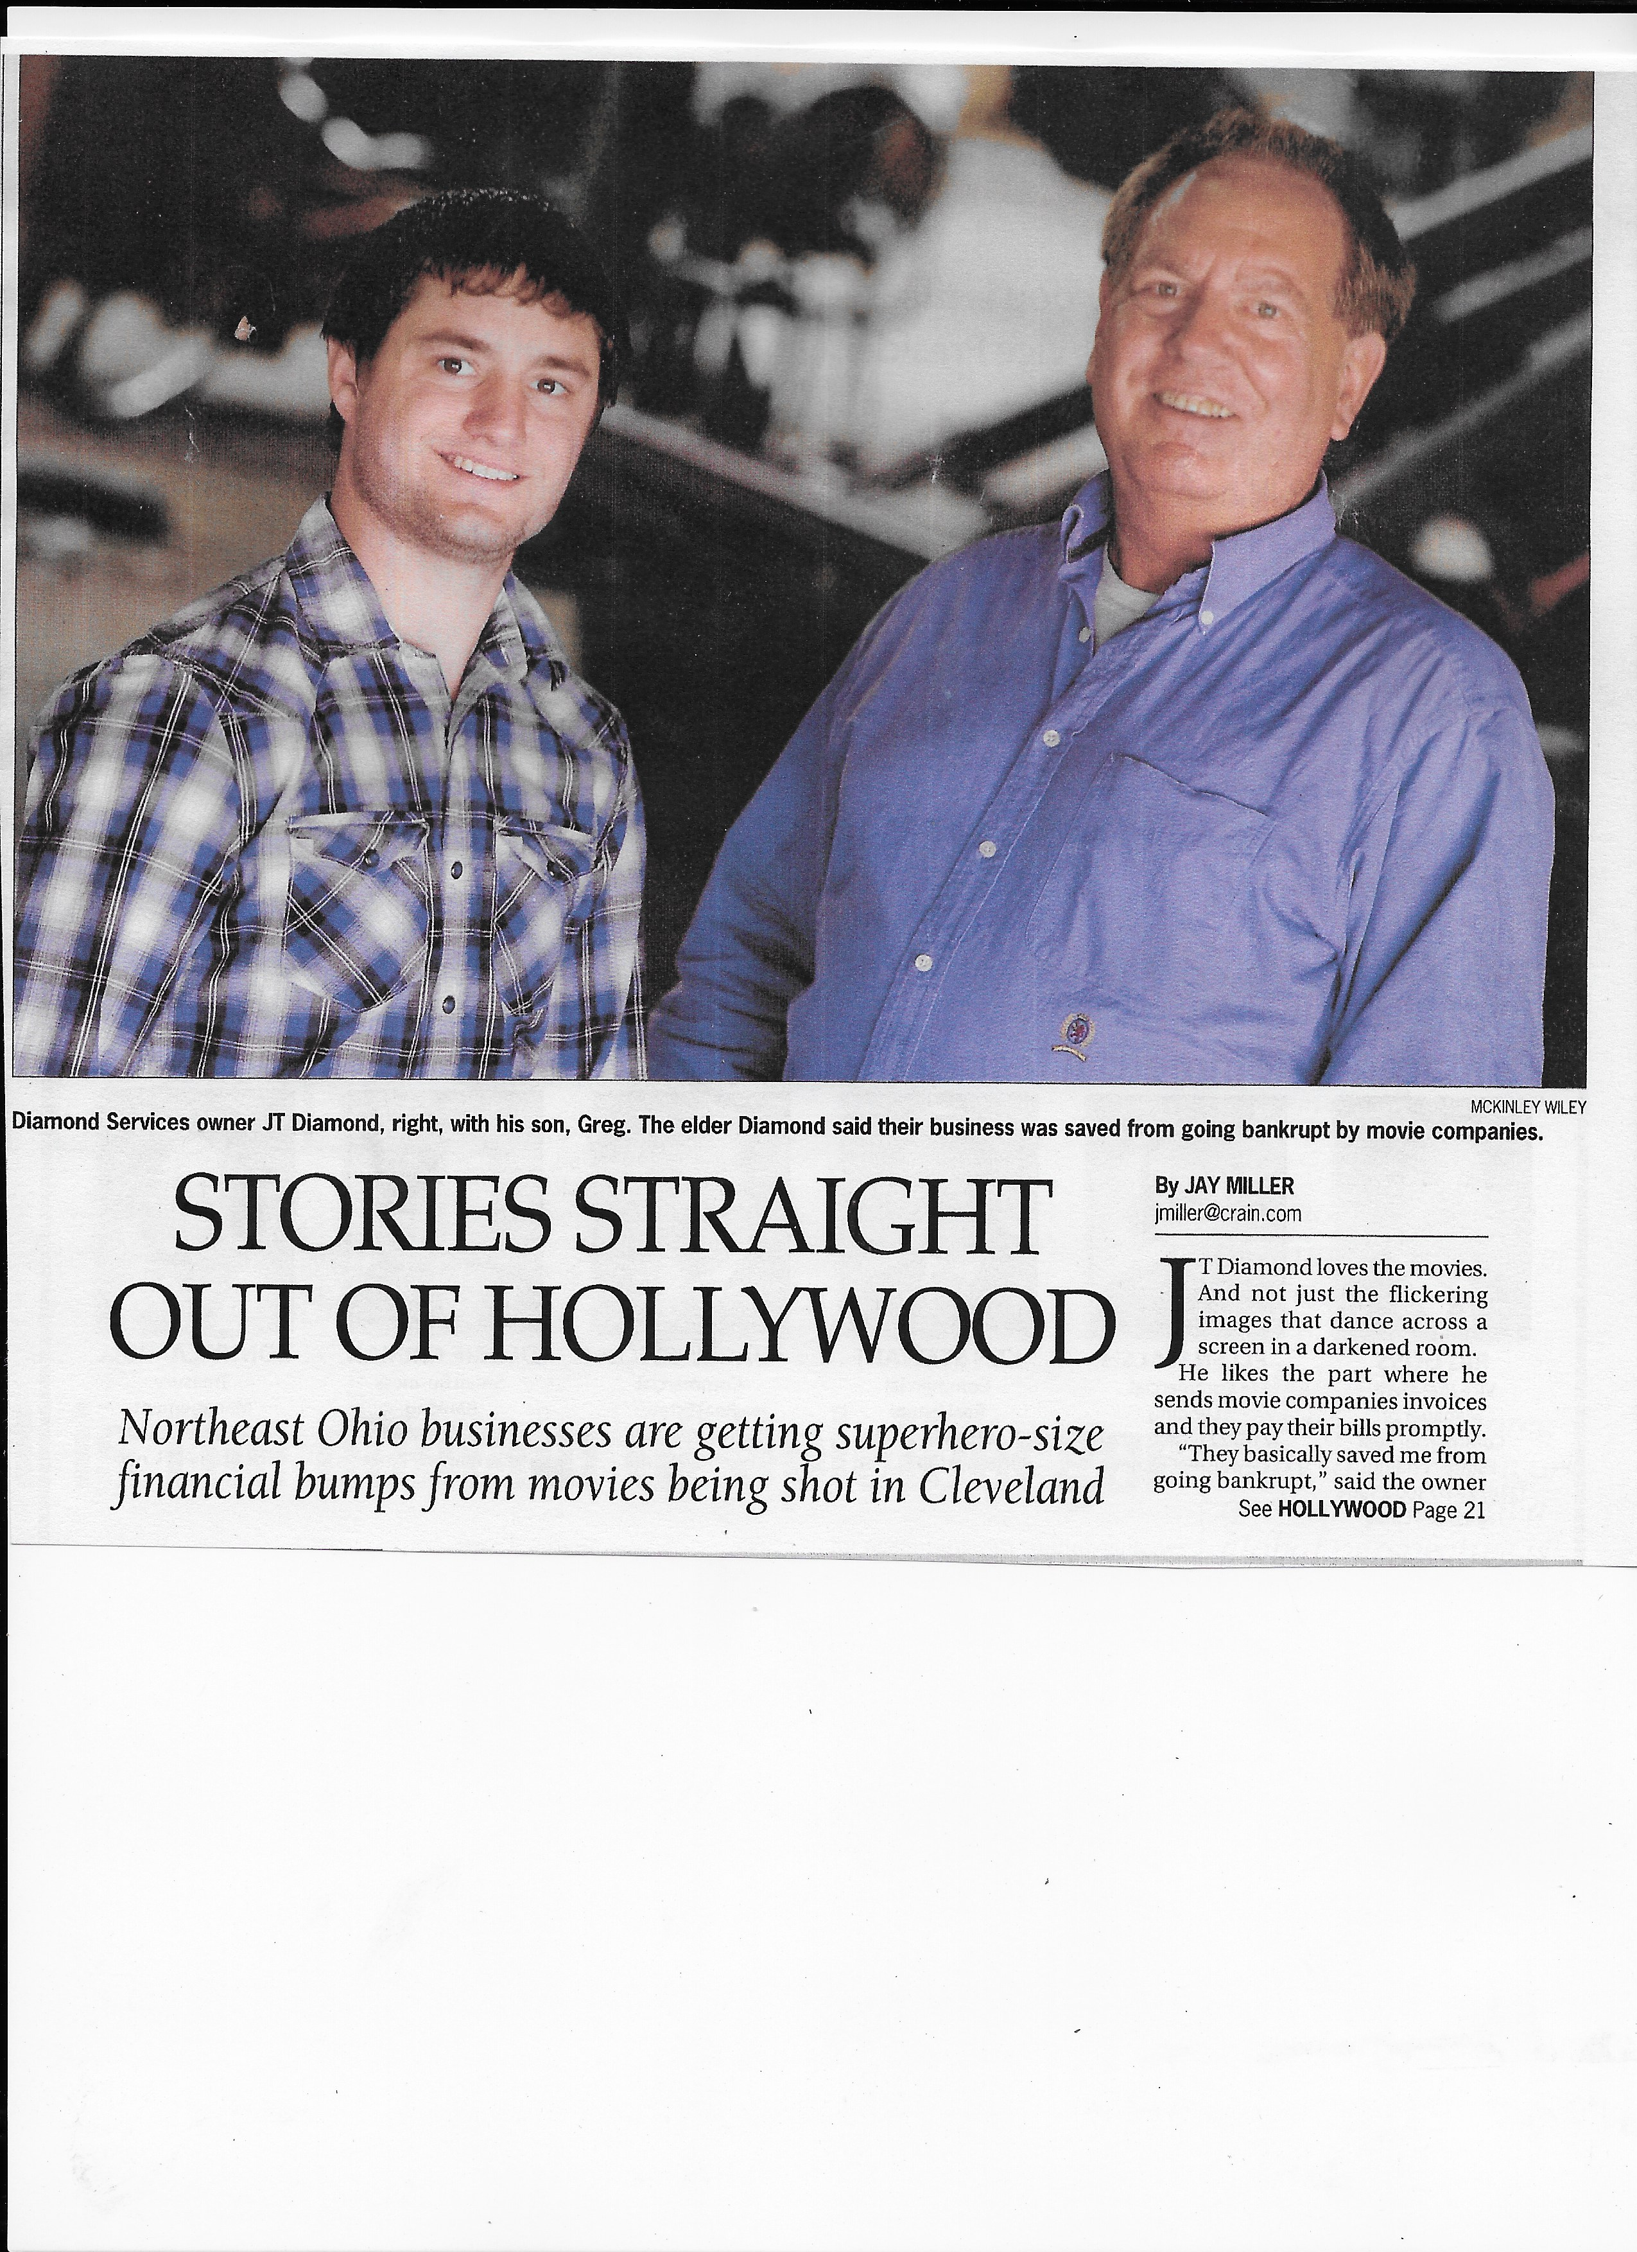

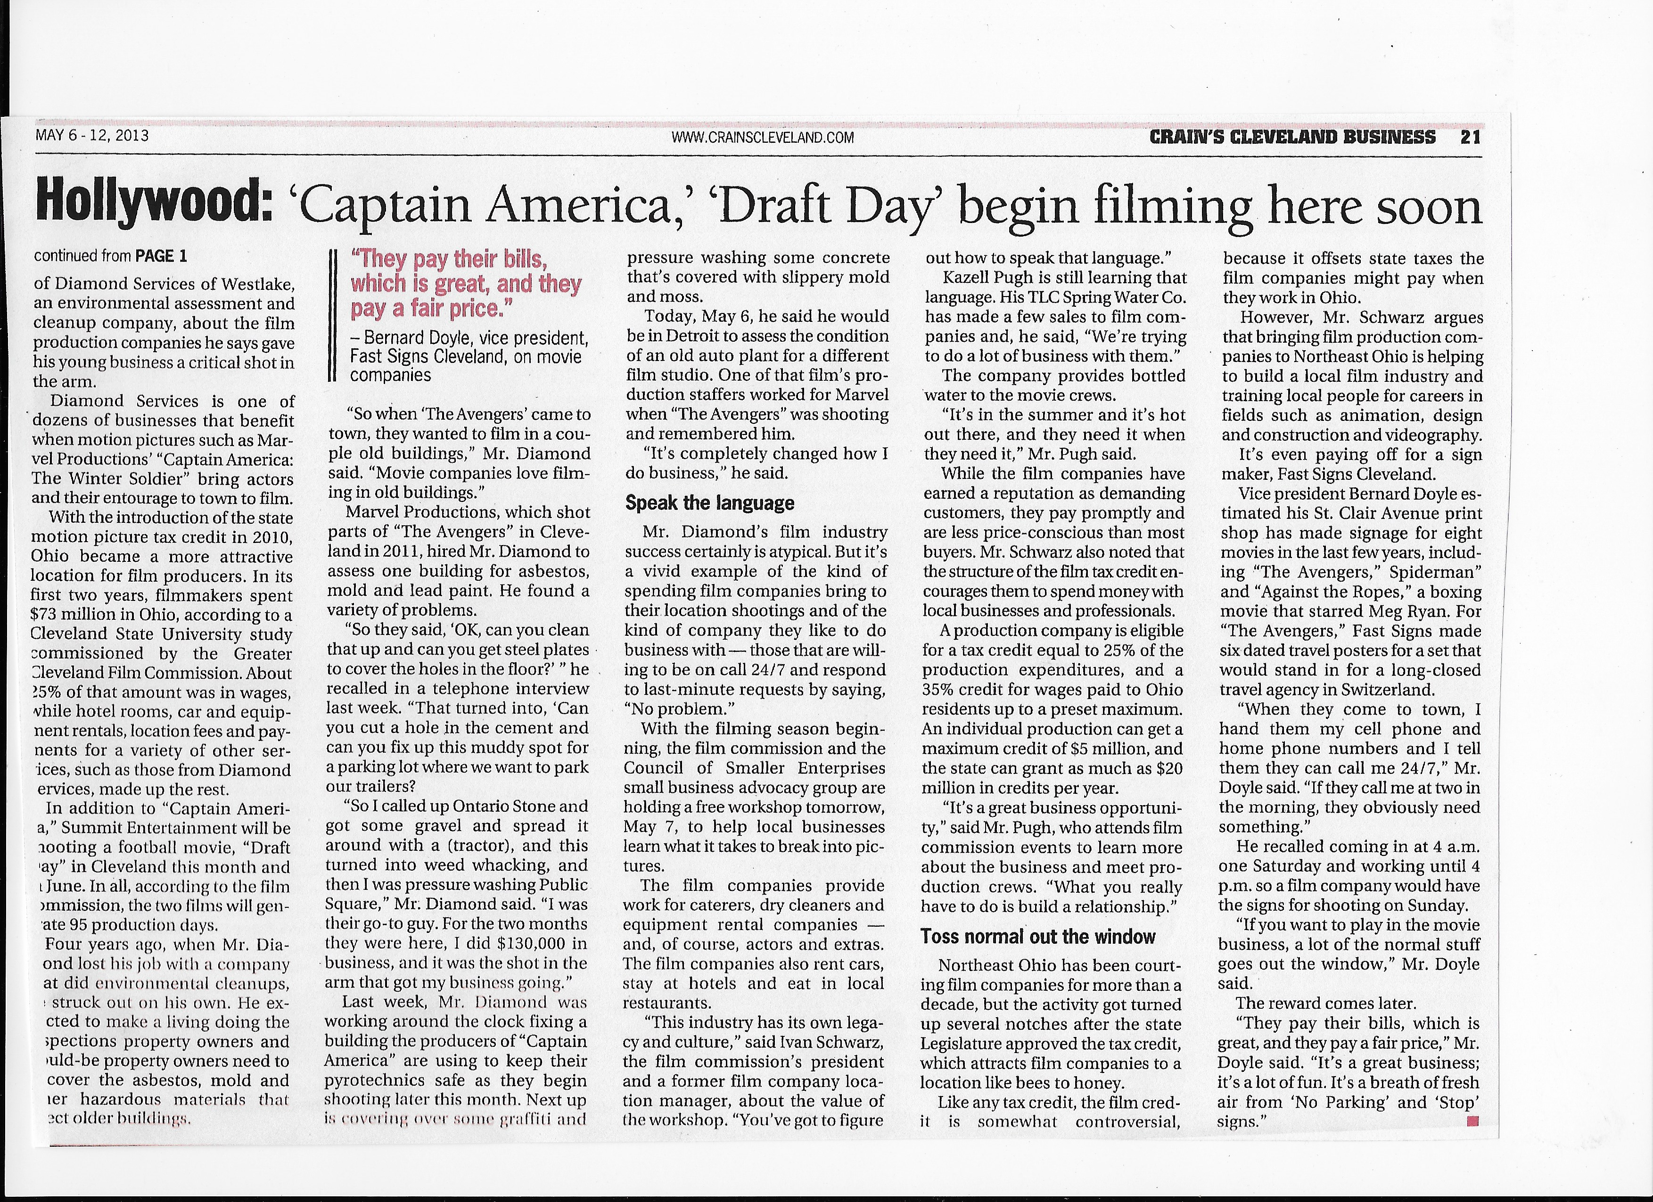

My Name is JT Diamond, I live in Westlake Ohio I own an Environmental Cleanup Company, I hire Ohio Workers.
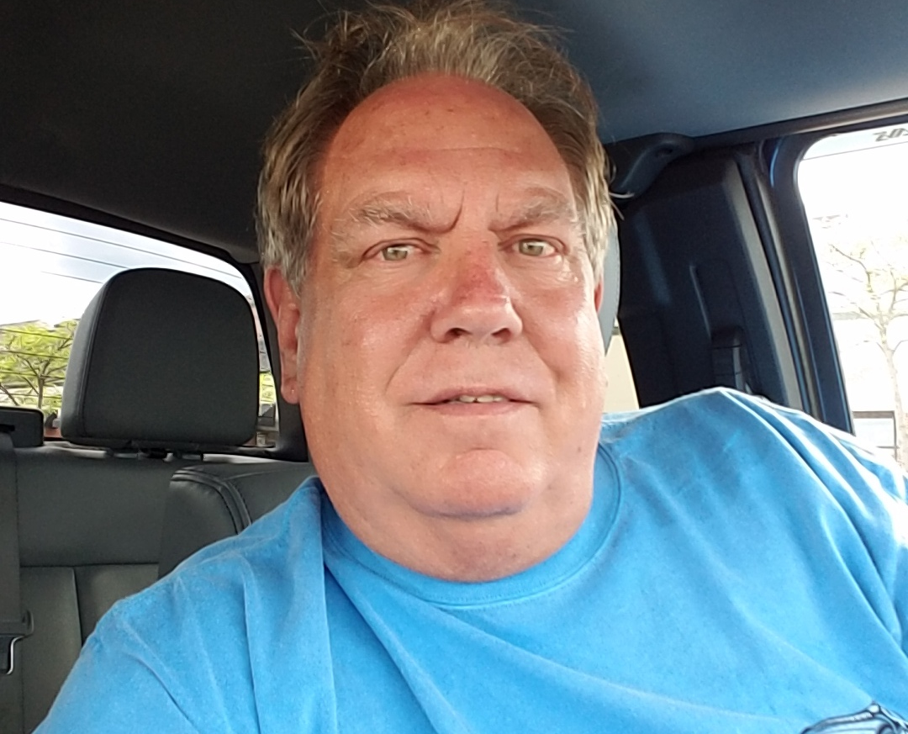
I am concerned about my Community, my region and My State and I VOTE!

JT Diamond
2241 Augusta Ct
Westlake, Ohio 44145
(216) 956-5243

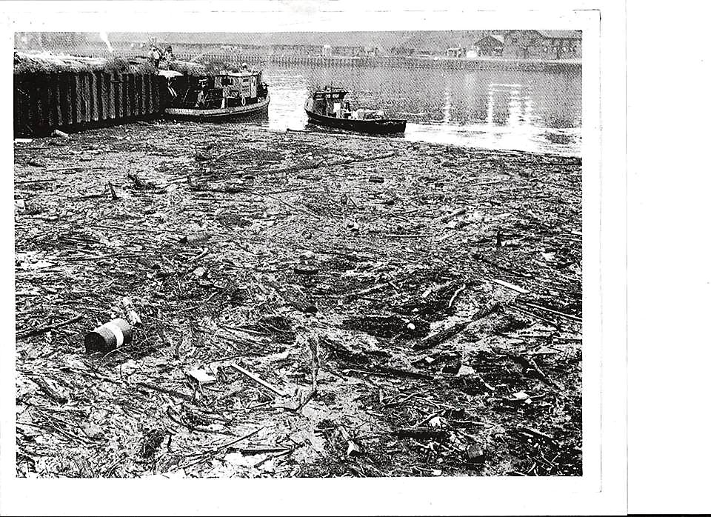

I have been working on cleaning up the environment all my life.
Picture Oil Spill 1972
Now I do environmental consulting and work on remediation of blighted houses and buildings in Northern Ohio, and one of the most rewarding things I do is work with movies that come to Northern Ohio with the Cleveland Film Commission, in order to evaluate any potential dangers or potential hazardous materials that my be present on a “location” where a film may be Shot. And clean up if necessary, at their request.
Pleas Vote for HB 166
OHIO needs it!

