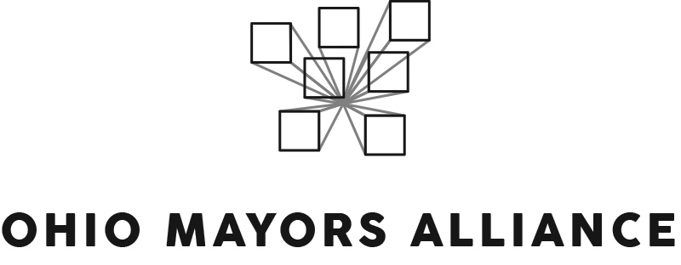

AMENDED SUBSTITUTE HOUSE BILL 166: MAIN OPERATING BUDGET (FY 2020-21)
Interested Party Testimony

Chairman Dolan, Vice-Chairman Burke, Ranking Member Sykes, and distinguished members of the Ohio Senate Finance Committee, my name is Keary McCarthy and I am the Executive Director of the Ohio Mayors Alliance. Formed in 2016, the Ohio Mayors Alliance is a bipartisan coalition of mayors in Ohio’s largest cities and suburbs.

Let me start by thanking the members of the committee for the work they have done on this budget. We know how challenging it can be to balance a variety of needs with a variety of resource priorities. For the mayors that I am fortunate to work with, they certainly understand this challenge and appreciate the work that you have done and will continue to do.

For the Ohio Mayors Alliance, there are several provisions in this budget that we support. These include: the ability to extend TIFs, the creation of a fund to help local governments recover audit costs, the partial restoration of MARCS funding, the ability to allow locals to place a lien on unpaid garbage bills, strengthening Opportunity Zones, funding for BCI that otherwise would have been passed on to our cities, and the H2Ohio fund.

We also appreciate the efforts to replace the language included in the executive budget on academic distress commissions. With two member-communities – Youngstown and Lorain – currently undergoing a state takeover via the Academic Distress Commission process, and several other member-communities next in line, this is a critically important issue for our mayors.

The Ohio Mayors Alliance supports immediate reform of this system to reestablish local control and restore accountability. We also believe reform should address the districts currently undergoing ADCs, as well as those communities that could be next. To that end, we are supportive of the changes to the system made in the House version. We also support Senate Bill 110 that would to help address the immediate challenges in Lorain. Ultimately, our view is that any long-term solution must restore local accountability and allow those districts that are currently in academic distress to find a pathway out of the current process.

We do have concerns with two provisions in the bill. The first is the elimination of the Motion Picture Tax Credit. This is an important economic development tool for our cities, and we would prefer to see this credit retained, if not expanded, as Senate Bill 37 would do. The second is the language that was retained from the executive budget that requires a city to pay the state any negative balances from monthly municipal net profit filings through the state’s Ohio Business Gateway portal. We agree with the Ohio Municipal League that this language should be removed and given more time in a separate vehicle to find a solution that doesn’t unduly burden our cities.

The Ohio Mayors Alliance appreciates not seeing a reduction in Local Government Funding and supports the governor’s modest increase of $34.5m in FY20 and $7.6m in FY21. However, we believe there is significant value in reinvesting in Ohio’s communities through the LGF and we would urge you to consider increasing that investment.

Our larger cities are becoming engines of economic growth, which powers the statewide economy. For our medium-sized and smaller cities with unique economic challenges, the LGF plays a critical role in stabilizing the regional disparities that are quickly growing in our state. Community reinvestment through an additional LGF increase is important for a variety of reasons and it often provides an even greater benefit to these mid-sized and smaller cities in Ohio.

Lastly, we appreciate the work that the Development Services Agency is doing to plan, prepare and organize for the 2020 Census. It is critically important that Ohio, which is growing at a slower rate than other states, does not have a significant undercount in the upcoming census. If that occurs, we risk losing one, if not two congressional seats, as well as billions of dollars in federal funds. For our cities, census data is tied to critically important Community Development Block Grant funding, which helps support local economic development initiatives.

We are looking forward to continuing to work on this issue and additional resources dedicated to our state and local efforts would be welcome. Specifically, we support allocating a $1.1 million for a grant fund that would help local complete count committees with specific hard-to-count populations. The local efforts to promote the US Census will be essential in 2020, and providing a modest amount of financial support for these efforts is critical.

Thank you again for your time and attention. I would be happy to answer any questions.

