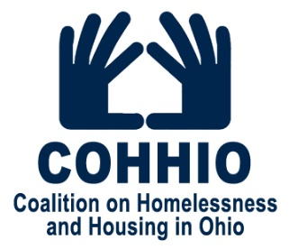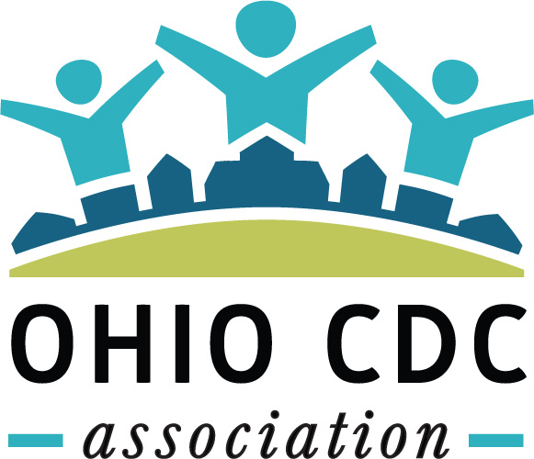

Testimony before the Full Senate Finance Committee

May 23, 2019

Chairman Dolan, Vice Chair Burke, Ranking Member Sykes and members of the Senate Finance Committee, thank you for allowing me the opportunity to provide testimony about an opportunity for the state to reverse the increasing rate of homelessness among Ohio’s children and families. My name is Gina Wilt And with me is Nate Coffman, executive director of the Ohio CDC Association whose members work to revitalize their communities across the state.

Because of great local, federal AND state collaboration, we’ve had real success in fighting chronic homelessness and reducing the number of veterans living on the streets. However, in recent years we’ve seen an alarming increase in the number of children entering Ohio’s homeless system.

Kids are nearly one-third of the 70,000 Ohioans in the homeless system, an increase of 25 percent over five years. That includes nearly 3,000 homeless babies under age one, a population that has grown 53 percent in five years.

This alarming rise of homelessness among children is result of the disconnect between family incomes and housing costs. Nearly 400,000 Ohio households now spend over half their income on rent. That doesn’t leave much room for error, so when these parents lose a job, get sick, or become pregnant, the family knocks on the door of homelessness and in too many situations families are added to long waitlists for safe and affordable housing.

Unfortunately, as the need has increased, the number of state dollars available to serve these families has dramatically decreased.

As you know, housing is fundamental to addressing so many other issues facing Ohio: infant mortality, opiate addiction, healthcare costs, lead poisoning, poor student performance, foster care, job absenteeism, and criminal justice. Research continues to grow and continues to reveal how access to affordable housing saves money and lives. I’ll highlight a few findings:

The risk of foster care placement among children from homeless families is 34 times higher than children who are housed. Housing homeless people reduced the number of arrests by up to 78% and cuts overall incarceration costs by up to 95%. Housing chronically homeless patients reduced hospital emergency room visits by up to 78%. Homelessness increases the likelihood of infant mortality, maternal mortality, low birth weight, premature birth and the need for additional hospital services. Not to mention the strong connection between safe and stable housing with education and job success.

And yet, the Ohio Housing Trust Fund, which is the primary state source of funding for housing and homeless programs, hasn’t seen an increase for 16 years.

The Trust Fund helps many communities, particularly in rural counties with fewer resources, leverage private and federal sources of funding for local housing and homeless programs. By statute, the Fund must grant 50% to rural communities and requires a 100% local match. In addition to homeless services, the Trust Fund supports the creation of affordable housing, and funds local home repair and accessibility programs that keep seniors and people with disabilities living in their own homes and out of assisted living. Unfortunately, many of these programs have waiting lists that are months or years long.

The Trust Fund has not received any increase in funding since 2003, when the legislature established the fee following voter approval of a constitutional amendment declaring housing a public purpose.
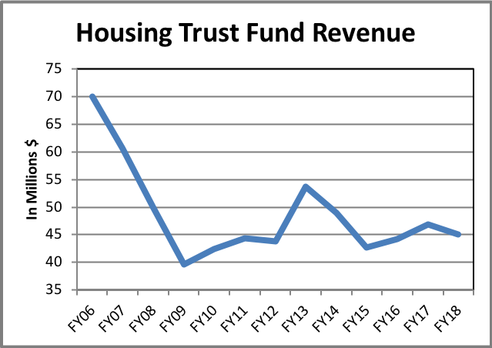
Since the recession, Trust Fund recording fee revenues have declined from a high of $73 million in FY 2005 to an average of about $45 million annually in recent years. The projected figure for this SFY is only $42 million. This has become the new normal even with a healthy real estate market. Declining revenues combined with accounting for the consumer price index (CPI), the Housing Trust Fund’s purchasing power has decreased 60% since the fee was created.

The Trust Fund has declined at the same time homelessness and housing needs have exploded. We request your support for an amendment to the biennial budget (HB 166) to partially restore revenue for the Housing Trust Fund. In the last budget, we proposed a substantial fee overhaul. Responding to the legislature’s concerns we are now coming forward with a less ambitious proposal. Currently the recording fee is $28 for the first two pages of each document plus $8 for each additional page. We suggest a very modest adjustment of $32 fee for the first page and $8 for each additional page. This adjustment would generate an estimated $8 million in additional revenue for the Trust Fund.

We have received some feedback that there was some confusion about the numbers in the Budget in Detail spreadsheet showing the Trust Fund at $41 million in FY 2018 and $53 million in FY 2019. All available funds have been spent every year, but actual spending is constrained by fee revenue that comes in to the Trust Fund. $53 million is the long-standing spending authorization, but actual spending has not come anywhere close to that amount in years.

Increasing Ohio’s investment in affordable housing will not only stabilize low-income families and children in crisis, but will positively impact our economy. Each development dollar the Trust Fund invests leverages more than $8 in private and federal matching funds and generates nearly $12 in overall economic activity for the state.

And I’ll add that one of the reasons why the Ohio Housing Trust Fund is successful is because of this public-private partnership. The private sector brings development dollars to the table, the local delivery providers bring all their non-profit fundraising efforts to the table, as well as any federal resources they can drum up, but without a strong Ohio Housing Trust Fund, those dollars can’t get us over the finish line to solve this invisible child homelessness issue. I know that Ohio is better than nearly 3,000 homeless babies, especially when we have a system available, ready and waiting to solve this problem.

In conclusion, we applaud the focus on improving the wellbeing of Ohio’s children. We know that if you focus on housing first and making sure every child in Ohio has a safe place to put their head at night, then all the other work you do after that will be more effective. Housing is an investment towards education outcomes, an investment towards healthcare outcomes, and an investment towards our economy.

We look forward to working together to build brighter futures for our families.

Thank you Mr. Chairman, I would be happy to answer any questions you might have.

