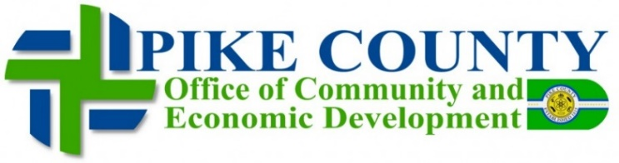
116 S. Market Street, Suite 103
Waverly, Ohio 45690
Phone: 740-947-4104 / Fax: 740-941-4308
www.pikecountydevelopment.com

The Honorable Senator Dolan
Ohio Senate, 24th District
1 Capitol Square, 1st Floor
Columbus, OH 43215

Dear Chairman Dolan:
I am writing as a proponent to retain language in HB 166 to reinstate the Rural Industrial Park Loan program (House Bill 98 and Senate Bill 137) at $25M in FY 2020. Pike County is a Small Community with Limited resources. In the last 10 years we have lost over 3,000 jobs with MASCO shutting down their cabinet manufacturing facility, and with the down sizing of the Department of Energy has created job loss for our Community. A program like the Rural Industrial Loan Program would greatly benefit small communities like ours.
Southern Ohio and eastern Ohio have not benefitted from the economic growth that Ohio has enjoyed following the Great Recession. This, in large part, is due to a dearth in competitive sites and buildings. The site selection process, which is a major driver of economic growth, identifies sites and buildings that have the necessary utilities and studies in place to minimize risk and maximize speed for industry. Simply put, if communities do not have an inventory of sites and buildings, they do not have a product to market to site selectors and industry.
Previous state programs, such as the Rural Industrial Park Loan Program, Urban & Rural Initiatives and the Industrial Site Improvement Fund, were utilized with great success to develop speculative sites and buildings in distressed areas of Ohio. Unfortunately, there is no such program in place to fund initiatives. The Facilities Establishment Fund, which has been receiving loan repayments from previous iterations of development programs, is well-capitalized with roughly $200,000,000 in the fund.
Assistance towards the distressed areas of Ohio will have a strong return on investment for the state. In the short-term, funds will be recouped for the development costs associated with these projects and in long-term the taxes generated through commercial activity, sales and income tax will grow Ohio’s General Revenue Fund, while employing Ohioans. This program is a win-win.
Our challenges like most other small communities is the lack of Capital Funds to expand and upgrade all the infrastructure needed for large Manufacturing Companies. One of our Successes would be helping Rural King establish their Distribution Center in our community. Another Success story is Valley Wood Cabinetry, a Foreign direct Investment from China.
I am supportive of the reinstatement of this important tool for economic development in rural Ohio.

Sincerely,
Gary Arnett, Director
Pike County Community & Economic Development

CC:
Vice Chair Burke
Ranking Member Sykes

