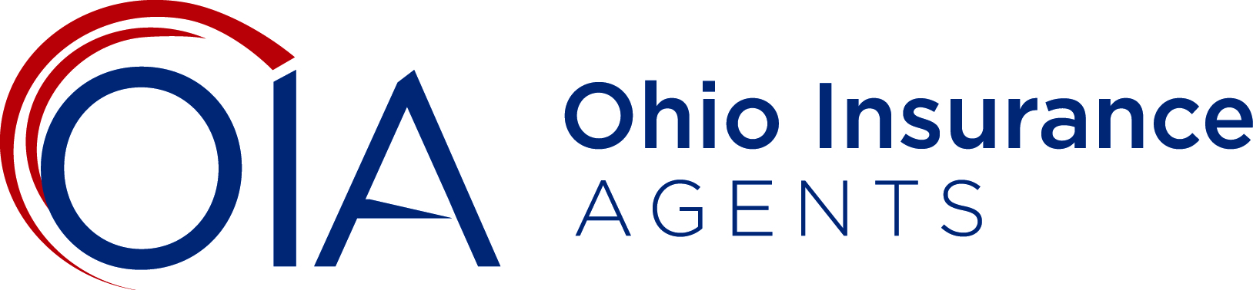
Chairman Dolan, Vice Chairman Burke and Ranking Member Sykes, my name is Carolyn Mangas and I am the government affairs manager for the Ohio Insurance Agents Association (OIA). I am providing this written testimony to express our concerns with the unexpected tax changes that were added to House Bill 166 (H.B. 166) prior to its passage by the Ohio House of Representatives.
OIA is the collective voice of more than 1,300 independent insurance agencies that employ more than 10,000 Ohioans. We promote, progress and protect the professional advice and guidance only independent agents provide. Our members write 82 percent of the commercial insurance policies and 44 percent of personal insurance policies in Ohio. We help agents by providing agency valuation support, succession planning, advocacy initiatives, professional development, business solutions and industry thought leadership. We are committed to fighting the commoditization of insurance because we believe the right insurance matters.
Proposed Tax Changes
Since many (if not the majority) of OIA’s 1,300 members are organized as pass-through entities, OIA has significant concerns regarding the changes that have been added to House Bill 166 that reduce the business income deduction (BID) from $250,000 to $100,000 and removes the cap of 3% on business income over $100,000.

Historically, the business income deduction was enacted to create tax parity between pass-through entities and general business C-Corps. This is because pass-through entities have to pay both the Commercial Activity Tax (CAT) and the Individual Income Tax, while C-Corps simply pay taxes on receipts under the CAT. Thus, the proposed changes in H.B. 166 impacts the parity between Ohio businesses.
Detriment to Independent Insurance Agencies
The Legislative Service Commission has indicated there will be a $528 million annual tax increase for small businesses as a result of these tax changes. It is important to note that more than 80% of our members employ less than 10 people, and these independent insurance agencies survive on small margins. Consequently, any contraction in these margins will require agencies to pause and evaluate expenses like employees, growth opportunities, professional development, technology, facility improvements and other controllable expenses. Ultimately, this tax change would force many of our members to change how they budget and manage their agency going forward.
The current form of the BID has only been in place since Tax Year 2016, and this substantial change was put forth quickly, unexpectedly and without input from Ohio’s impacted business community. With the year nearly half over, our members have already done their tax planning for the year, so a retroactive change is especially troublesome and quite frankly not welcome.
OIA greatly appreciates the steadfast support that the Ohio Senate has provided to ensure a favorable tax climate for Ohio’s small businesses over the last several years. Unfortunately, instead of spurring economic opportunities for insurance agents and their clients, the tax changes proposed by the Ohio House will be detrimental to Ohio’s overall economic growth. Ohio should strive to retain the business-friendly tax status it has earned over these last several years so that it can keep business owners in Ohio.
We urge members of the Ohio Senate Finance Committee to remove these harmful provisions from House Bill 166 until a more comprehensive analysis of such significant changes can be conducted. Please feel free to contact me if you have questions regarding our position.

