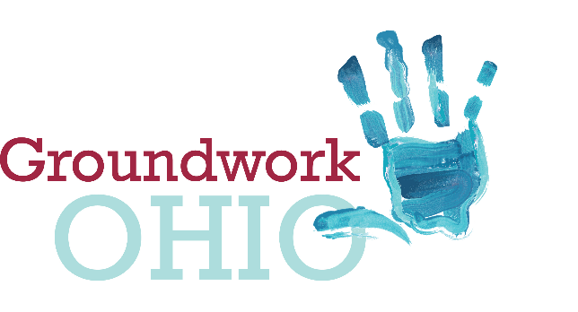
Lynanne Gutierrez
Policy Director & Legal Counsel
lwolf@groundworkohio.org
mobile: 614-204-6106
172 E. State Street, Suite 400
Columbus, Ohio 43215

Ohio Senate
Finance Committee
FY2020-2021 Operating Budget
Groundwork Ohio
Lynanne Gutierrez, Policy Director & Legal Counsel
May 28, 2019

Good Afternoon, Chairman Dolan, Vice Chairman Burke, Ranking Member Sykes and members of the Senate Finance Committee. I am Lynanne Gutierrez, Policy Director and Legal Counsel for Groundwork Ohio. Thank you for the opportunity to give testimony concerning Substitute House Bill 166, Ohio’s budget bill for state fiscal years 2020 and 2021. My testimony is limited to comment and concern on Ohio’s quality child care system.

Today, hundreds of thousands of kids were dropped off for child care as both their parents—or their only parent in a single parent household—headed off to work. But too many of these kids, especially those who are receiving subsidized care through our publicly funded child care program, are in environments that may not be promoting quality early learning and could even be having a detrimental effect on their development.

We know that brains are built on a foundation of early experiences and that the first few years of life include a surge of new neural connections—more than a million each second. We also know the benefits of investing in quality programs early—increased kindergarten readiness, high school graduation, and lifelong earnings—and the cost of failing to invest—most significantly in the form of costly interventions through the criminal justice system. Our state and this legislature made a clear choice—the right choice—to follow the research and invest in today’s families and the next generation by implementing our quality rating and improvement system, Step Up to Quality, back in 2004.

It’s been 15 years since our system was instituted and, despite seeing strong positive outcomes for kids who are receiving quality care, the state has failed to make the investments our system needs to fully deliver on the promise of quality. We have come a long way in delivering on the statutory mandates requiring that, in order to receive public dollars, programs have to be rated at least a 1-star in SUTQ by 2020 and at least a 3-star by 2025. As of February 2019, 45% of programs and 57% of kids are served in quality rated programs (1-star or above in our SUTQ system). In fact, since the beginning of January this year we have realized a 13% increase as of the end of April in participating programs. This increase is more than what was achieved in the entire calendar year 2018.

While we have made incredible progress and are on our way to delivering on the promise of quality for Ohio kids, our system needs increased state investments in quality infrastructure outside of the rate structure to ensure that our quality goals are met. Just as there is no silver bullet or deregulation policy that will mend broken roads and bridges, the same is true for our youngest most vulnerable children and their access to quality child care, an intervention that can get them out of the cycle of intergenerational poverty and onto prosperity. New resources are required.

We celebrate federal child care dollars being allocated to increased rates for child care providers. Child care provider base rates have long been woefully out-of-line with the current market rate and rates are a critical piece to ensuring increased access to quality child care in our state. This update was motivated by our state being in federal corrective action for insufficient rates. Unfortunately, while the overwhelming effect of this rate adjustment is very positive, 13 primarily rural counties will see an actual decrease in rates under the current proposal. We believe that as the state moves forward with their existing authority to update rates, this must be remedied.

Accordingly, we ask for you to support amendment number SC3663, a “hold harmless” for child care providers serving children in the 13 counties (Allen, Ashland, Eerie, Preble, Sandusky, Seneca, Auglaize, Belmont, Knox, Ottawa, Portage, Trumbull and Harrison) that will see a rate decrease in the proposed rate update. Rates are a critical piece to provide access to quality child care for poor working families and their children. These 13 counties, mostly rural communities, cannot afford to lose money given the critical work they do for children and families. At a time where they could actually benefit from a rate increase as they work towards meeting our state quality mandates, we are trying to maintain their status quo so that no children lose access to care.

Rate updates are necessary, but not sufficient. Given the urgent need for high-quality child care, we are disappointed to see that no new state dollars are going into the system. We are deeply concerned about this continued lack of state investment and are thus advocating, once again, for increased state investment in the system that supports the infrastructure of the quality system.

We also ask for your support of amendment number SC2827x1 which invests $15 million over the biennium in Quality Infrastructure Grants. This amendment creates a competitive opportunity for early childhood stakeholders (community collaboratives, organizations, resource and referral, providers, local government, etc.) to satisfy one-time needs that support child care programs becoming quality rated to meet our 2020 and 2025 statutory mandates for serving more children in quality child care programs. With this goal in mind, funds can be spent on quality workforce supports including, but not limited to wage incentives and assistance with certification and degree attainment; professional development and technical assistance; facilities improvement and classroom supplies; and curriculum and assessment.

Like any other investment in our state’s infrastructure, this investment will pay dividends—not just to families and children who rely upon child care—but by providing a more consistent workforce to current employers, attracting new businesses to the state, improving local communities, and supporting our state’s long-term economic success.

Thank you for your time and I’m happy to answer any questions.

