Hello. My name is Rebecca Toman, a mother and registered nurse, from Mahoning County. I am here to testify in support of the Informed Choice Amendment that is vitally needed to protect Ohio’s disabled children and their families.
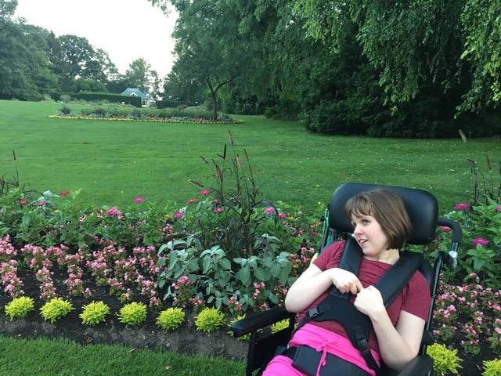
Sephora is enjoying the sounds of the birds and lovely scents of the Fellows Riverside Gardens in Mill Creek Park
My youngest daughter Sephora was born with profound disabilities. She joined her three siblings, aged 7, 6, and 1. Today, as a 25-year old adult, Sephora functions at the level of a two-month old. She has microcephaly, an intractable seizure disorder, cortical blindness, cerebral palsy and relies upon a wheelchair. Even for me, a former ICU nurse, the demands of her care were overwhelming. Our dining room became an ICU with a feeding pump and equipment for suctioning, as Sephora frequently developed pneumonia as an infant. She had a special ketogenic diet, steroid injections, and numerous seizure medications several times a day. I took her to physical and occupational therapy twice a week and there were frequent medical visits, sometimes over an hour away in Cleveland. This all was occurring while my husband and I raised Sephora’s three siblings, who needed their mother just as much.
One day, I remember vividly, standing at Sephora’s bed, doing homework with my son and daughter, thinking, this is surreal. This is not a good quality of life for Sephora, for her siblings, for my family. As their mother, I needed to do something.
Sephora had been enrolled in an early intervention program with Mahoning County Board of DD. I reached out to Mahoning County again for help. They suggested caregivers and/or nurses could come to our home a few hours a week for some relief. I knew that wasn’t going to be enough and I knew I wouldn’t be comfortable with disturbing my family’s home dynamic, as it was chaotic enough. I placed Sephora on a waiting list for waiver services, but knew that was not the right answer.
The right fit came to us purely by chance, when Sephora was
3 1/2 years old, in a casual conversation with Sephora’s teacher at the County Board School. Her teacher mentioned Hattie Larlham. Despite my previous contacts with Mahoning County, I had never heard of Hattie Larlham or the term, Intermediate Care Facility. My husband and I interviewed with Hattie Larlham for respite care. We toured the facility and were very impressed.
Over time, the increasing challenges of caring for Sephora led us to consider full time residential services at Hattie. They had 24 hour nursing care, a medical doctor and nurse practitioner to direct her immense medical, physical, occupational, and speech therapy needs on site. There was an indoor therapy pool that she just loved and a playground. She could even attend school at Hattie. This could be the answer to our prayers. It met all her needs. When Sephora was 5 years old, we made the decision to admit Sephora to Hattie Larlham. That was by far the best decision we ever made.
Sephora thrived at Hattie Larlham and began to make milestones. She never got pneumonia again and regained head control. Hattie Larlham procured horseback riding to assist in Sephora finding her center for sitting upright. She joined the Girl Scouts and had her own peer volunteer. She was engaging holistically in the world around her, in a way she could not possibly do at home. None of this would have been possible without Hattie. And, we found it purely by chance.
I cannot stress enough the positive impact this ICF facility, that we now call our second home, has had on our family. It kept us whole. It has given Sephora a quality of life full of love and joy and more importantly, optimum health. I cannot understand why our County Board did not inform us of it. That needs to change. An ICF option must be part of the conversation when speaking to families. They need to know that this kind of intense medical/nursing/24 hour care is out there and that it is a worthy option to be respected and applauded for the life-changing care it provides.

