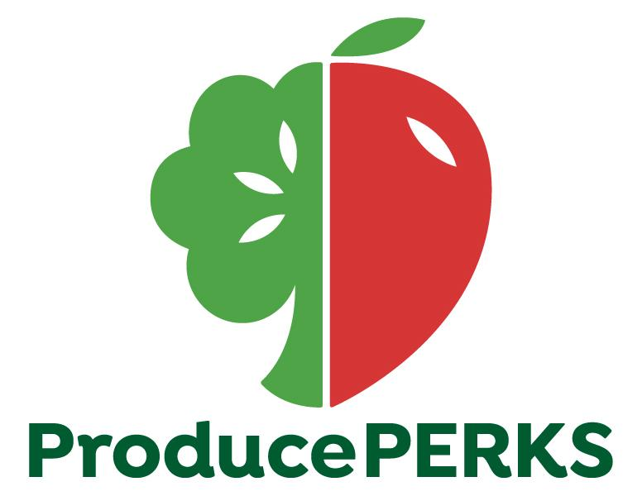
Interested Party Testimony- Senate Finance Committee
Substitute House Bill 166- State Operating Budget
May 28, 2019

Chair Dolan, Vice Chair Burke, and Ranking Member Sykes – thank you for the opportunity to provide testimony on Substitute House Bill 166, the State Operating Budget, in support of Produce Perks Midwest’s funding request which would appropriate $500,000 in each fiscal year within the Department of Job and Family Service’s TANF Block Grant for Produce Perks to expand services.

My name is Tevis Foreman and I serve as the Executive Director of Produce Perks Midwest, the lead agency administering the Produce Perks program for Ohio. Through innovative nutrition incentive programming and local farmer economic growth initiatives, we are improving the health of the communities we serve and strengthening Ohio’s food system – this includes putting over $800,000 back into our local farming economies in 2018. There is high demand for our programming and significant business growth opportunities, and with your help we can reach far more communities across the state.

Produce Perks is Ohio’s nutrition incentive program, an evidence-based model that empowers SNAP households to purchase fresh, healthy fruits and vegetables from Ohio’s family farmers, farmers markets and grocery-retailers across the state. It increases affordable access to healthy produce for 1.5 million Ohioans receiving SNAP benefits, healthy food they otherwise would lack. Most notably, it improves health while saving the state money. Produce Perks programming increases the consumption of healthy produce among target populations, resulting in lower Medicaid expenditures tied to costly chronic disease – such as diabetes, obesity and heart disease, among others. The beneficiaries of this program are 100% TANF recipients. Additional program beneficiaries are Ohio’s family farmers and small businesses that work so hard to thrive in our state, who love this program so much they offer seasonal recipes for cooking on a budget, nutrition education and cooking demonstrations on-site to ensure their customers know how to cook and eat heathy produce.

In 2018 alone, Produce Perks generated over $800,000 in healthy food purchases that benefited over 500 Ohio farmers. We are operational at over 100 locations statewide but only reaching 1% of those who could participate in this program.

One small business family farmer, Bryn Bird of Bird’s Haven Farm in Licking County shared,

“At the Canal Market District in Newark, OH, Produce Perks accounted for close to 40% of our annual market sales. This gave us an entirely new market to sell to, increased our overall profits for the year and helped us bring local produce to a community that had been without local produce for decades. We have countless stories of customers who had never tried ground cherries but only because of Produce Perks they were able to buy them, found their kids loved them, and began making special trips each week for their child to enjoy a favorite healthy snack.”

Our work creates healthy behavior changes and improves net income for family farmers and small businesses alike. Produce Perks is a nationally recognized program, receiving a federal grant in 2018 from the USDA’s Food Insecurity Nutrition Incentive (FINI) program. With state funding – we can leverage and enhance these dollars, reaching more communities, reversing our increasing rates of diabetes, heart disease and BMI, and ultimately, lowering our state’s costly Medicaid expenditures.

Ohio spends $50 million annually to address chronic, diet-related disease. Produce Perks directly addresses this by providing a $1-for-$1 match for fruits and vegetables, doubling the purchasing power of low-income Ohioans to buy fresh, healthy produce (our dollars can only be used on fruits and vegetables). In 2018, our average customer produce purchase increased by 53.2% at participating grocery-retailers.

Ben Holter, pharmacist and partner at Shrivers Pharmacy in Athens County, shared

“As a healthcare professional, I can attest to the benefits proper nutrition has in preventing chronic disease and personally witness on a daily basis the detrimental effects that poor nutrition has on the health of our communities. When first deciding to offer fresh, local produce in our pharmacy, our goal was to promote the overall health of the community and provide another access point for healthy food. Produce Perks has been a great partner in helping further that goal.”

The Health Policy Institute of Ohio’s (HPIO) 2019 Dashboard ranks Ohio in the bottom quartile of states on health value (46th), meaning Ohioans are less healthy and spend more on health care. HPIO notes, a primary reason for such poor ranking is “missed upstream opportunities to invest in prevention…and most spending is on costly downstream care to treat health problems.”

The Ohio Department of Health (ODH) and HPIO both recommend nutrition incentive programming (Produce Perks) as the top-rated, evidence-based strategy relevant to state policy to address food insecurity and improve health outcomes. Produce Perks is recognized as a key strategy within ODH’s State Health Improvement Plan.

Produce Perks spurs economic growth. The USDA estimates that every $1 in SNAP spending creates $1.80 in economic activity, and this impact is magnified when purchasing locally-grown food. Based on these estimates, Produce Perks generated over $1.44 million in economic activity within Ohio’s food system in 2018. These are dollars going directly into Ohio communities, purchasing healthy foods from Ohio farmers. Our work redirects federal dollars to create positive impacts on health and economy — it is the highest and best use of federal SNAP dollars.

Ohio is a leading agricultural state with over 73,000 farms (7th highest nationally), yet we rank 45th for food insecurity. Consequently, we experience some of the nation’s worst health outcomes tied to chronic disease and disparity, resulting in unsustainable health expenditures. As a proud agricultural state, we can do better.

Food Hardship in America: A look at National, Regional, State, and Metropolitan Statistical Area (MSA) Data on Household Struggles with Hunger, 2018 report.
Ohio MSAs food hardship rates in 2016-17.
OH Metro. Statistical Area (MSA) | Food Hardship Rates for Households with Children | Food Hardship Rates for Households without Children | Overall Rate of Food Hardship | National Rank Food Hardship out of 108 MSAs
Akron | 19.1% | 15.6% | 16.6% | 35th
Cincinnati | 14.5% | 12.8% | 13.4% | 78th
Cleveland-Elyria | 20.2% | 13.7% | 15.6% | 46th
Columbus | 17.9% | 15.6% | 16.5% | 36th
Dayton | 20.7% | 13.9% | 16% | 42nd
Toledo | 18.5% | 13.7% | 15.2% | 53rd
Youngstown-Warren-Boardman | 34.8% | 16.6% | 22% | 2nd

There is an inherent link between health and food. According to the American Diabetes Association (ADA), those experiencing food insecurity have an approximately twofold risk of diabetes compared to those who are food secure. With food insecurity, individuals may rely more heavily on less nutritious, inexpensive, calorie-dense food alternatives, contributing to higher diabetes rates among this population. In Ohio, 1.3 million people are living with diabetes and the average medical expenditures per person with diabetes per year is $13,700 in 2012 dollars.

To rein in this profligacy, the American Heart Association recommends creating a healthier, more sustainable food system through innovative, system-level approaches that create healthy behavior change, strengthen private sector and community, and align policies with evidence-based recommendations. This is exactly what Produce Perks does.

An example of health impact; following implementation of a 6-month Produce Perks pilot project in two Cincinnati Public Schools with soaring BMI and childhood obesity rates:

- BMI rates remained stable or decreased for 78% of participants,
- A1C numbers measuring blood sugar levels used to diagnose diabetes and pre-diabetes dropped for 47% of participants, and
- the majority of the children participating decreased their Triglycerides.

Produce Perks advances years of investment and the collective work of partners from across our state. We’ve experienced annual growth in every facet of our program, with a 166% increase in healthy food purchases from 2017-18. This is why the American Diabetes Association supports this budget request along with the Ohio Grocers Association and dozens of other health organizations, farmers and small businesses across the state.

Produce Perks is currently funded through a public-private partnership. In 2018, the USDA awarded Produce Perks Midwest the FINI grant to expand programming. Produce Perks was the top-rated proposal in the nation and Ohio is among a small contingent of states leading nutrition incentive programming to the scope and scale in which we are. Ohio is emerging as a national leader addressing costly health expenditures while simultaneously revitalizing urban and rural food systems of small business farmers across the state.

With $1 million from the state, Produce Perks could expand programming to reach 1000+ Ohio farmers, and over 300 farmers markets and retailers in communities throughout Ohio’s highest-need counties. Furthermore, these dollars would leverage a renewal of our FINI award in 2021.

I implore you to support our amendment of $500,000 in each fiscal year within the Department of Job and Family Service’s TANF Block Grant for Produce Perks to expand services to benefit Ohio’s diminishing family farmers, small business owners, and countless communities across Ohio – Produce Perks improves the health and wellness of our great state.

This work truly creates more efficient and effective systems, with immediate impacts and compounding returns on investment.

I can answer any questions at this time.

Thank you.

Sincerely,

Tevis Foreman
Executive Director
Produce Perks Midwest, Inc.

