Testimony before the Ohio Senate
Finance Committee: Health and Medicaid Subcommittee

May 28, 2019

Presented by:

Cindy Farson
Executive Director, Central Ohio Area Agency on Aging
Board of Directors: Ohio Association of Area Agencies on Aging

Chairman Dolan, Vice Chair, Ranking Member Sykes, and members of the Committee, thank you for the opportunity to speak about H.B. 166, and in particular, the Senior Community Services program that is part of the Ohio Department of Aging’s budget. My name is Cindy Farson and I am the Executive Director of the Central Ohio Area Agency on Aging, and a member of the Board of Directors for the Ohio Association of Area Agencies on Aging Board of Directors.
We are part of a national network of over 600 on-the-ground organizations in each state, mandated by the Older Americans Act, and charged with helping Americans thrive in our homes and communities as we age.
We are mission-driven primarily not-for-profit organizations that operate a complex service delivery system that provides access to community-based, in-home and elder rights services to older Ohioans and people with disabilities.
We are granted with the flexibility to ensure that our communities’ local needs and preferences are taken into consideration and that the resulting local delivery system is tailored to our communities.
Programs that connect us to our communities at all stages of life are the most effective strategy for addressing social isolation. Without these programs, social isolation greatly increases our risk of neglect and abuse. Our communities are social structures that need strong, integrated supports to make these connections for us as we age. All of these supports are needed to effectively prevent and address elder abuse and neglect. We support increased investments to bolster and reinforce the effectiveness of these important social supports to prevent social isolation, and thereby reduce the risk elder abuse and neglect.
Among the social supports we rely on to connect us as we age is Ohio’s Senior Community Services program (ALI 490-411). Senior Community Services supports non-Medicaid services that address the social determinants of health for older Ohioans to allow us all to thrive in our communities as we age. Transportation, meals, housing assistance, personal care, and other types of support prevent social isolation and connect us to our communities. We leverage resources so that we have the flexibility to ensure our communities’ local needs and preferences are taken into consideration and that the resulting local delivery system is tailored to our communities.
My agency, the Central Ohio Area Agency on Aging, works closely with primary partners in each of our 8 counties to serve older residents who are not yet facing the need for Medicaid-based home and community services or don’t qualify. We provide low cost, less intensive interventions - things that folks need to stay home and engaged with their community for as long as they can such as home delivered meals, transportation and personal care. When the Senior Community Services funding was reduced over the years by more than half our partners felt those cuts. We were unable to provide the same level of service to the community. My staff that go out to individuals’ homes, our assessors, who help individuals by identifying what resources are available, felt those cuts because it limited the options they could offer people. We would like to restore these valuable, cost effective services. We hear often from counties who struggle with their Adult Protective Service cases. Due to a longstanding lack of sufficient resources for APS, they just don’t have the services to put in place for those they are trying to help out of situations of abuse and neglect. Services can help stabilize survivors of elder abuse and neglect and ultimately, we hope that they can reduce the risk of elder abuse, neglect and exploitation in the future. The Senior Community Services program is an important resource that enables our agency to work with APS to link services to these individuals, but we are not able to do it with the limited funding available and the continuation of cuts.
We support an additional $1.9 million over the House version of HB 166 to bring the Senior Community Services program to the pre-recession level of $10 million per year to bolster and reinforce the effectiveness of the program, and we ask that the program retain the flexibility to meet local needs.
We greatly appreciate the Governor’s proposal to increase investment in the Senior Community Services program. Department of Aging Director McElroy has indicated that the entire increased investment in the House bill ($1.2 million) will be directed toward a statewide initiative to enhance and expand the Senior Farmers Market Nutrition program. The Senior Farmers Market is currently a federally funded program that is not available in every part of the state due to a variety of factors. Our Area Agency on Aging members who do not currently have a program are supportive of the opportunity to start a Senior Farmers Market Program in their regions.
However, earmarking funds from the Senior Community Services program is contrary to the longstanding spirit and intent of the program – to give Area Agencies on Aging the ability to leverage their resources to meet the existing, identified needs of their local communities. If an AAA determines they want to use these resources to start a Senior Farmers Market program, or to expand an existing program, they have the ability to do that right now, and should have the ability to make those determinations in the best interest of their communities.
The key to being able to do this is the availability of resources. The Senior Community Services program has experienced cuts of over 50% in the last several years. This limits what AAAs can do.
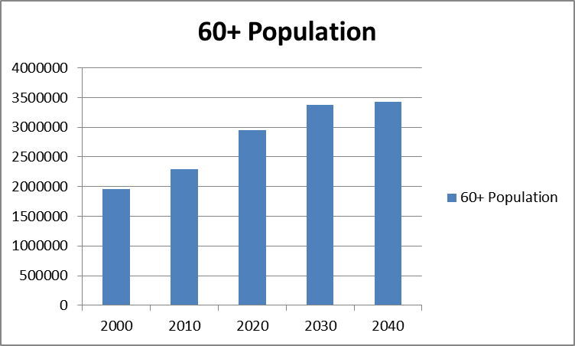
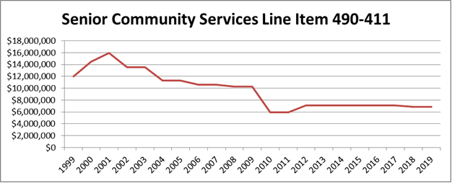

With a modest increase in the program, and the ability to focus on local needs, we can explore and expand innovative ways to deliver services that facilitate those important connections to community in a way that meets our local needs.
Examples of Current/Potential Innovations:

- Elder Abuse Victim Outreach – Area Agency on Aging 3 (Lima)
- Intergenerational Congregate Meals – Ohio District 5 Area Agency on Aging (Mansfield)
- Transportation Coordination – Area Agency on Aging 3 (Lima)
- Care Coordination – Direction Home Akron Canton Area Agency on Aging
- Meals as You Mend – Area Agency on Aging 9 (Cambridge)
- Housing Transition Care Coordination – Direction Home Akron Canton Area Agency on Aging
- Direct Care/Personal Care Workforce Recruitment

Low cost and less intensive interventions through Senior Community Services also:
- Delay and divert from enrollment in Medicaid,
- Address determinants of long-term poverty (Housing, Nutrition, Transportation, etc.),
- Enhance health and wellness programming (Healthy U, Matter of Balance),
- Support family caregivers,
- Include high risk and diverse populations (opioid crisis, rural capacity); and
- Maximize new and existing Medicare benefits.
Medicaid HCBS Waivers:
For 40 years, Area Agencies on Aging have expanded meaningful, cost-effective options to live healthy, engaged, secure lives in our homes and communities. Our efforts saved the state an estimated $12 billion, even before managed care entered this space with MyCare Ohio.
PASSPORT and Assisted Living are Medicaid home and community-based (HCBS) waiver programs that have successfully enabled thousands of us to thrive in our homes and communities each year. We have promoted and implemented new services, improved access, and tested innovative approaches to expand and promote these programs.
The House version of the budget includes a 2.7% rate increase for PASSPORT home care attendant, personal care, and waiver nursing services; increases in PASSPORT home delivered meal rates; and a 2.7% increase in the assisted living waiver rates. We are appreciative of these increased investments. It is an important acknowledgement by House members of the positive impact of home and community-based waiver programs on healthy aging outcomes, and a healthy state budget as we look to the future.
Right now, the PASSPORT and MyCare programs are experiencing significant challenges in finding personal care aides to provide services. Our Area Agencies on Aging have reported that across the state, in the last year, at least 80 personal care providers have dropped out, and at least another 10 have so far indicated they might do the same. We are not easily able to replace these providers. Providers face low rates, staffing shortages, difficult and conflicting bureaucratic hoops, and economic forces that combine to convince them that our programs are just not worth it to them. Without the ability to provide the services, eligible participants are turned away or disenrolled, and are forced to turn to options much more expensive to the state – nursing facilities supported by Medicaid. Also, the assisted living waiver rate increase is the first since the program started in 2007. Low rates have made it difficult to get assisted living providers to participate in the program.
We need forward thinking, common sense solutions to address what will otherwise become an unsustainable model for long term services and supports, putting our state’s fiscal health, and the health of all of us as we age, at great risk. Realigning Ohio’s investment so that we have parity for home and community-based services as well as nursing facilities, with a concerted effort to greatly increase home and community based placement, and promote an emphasis on workforce and small business development for personal care aides, is a path we encourage you to adopt.
We support a stronger focus on supports for going home from institutional care and building upon the Area Agencies on Aging successes by investing in home with increased rates, training and incentives so that we can have the right supports we need where we need them
We support proposals to increase the assisted living waiver rates put forth by the Ohio Assisted Living Association and other organizations, and increased investment in personal care services in the PASSPORT program. We also believe that the state needs a longer term strategic plan that looks at all aspects of the workforce and the need, with specific strategies for building capacity for these important supports.
We must ensure adequate funding and system resources are dedicated to the full spectrum of supports to enable us all to live healthy, engaged and secure lives as we age and access the supports we need in our homes and communities. We ask that you support an investment of an additional $1.9 million per year over the House version of HB 166 to bring the Senior Community Services program to the pre-recession level of $10 million per year so that we can bolster and reinforce the effectiveness of the Senior Community Services program, and we ask that the program retain the flexibility to meet local needs.
Thank you for the opportunity to testify. I am happy to answer any questions you may have.

