Proponent Testimony for HB 166
Antonio Ciaccia
Director of Government & Public Affairs, Ohio Pharmacists Association
Chairman Dolan, Vice Chair Burke, Ranking Member Sykes, and members of the Senate Finance Committee, my name is Antonio Ciaccia, Director of Government & Public Affairs for the Ohio Pharmacists Association (OPA). I thank you for the opportunity to give our perspectives as interested parties on HB 166, which will make a number of significant reforms for pharmacy benefits delivery in Ohio.
In case you haven’t heard from your local pharmacist, or in case you haven’t read the nearly 100 pieces in the Columbus Dispatch over the last year, or the litany of other newspaper editorials and national features on Ohio’s pharmacy dilemma, allow me to walk you through how billions of dollars in Ohio Medicaid’s prescription drug program are actually being spent, and how Ohio has become ground zero for one of the biggest controversies in health care.
Before I bring you up to speed on what has occurred within the pharmacy benefits segment of the Ohio Medicaid managed care program over the last couple years, I’d like to first highlight some key features of the House-passed version of the budget, and our thoughts about how to ensure efficient delivery of pharmaceutical care to Medicaid beneficiaries, end pharmacy benefit manager (PBM) abuse of taxpayer dollars, and build better incentives within the pharmacy program to maintain access and drive quality.
In light of the recent state findings that PBMs were taking advantage of their unchecked role in the middle of prescription processing, the budget currently contains language that strips PBM contracting away from Ohio’s Medicaid managed care organizations (MCOs) and instead creates one master PBM contract for single PBM to service each MCO. The budget language requires full transparency and a fiduciary role of the PBM to the state.
While these are admirable steps to reclaim control of a program that has gone off the rails and now become an impetus for nationwide reform, we do have a few concerns to share regarding the current language.
As Speaker Householder mentioned after the budget’s passing, “Somebody said PBMs are like having a wolf in the henhouse, so I said we should limit it to one wolf … We can keep a pretty good eye on one wolf.” Based on past experience, it’s hard to argue with the sentiment.
However, one of the big problems with the PBM industry is the overconcentration of the market. This fact was highlighted by the White House Council of Economic Advisers last year. Part of the reason we are where we are today is that two PBMs had complete control over the entire Medicaid managed care market, leaving pharmacy providers largely powerless against the entities they have to contract with in order to gain access to their patients. The current budget proposal moves all patients into one PBM, further concentrating the market.
Further, in lines 6010-6019, the language that requires PBMs to act as fiduciaries is overly focused on seeking the lowest prices, which means now the singular state PBM, with all its leverage would be required to cut rates as low as possible, meaning pharmacies will likely get reimbursed even lower than they are today. Pharmacy care (and healthcare in general) is not and should not be a race to the bottom on price. If price was the only metric in healthcare, then access and quality would suffer immensely.
In order for this language to work without compromising pharmacy access and quality more than it already has today, we believe language should be added to create some form of a rate floor for the dispensing, and to ensure that there is a standard of care accounted for in the expectations of the pharmacy. It needs to be about more than price.
To that end, we believe that setting a reference-based pricing benchmark to calculate drug ingredient costs will help provide a reliable tool to approximate true drug costs in light of the pricing manipulation uncovered in Ohio’s PBM audit. Additionally, recognizing that pharmacies are operating in the deep red within the Medicaid managed care program, a baseline dispensing fee floor should be created to cover the costs of operation and rendering services.
Additionally, recognizing that the incentives of the current system are pointed in the direction of filling prescriptions as fast as possible, we also recommend adding language to begin incorporating value-based payment and quality incentive programs within the pharmacy benefits space, where pharmacies can be rewarded for their role in achieving positive outcomes for the patients they serve.
The baseline dispensing reimbursement floor will provide a predictable foundation to build a better care model on top of – one that in the future could become a growing portion of the overall reimbursement structure, thus better incentivizing value over volume.
Ohio has led the nation in exposing PBM pricing gymnastics that take advantage of providers and taxpayers in the Medicaid system, and we believe this roadmap will help show others how to build a better model in its place.
Also in the budget, we are pleased to see language added to prohibit PBM gag clauses and co-pay clawbacks. After working to eliminate them for the past couple years, we are glad to see this being prioritized in the budget.
The other language we would like to provide feedback on is the language that refers to the state PBM paying no more than the international price index. The problem with this language is that wholesalers and pharmacies cannot obtain the drugs at those rates. Nor do those rates include any accommodation for a margin. We believe there are other reference-based price lists that can be used as the baseline for drug spending, but the language as is, needs to be better refined to be workable in the pharmacy market.
Thank you for allowing us to share our thought on the current budget language. Please see below for background on the need for PBM and pharmacy payment reform.
In the middle of 2016, I was inundated with calls and emails from panicked pharmacists who saw sweeping reimbursement cuts at their pharmacies through the Medicaid managed care program. Independent and chain pharmacies alike saw their gross margins on prescriptions chopped in half without any notice or change in contract terms from the managed care third party intermediaries, known as pharmacy benefit managers (PBMs). While taking losses on prescriptions is nothing new in pharmacy, the sheer volume and size of these cuts were unlike anything Ohio pharmacies had ever seen.
At the time, we sought answers from the Ohio Department of Medicaid and their managed care organizations (MCOs), but we came up short. Essentially, pharmacists were told that they needed to take the issues up to the PBMs that were administering the benefits for the MCOs. In Ohio, we have five MCOs. One has their own PBM called OptumRx, and the other four MCOs have historically contracted with CVS/Caremark as their PBM.
After about a month or so without any reasonable explanations, reimbursements gradually increased, but they settled well below the rates that were in place before the cuts took place. What we learned after the fact was that in 2016, some contract changes between the MCOs and their PBM removed transparency and accountability in terms of what was actually being paid to pharmacies dispensing medications to Medicaid patients.
Effectively, at this point both CVS/Caremark and OptumRx, who own their own pharmacy businesses as well, had obtained an unchecked power to set the reimbursements to their own pharmacies, set the reimbursements to competitor pharmacies, and set the rates billed back to the state. Managed care organizations, who years ago argued that they wanted to carve in the pharmacy benefits so that they could drive better quality, improve outcomes, and control costs, instead outsourced the benefit to someone else – for-profit entities in the pharmacy business who had now been handed complete control of Ohio’s Medicaid pharmacy marketplace. And unsurprisingly, pricing cuts and volatility ensued.
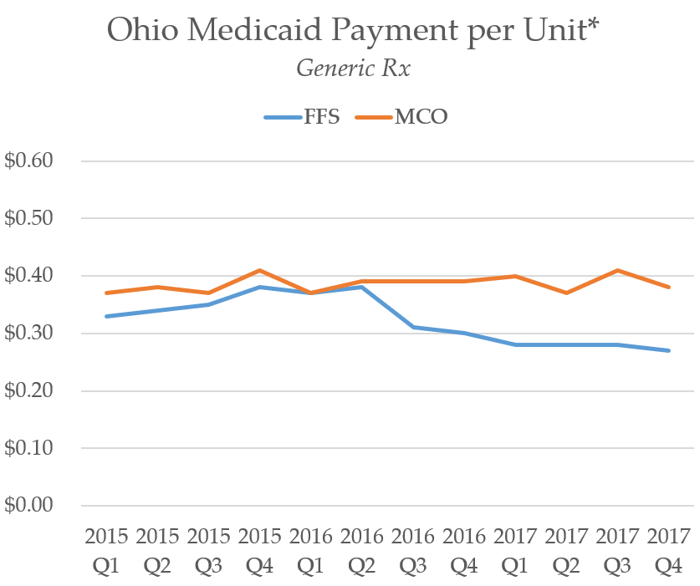
We decided to examine data from the Centers for Medicare and Medicaid Services (CMS) to see exactly what happened after PBMs gained complete, non-transparent control of the pharmacy program. We compared the rates being charged to the state (CMS’s State Drug Utilization Database) through the Medicaid managed care program and the Medicaid fee-for-service program (where prices are transparent and fixed off of actual drug costs). What you’ll see on the chart is that the prices being charged were generally similar up until the contract change in mid-2016. Drug prices in the fee-for-service program went down, but managed care stayed high. The MCOs’ PBM pharmacy prices essentially became detached from reality.
In examining these data trends, it was alarming to learn that while drug prices were dropping and pharmacy margins were getting severely pressured, the state was not realizing the savings.
Over the course of the following year, pharmacists reported ongoing erosion of their margins from PBMs in the Medicaid managed care program, and then in August 2017, there was another wave of cuts. And then on October 26, 2017, the bottom fell out again. Sweeping cuts to local pharmacies threw the entire marketplace into chaos. Pharmacies weren’t just losing money on a few drugs here and there, but at this point, if you averaged out all the drugs dispensed through the program, pharmacies were operating in the red in the aggregate – meaning they bought the medicine, dispensed it to the Medicaid patient, received no gross margin for the actual service, lost money on the drug itself, and then were left to figure out how to pay for their rent, utilities, software expenses, and of course, employees. Pharmacists reported that important addiction medications like generic Suboxone were being dispensed at $100 losses per prescription. It was a fiscal nightmare for Ohio pharmacies that was created literally overnight by this quick and easy change of rates by CVS – a change that had nothing to do with any changes in market prices of the underlying drugs.
I was receiving complaints from nearly every pharmacy in the marketplace – big and small. The pharmacies that I wasn’t hearing from: CVS and OptumRx.
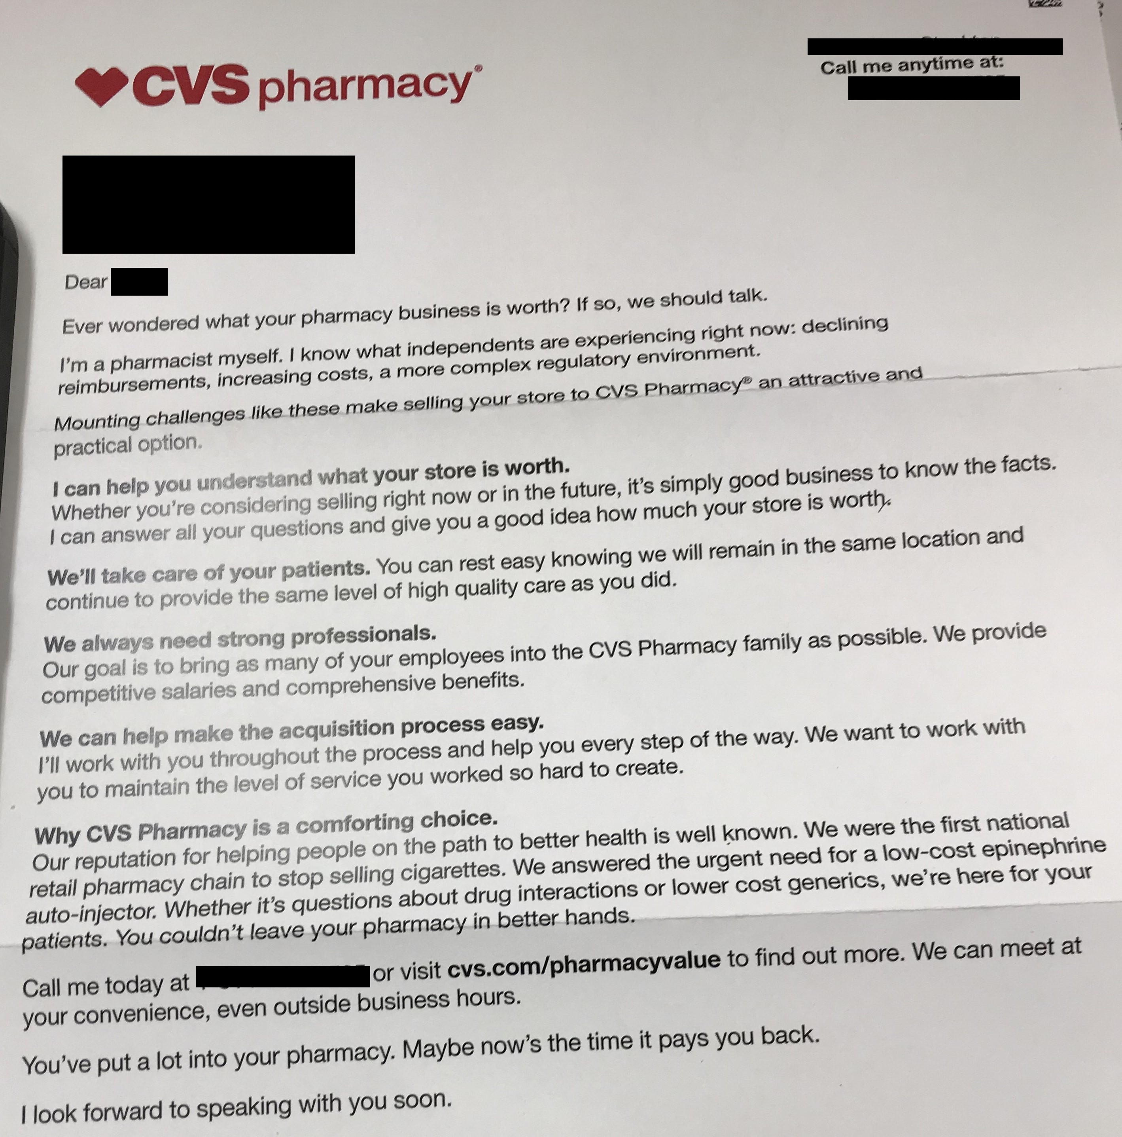
Making matters even more perplexing for pharmacists, is that in the midst of the most significant pharmacy reimbursement cuts from CVS/Caremark they had ever seen, CVS sent letters to Ohio pharmacy owners, soliciting to purchase their pharmacies, citing low reimbursements as the reason for long-time owners to leave their pharmacies “in better hands.”
Again, as we sought answers and action from Medicaid and the managed care organizations tasked with managing the program, we were referred back to the very PBMs that were setting the unsustainable rates. Pharmacies meanwhile started laying off staff, pushing prescriptions out the door quicker, cutting services, and closing their doors.
As the calls began pouring into the legislature, Medicaid eventually sought answers from the MCOs, who in turn referred Medicaid to CVS to discuss the cuts. They eventually capitulated and updated some prices, but overall, the cuts persisted. Over the course of a two-year stretch, pharmacies reported an overall 60-80% erosion of their gross margins in Medicaid managed care. Over that same time period, Ohio lost a net of 164 community pharmacies. As reported in the Columbus Dispatch, also over that time period, while most pharmacies saw a decline in locations, the top three pharmacy chains in terms of location growth were: Walgreens (+2), Ritzman (+3), and CVS (+68).
Meanwhile, at the January meeting of the Joint Medicaid Oversight Committee (JMOC), we learned from JMOC’s actuaries that despite a rapidly deflating generic marketplace and pharmacy margin cuts of 60-80%, state spending on Medicaid managed care prescription drugs increased 22.5%. Ohio was paying a lot more for a lot less.
It was at this time that lawmakers began demanding answers. The Columbus Dispatch began digging in, and then-Ohio Auditor Dave Yost called for an audit of the program.
As reimbursements to pharmacies crept up slightly into April 2018, they remained well below the cost of the actual service, and these PBMs still controlled the dials for all drug spending in the Medicaid managed care program. Ohio lost another 13 pharmacies in just those three months.
As we awaited the results from Medicaid’s analysis of the program, as well as the state audit, we started reviewing more CMS data, and we began comparing CMS State Utilization Data (what state Medicaid programs report to CMS as the cost of the drug) to National Average Drug Acquisition Cost – NADAC (the actual average pharmacy invoice acquisition cost for drugs), and we found growing discrepancies between the actual prices of drugs versus what the state had been getting charged. The results were stunning.
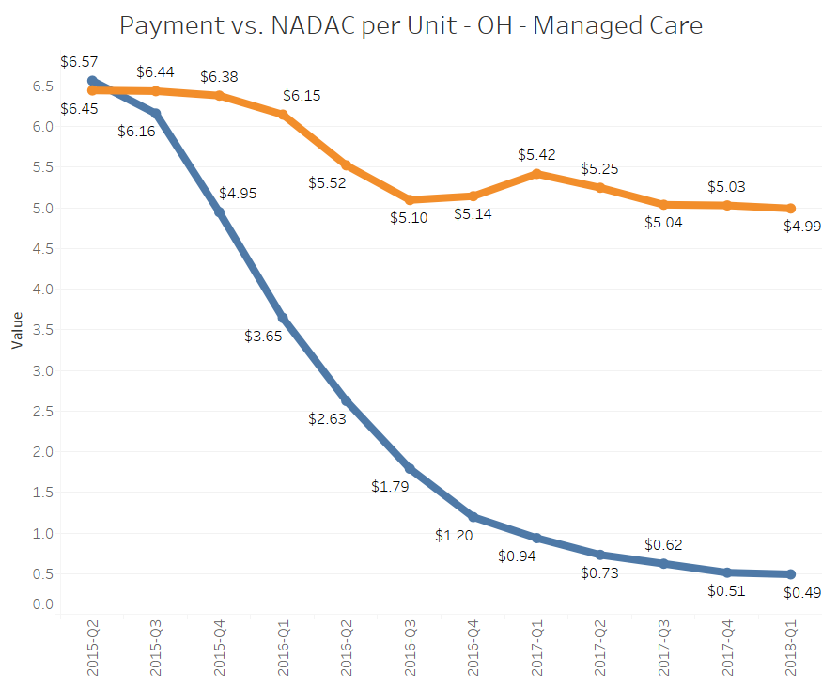
Popular drugs like generic Nexium (Esomeprazole 40mg capsule, right) were deflating significantly in price, but Ohio went from having almost no markup to getting charged more than 10 times the actual cost of the drug.
While we cannot conclude that these markups are necessarily all being captured by the PBM, I can tell you that the PBM is the party that controls the decision on what to price to charge managed care for any given generic claim, which begs the question, “why?”
This is just one of hundreds of drugs that we’ve analyzed, but the tactic is not unique to Esomeprazole, and it is being exploited on a litany of generic drugs. Some drugs have been found to have markups of more than $3000 per prescription.
To reiterate, the “markup” is not what the PBM receives and not what the pharmacy receives. It is essentially the margin that the PBM and the pharmacy “share” on a claim (but note, it is not uncommon for the pharmacy to receive a negative margin, especially in Ohio managed care, meaning that in those instances, the PBM pockets all of the markup plus whatever they underpay the pharmacy).
That of course leads to the logical question of how markup is divvied up. That’s where the state auditor’s PBM report comes in, which was released in August of last year.
The report revealed that PBMs pocketed a whopping $224.8 million in hidden spread pricing (the difference between what the PBM pays pharmacies and what they bill the MCO/state) between Q2 2017 and Q1 2018 within the Ohio Medicaid managed care program, $208.4 million ($6.15 per prescription) which came from generic drugs.
While this is just one way that PBMs make money, in the context of spread, the question is, if PBMs pocketed $208.4 million on generic drugs in the Ohio Medicaid program, how much did pharmacies receive for actually dispensing those drugs? Applying a bit of arithmetic to the table on page 2 of the Auditor’s report (below), we calculate that pharmacies received, on average, $13.40 per generic prescription (($662.7M - $208.4M) / 33.9M prescriptions).
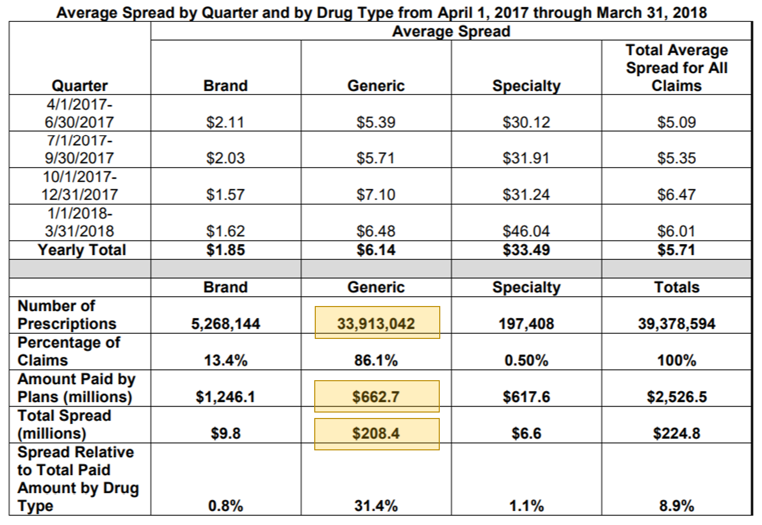
To be clear, that $13.40/prescription is the total revenue that Ohio pharmacies received per prescription, not the pharmacy’s gross margin per prescription. To estimate what the gross margin per prescription is for the pharmacy, we need to know the ingredient cost. We ran an analysis of all generic oral solids that were dispensed over the course of the auditor’s report and we factored in the NADAC price on every pill and capsule that Medicaid paid for over that time period. We then divided that by the total number of generic oral solid prescriptions dispensed over that time.
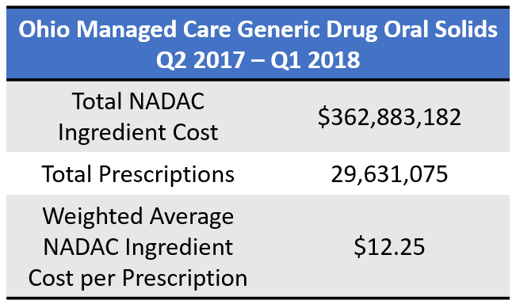
As shown below, the analysis showed a weighted average NADAC cost of $12.25 per prescription, meaning on average, out of the $13.40 per prescription that pharmacies received on generic drugs, pharmacies spent $12.25 per prescription in order to acquire those drugs from their distributors. Based on the data in Auditor Yost’s report, this would leave an average Ohio pharmacy with a margin of only $1.15 per prescription. This margin is in stark contrast to Ohio’s results from its own cost of dispensing survey, that aimed to capture the overall costs associated with operating a pharmacy and dispensing medications to patients. At that time, Ohio’s cost of dispensing survey arrived at an average cost to dispense of $10.49 per prescription. This is the gross margin that Ohio Medicaid determined a pharmacy needs to cover its day-to-day operating costs (e.g. pharmacists, technicians, rent, utilities, pharmacy software, licensing, etc.). So we estimate that managed care Medicaid is falling short of Ohio Medicaid’s own targeted dispensing fee by nearly 90% on generics.
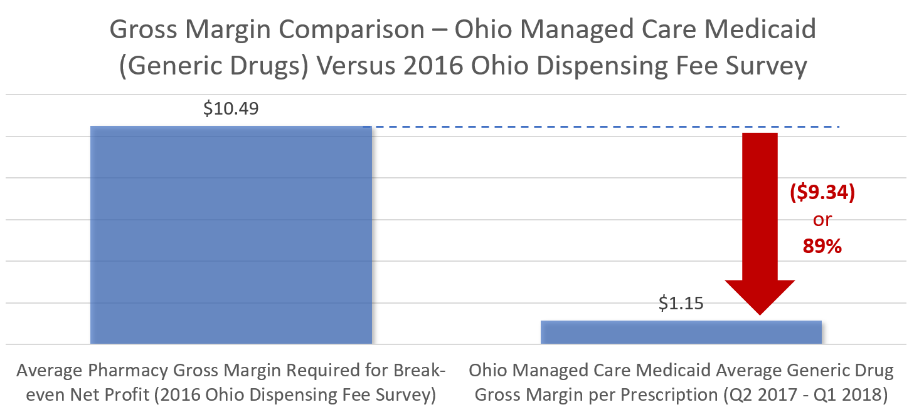
Since nearly 85% of the drugs dispensed are generic drugs, you can see how quickly a pharmacy with a high Medicaid volume can be knocked out of business. Even more alarming is the fact that while pharmacies were collecting $1.15 per prescription on generic drugs, PBMs that have their own pharmacies were pocketing the $6.15 per prescription spread on the other side of the transaction, giving their overall companies a clear advantage over their competitors. And Medicaid’s own commissioned report seems to validate these types of pharmacy numbers. According to their report, while PBMs were making three to six times the going rate for PBM services, pharmacies were paid more than $350 million below typical market rates in Medicaid managed care. This is why Ohio pharmacies are vanishing.
Unfortunately, this spread pricing mechanism that is at the heart of what has become a national controversy may not even be the most financially significant misaligned incentive in place within Medicaid managed care. Another very concerning misaligned incentive is rebates. The Medicaid Drug Rebate program mandates all drug manufacturers that produce drugs dispensed to Medicaid patients to commit to a sizable rebate program. The base rebate (or discount) for brand name, “innovator” drugs is 23.1% of the Average Manufacture Price. In addition to that, there is a Consumer Price Index (CPI) adjustment factor that ensures that the state and federal government will effectively never be charged for any more than an inflationary increase in any given year.
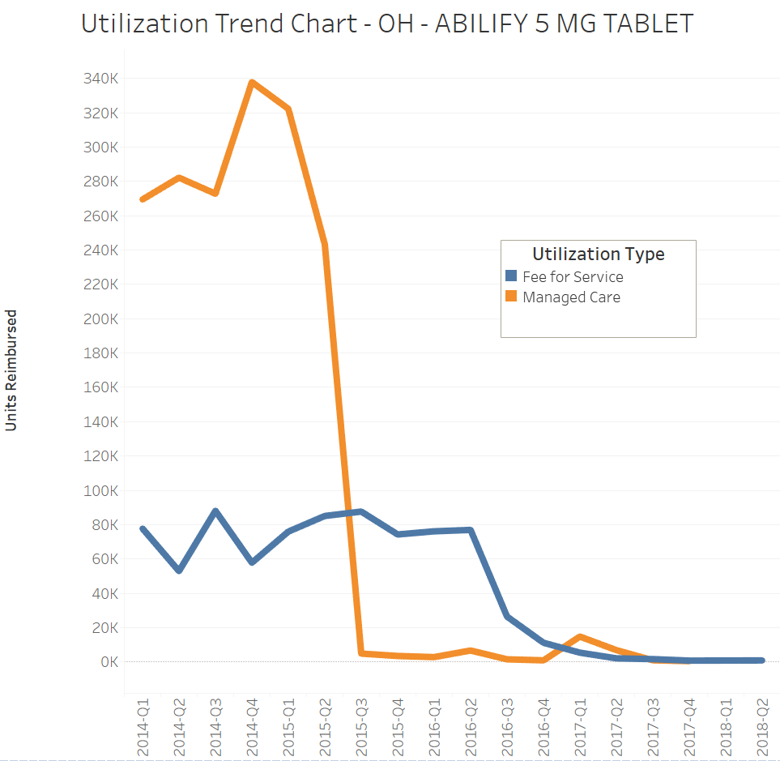
We modeled out the impact of these two factors alone. Let’s assume that a manufacturer increased the list price of its brand name drug by 10% a year for the 10-year period of exclusivity left on its patent after years working to bring the drug to market. But inflation only increased 2% a year. By the time the generic is released in year 11, Medicaid would be collecting a 72% rebate on this drug. This means that for the state and federal government to save money, the generic would have to be priced at more than a 72% discount to the brand, but that rarely happens early in the life the generic. However, both the PBM and the managed care organization have the economic incentive to control the Preferred Drug List to switch the state to the generic as quickly as possible. You can see this is exactly what happened with one of the most commonly dispensed mental health medications, generic Abilify (Aripiprazole 5mg), in late 2015 (right).
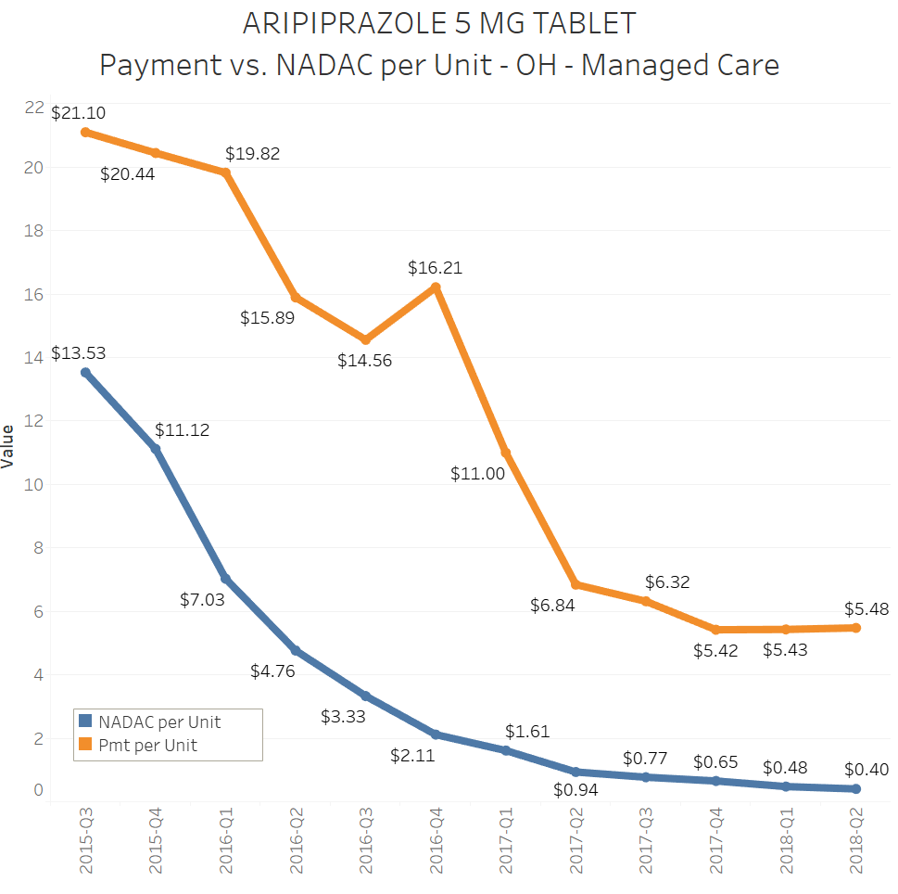
We have already established that the PBM makes loads of money off of generic spread, so switching to the generic shifts the price-setting capabilities to the PBM and allows the generic profit machine to start churning. And if you see what happened to the markup once generic utilization ramped up, that’s exactly what happened (right).
So the question is how much money is the state losing out on due to these misaligned incentives? While this is admittedly hard to quantify, we can look to MACStats, published by the Medicaid and CHIP Payment and Access Commission (MACPAC) for a hint. According to MACStats, in FY2016 gross drug spending in Ohio was $2.961 billion: $2.554 billion in managed care and $408 million in fee for service. Rebates on managed care were $1.273 billion or 49.8% of gross drug spending. On the other hand, rebates on fee for service were $247 million, or 60.5% of gross drug spending. In other words, fee for service produced more than 10 points of additional rebates when compared to managed care, an enormous number if we applied this to the more than $2.5 billion of managed care gross spending.
There are a lot of moving parts that need to be analyzed to do a full cost/benefit analysis, but it is very clear by analyzing the incentive structure that managed care may not be adequately incentivized to produce the lowest net costs for the state, and based on the pillaging of the pharmacy marketplace in recent years, it is abundantly clear that there are poor incentives for maintaining access and quality as well.
While this is only a fraction of what I want to discuss, I realize that there is only so much appetite for drug pricing talk, but I will remind this committee of a few things:
- The attrition of the pharmacy marketplace has still never been tackled by Medicaid in a meaningful way, despite the paltry access standards currently set within the program. It is difficult to hold anyone accountable if MCOs fail to meet the minimal access standards when prices drive providers out of business, because penalties are only able to be enforced when an existing provider is not “in-network.” If there is no pharmacy, there’s no access standard to enforce.
- At least two managed care plans directly profit themselves off of the pricing spreads, resulting in overinflated drug costs, and thus overinflated per-member-per-month rates from the state. This means that not only do the plans have the benefit of reaping the rewards of low-balling providers and reporting a higher price to the state, but they also get the added benefit that those overinflated prices can impact their per-member-per-month rates during the next budget cycle.
- The shift to managed care for any benefit is touted as a shift towards quality, innovative care models, integrated care, and value-based payments. Despite managed care organizations owning the pharmacy benefit for nearly a decade, aside from a couple programs, the incentives for pharmacies are to just fill prescriptions as fast as they can to maximize their margins, or to chase the few drugs that PBMs decide to overpay on.
- PBMs typically defend these issues by saying that despite many alarming examples, everything gets worked out in the aggregate. But the details matter. If the service being rendered to the patient is essentially the same, why should one drug have a markup of a few cents per tablet and another have a markup of $150 per tablet? This a massive red flag that someone may be gaming the system.
- Arbitrary drug pricing markups create warped incentives throughout the supply chain to dispense certain drugs over others, and as a result, serve some patients over others.
- By overinflating drug costs through spread pricing, plans have also shifted administrative costs into the medical portion of their medical-loss ratios that exist to ensure money received from the state is actually being spent on patient care. By artificially ballooning these pharmacy costs, managed care plans are afforded added real estate to increase their budgeting for administrative expenses and profits, while spending less on actual patient care. Just this month, CMS issued new guidance prohibiting these types of accounting practices, and referred to the findings in Ohio as the reason for the change.
- Any cost analysis of one pharmacy benefits system versus another must take into account a number of factors. Keep in mind, PBMs control the dials of every price and most decisions. There are a myriad of ways they can manipulate the current system, which makes cost comparisons of alternative models extremely difficult. Hence why cost estimates for reform have varied wildly.
- PBMs largely capture the specialty drug marketplace in Medicaid managed care through their own pharmacies and restrict competitors from dispensing these expensive (and high-margin) medications. This space has the least transparency on markups, and it also happens to be the biggest cost-driver in the program. Ohio Medicaid has been examining this issue as well, and after new revelations showing some of the high specialty drug margins last month, Medicaid announced their intent to reform that space as well. Any cost analysis for reform should factor in savings from exposing currently protected PBM market share to actual pharmacy competition.
- While the Ohio Department of Medicaid has since prohibited spread pricing, the state continues to pay the same per-member-per-month rates for prescription drugs. I can tell you that from hearing from local pharmacies, outside of UnitedHealthcare, the pharmacy margins have not materially improved in this new model. If the state is still paying a premium and pharmacies continue to be under-reimbursed, there is a good chance that Ohio’s $6/prescription spread pricing problem has turned into a $6/prescription administrative fee problem.
If you’re not concerned about the long-term deleterious effects of this warped system, I will draw your attention back to your districts. The money being sucked out of pharmacies is coming right out of your communities and being shipped out of state to some of the wealthiest companies in the world. Your communities are losing needed healthcare providers, employers, and local tax revenue in the name of quarterly earnings for Wall Street. Just this year, weeks into the new “transparent, pass through” system, the lack of pharmacy payment reform yielded another big blow. After years of low reimbursements, CVS purchased all 20 Ritzman Pharmacies in Northeast Ohio, and announced plans to close 17 of those 20 locations. Here was another Ohio-headquartered, family-run pharmacy organization with an impeccable reputation in the community, deleted off the map due to the absurd construct of local pharmacies having their reimbursement rates subjectively set at the whims of their competitors.
With stories in the Wall Street Journal, NPR, Bloomberg, Axios, NPR, and more now focusing on what’s happening Ohio, we believe our state has the opportunity to get this system under control and be a model for other states looking to rein in drug spending. It comes down to this: what do you want to buy with your Medicaid prescription drug budget? Do you want to cover more medications? Do you want to cover more services? Do you want to create innovative care models? Do you want more local provider access points? Or do you want more expensive claims processors?
Today, I give you this testimony as pharmacies continue to close. Just last week, we saw pharmacies close their doors in Chillicothe and Middletown. Just two weeks ago, Newcomerstown pharmacy owner Jeff Neidig informed members of the Health & Medicaid Subcommittee that his rural, high-Medicaid practice is in dire straits, having lost $150,000 last year. His story is not unique. Despite all of the attention and heat, the market has barely budged, and taxpayers are again footing the bill for this continuous PBM cash-grab. It is impossible to run a functioning business and healthcare practice in this type of environment, and I fear what is being lost at the pharmacy counter goes beyond just boarded up practices.
Our Medicaid Department has begun working towards a solution to this mess, but my fear is that the current proposed solutions of transparency will only tell us what we already know: PBMs are taking advantage of our providers and our state. That is now abundantly clear, and so now the questions are, how do we make it stop, and what type of program do we build in its place?
While I come before this committee on behalf of the Ohio Pharmacists Association to end the crippling cuts at the pharmacy counter, I also ask that that you take back the wheel of a program that has veered far off the rails. PBMs have taken control of this program, and it is time for the state to take it back.
The Ohio Pharmacists Association applauds the work of the House, as well as several members of this committee who have rolled up their sleeves on this issue over the past year. We would also like to thank the Columbus Dispatch and their work through their special Side Effects series, which has moved the public discourse on this complicated issue light years from where it was before they started their reporting. I’d lastly like to thank the Department of Medicaid for their work – we did not start out seeing eye-to-eye on these issues, but I believe they have done a remarkable job getting up to speed and tackling this issue head on in recent months. While their ideas for policy fixes may not be the same as our association’s, the fact that they are engaging meaningfully has me hopeful that this system will change somehow in the future.
Thank you for the opportunity to share our thoughts on HB 166, and I’ll happily answer any questions you may have.
Antonio Ciaccia
Ohio Pharmacists Association
aciaccia@ohiopharmacists.org

