Sub HB 166 Written Testimony
Ohio Senate Finance
Tuesday, May 28, 2019

Chairman Dolan, Vice Chairman Burke, Ranking Minority Member Sykes, and members of the Subcommittee:
Thank you for the opportunity to submit written testimony for your consideration of an important request for the biennium budget regarding suicide prevention through education, early identification and timely referral. I am Jack Binder and I am the CEO of LifeAct, a 26-year nonprofit organization devoted to preventing adolescent suicide through proven educational intervention. Its evidence-based core programming, delivered to a record-breaking 29,863 Northeast Ohio middle and high school students in their classrooms last school year, teaches youth to recognize the signs of suicide and to seek assistance.
We support Governor DeWine’s proposal for k-12 funding for wellness and prevention curriculum and resources that are desperately needed. The key to suicide prevention is education, early identification and timely referral. I would like to share some recent Centers for Disease Control statistics with you:

- Suicide is the leading cause of death, after accidents, in youth, teens and young adults (ages 10-34) according to the 2017 Centers for Disease Control (CDC) statistics ⁽¹⁾.
- Nationally, the suicide rate for youth, teens and young adults increased 53% between the years 2007 -2017.
- The State of Ohio has seen a 24% increase in suicides from 2008 – 2017 for all ages.
- The percentage of Cleveland, Ohio high school students who have attempted suicide is the second highest among the 21 urban school systems surveyed in the United States in 2016. This survey reports that 18.6% of these students have attempted suicide, which is more than double the National Average of 7.4%.

Saving Young Lives through Education
LifeAct is a 26-year nonprofit organization devoted to preventing adolescent suicide through proven educational intervention. Its evidence-based core programming, delivered to a record-breaking 29,863 Northeast Ohio middle and high school students in their classrooms last school year, teaches youth to recognize the signs of suicide and to seek assistance. That same school year, 2,504 of the 29,863 participating students came forward to a LifeAct instructor for help. These “at-risk” youth were immediately connected to a school or community-based professional mental health resource for further intervention and treatment.
LifeAct’s school programs use compelling real-life scenarios, role-play, skits, small group activities, technology-driven presentations, and interactive Q & A to engage youth in real-time dialogue while learning about suicide and strategies for prevention. Trained, credentialed instructors visit schools, community centers, and other educational settings to deliver LifeAct’s proven curricula. LifeAct instructors are key to helping students recognize the warning signs of suicide -- theirs or a friend’s -- and motivating them to come forward to get help. Untreated, childhood mental illnesses can lead to a downward spiral of school failure, substance abuse, unemployment, and sadly, suicide.

Empowering Youth to Prevent Suicide
TO EDUCATE
Objective: Deliver LifeAct’s middle or high school suicide prevention program to at least 30,000 Ohio youth, with a secondary goal to focus on those in urban/inner ring school districts – schools that have had a much higher referral rate historically.
TO MOTIVATE
Objective: Motivate at-risk youth, usually at least 8% by past years’ results or 2,400 students of the expected 30,000 students in 2019, to reach out to a LifeAct instructor for help for themselves or for someone they know. LifeAct’s skilled instructors establish a rapport and trust with youth/teens, who are empowered to be proactive to call on caring adults for help.
TO CONNECT
Objective: Link each of the 2,400-plus middle or high school students who ask for assistance to a professional mental health resource before dangerous behaviors can set in and result in irreparable damage. These at-risk students will be referred to a school-based mental health resource or to one of LifeAct’s two care network partners: FrontLine Service or Rainbow Babies & Children’s Hospital of University Hospitals system.
TO RESOURCE
Objective: Provide every 2019 LifeAct program middle or high school student with 24/7 crisis tools to connect to help after the course in the form of help cards, LifeAct pens with hotline information, as well as access to LifeAct’s Youth Advisory Board social messaging, and LifeAct’s website with 24/7 crisis or text chat. Website visitors can access “In Crisis,” “I Might Need Help,” or “My Friend Might Need Help” portals to be connected to appropriate mental health resources.

Making A Life-Changing Impact
Two independent studies have shown that participation in a LifeAct school program is significantly related to a lessening of risks associated with suicide among adolescents. LifeAct’s school programs have been recognized as “evidence-based” and are listed on the Center for School-Based Mental Health Programs and the Ohio Mental Health Network for Schools Success’ Quality and Effective Practice (QEP) Registry. LifeAct and its programs are also now listed on the Ohio Mental Health Network for Schools’ Success “Pockets of Excellence” website.
Last school year, LifeAct’s school programs taught the 29,863 Grades 6-12 students suicide prevention knowledge and skills designed to last a lifetime. These students were not the only beneficiaries since the school program empowers students to take appropriate actions if they see a friend or family member showing signs of depression and suicide. In addition, the 2,504 students who came forward to a LifeAct instructor during or after the course received early professional crisis intervention. Finally, LifeAct’s school programs provided a gateway to better mental health by lowering the stigma of seeking and receiving professional care. Early intervention and treatment are crucial to getting students on track to lead productive lives and stop the multi-generational impact of ongoing mental illness.

Building Capacity to Meeting the Demand
The demand for LifeAct’s school program is increasing as awareness of youth suicide as a priority public health issue is growing. LifeAct is committed to expanding its school program service footprint throughout Ohio. LifeAct programs are offered without charge to schools to remove any economic barriers to participating schools. Currently, LifeAct receives minimal public sector funding (< 8%) so annual support from individuals, corporations and foundations and two special fundraising events is critical to meet its $642,771 school program 2019 budget.
The unique factors that make the LifeAct program so successful are:

- Our Evidence-based program is delivered by our trained professional staff who are trained and supervised by the LifeAct team. We do not distribute our curriculum - we distribute our educators.
- Our instructors deliver the program in-person, making themselves available for questions and referrals (> 2,400 student referrals last year).
- Our program is designed to empower the teens to play an active role in the solution. They will be the first to know when they – or a friend – need help

Our Request
LifeAct has been called upon by school districts throughout the State of Ohio to deliver our life-saving programming. As we expand to meet this demand (growing from 5 counties to 13 counties in the last 5 years) we need to identify, train, equip and supervise a much larger number of professional instructors. This will include additional supervisory capacity as well as increased technology expense.

We believe that $ 750,000 for the biennium would enable our organization to TRIPLE our program delivery throughout the State of Ohio. Additionally, the tangential benefits of mental health training and depression awareness education extend well beyond just preventing suicide. A major societal cost is the burden that those with undiagnosed or untreated mental illness levy on the public and private infrastructure, healthcare system, correctional system and the cost of lost productivity from unemployed or under-employed individuals. Untreated mental illness also has a negative impact on families and future generations that is very significant.

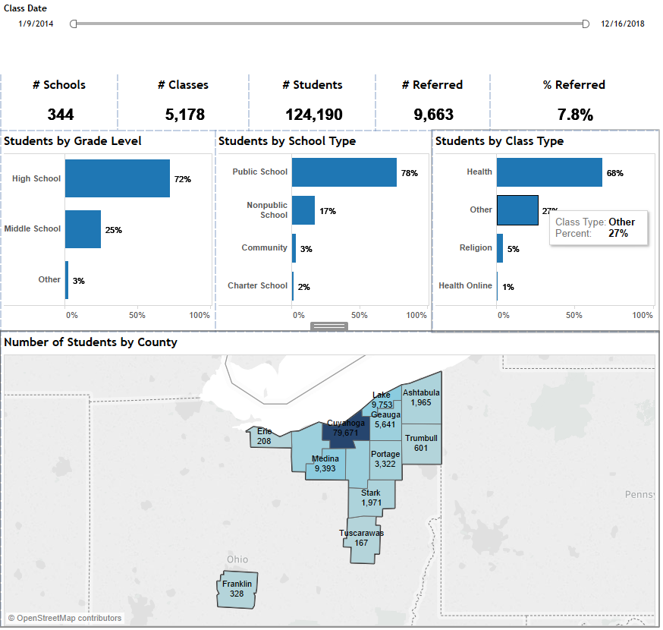

Conclusion
LifeAct’s goal is to reverse the alarming rise in teen suicide, which nationally has increased every year over the last decade. It does this by developing and delivering innovative, research-based suicide prevention programs for young people that reduce the stigma of mental illness and teach suicide prevention knowledge and skills designed to last a lifetime. To date, over 230,000 Northeast Ohio students have taken part in a LifeAct Grades 6-12 school program since the high school version was launched in 2000. During this time, LifeAct has referred more than 12,000 youth to a professional mental health resource for intervention or treatment.

LifeAct’s vision is to reverse the alarming rise in youth suicide, which nationally, has increased every year over the last ten years. We believe that these objectives are in the greatest of interest for the residents of Ohio – and especially our children.

We greatly appreciate your consideration of this important funding request on behalf of Ohio’s children. I welcome an opportunity to answer any questions and will look forward to an opportunity to visit with you in Columbus in the coming weeks. Please do not hesitate to contact me should you require any additional information.

Thank you.

Jack Binder, CEO
LifeAct

For additional information or inquiries, please contact
Jack Binder, CEO at 216-464-3471 or ExecDir@lifeact.org

Supporting Documents (on request)
2018-2019 LifeAct Organizational Budget
2018-2019 LifeAct Board of Trustees
2017-2018 Audited Financials
Letter of Support, Dr. Robert Ronis of University Hospitals Department of Psychiatry
Letters of Support, Benedictine HS and Memorial Junior High School
2017-2018 Community Impact Report
⁽¹⁾