Fair School Funding Plan and Amended Substitute House Bill (Am. Sub. HB) 166
Testimony to the Senate Finance Subcommittee
Ellen McWilliams-Woods, Assistant Superintendent, Akron Public Schools
Tom Hosler, Superintendent, Perrysburg Exempted Village Schools
Ryan Pendleton, Treasurer/Chief Financial Officer, Akron Public Schools
Mike Sobul, Treasurer/Chief Financial Officer, Granville Schools
Michael J. Barnes, Superintendent, Lakewood City Schools
Jenni Logan, Treasurer/Chief Financial Officer, Lakota Local Schools

Ellen McWilliams-Woods

Chairmen Dolan, Vice Chair Burke, Ranking Member Sykes and members of the Senate Finance Committee thank you for the opportunity to be here today to promote the proposals of the Cupp-Patterson Fair School Funding Plan and provide recommendations for changes to Amended Substitute House Bill (Am. Sub. HB) 166.

My name is Ellen McWilliams-Woods. I am the Assistant Superintendent in the Akron Public Schools. Our Superintendent, David James, and I have been in our leadership position in our district for 11 years and I have been in our district 30 years and Superintendent 28 years. I am here proudly representing our Fair School Funding Workgroup convened by Representative’s Cupp and Patterson. We are a team of 16 diverse superintendents, treasurers, and educators who represent all regions of our state, districts with widely different poverty or wealth levels, different settings from urban, suburban, rural, career centers, and educational service centers; and even different geographic landscapes and mileage that impacts our transportation and access to resources. My background includes growing up in suburban Shaker Hts, but my family owned a 50 acre farm in rural Holmes County that I spent 40 years of my life living there on weekends and in summers; I started my teaching career in suburban Cleveland Hts, and have spent the last 30 years in one of the largest urban districts in the state. I personally represent the intentional diversity of our group. Our Fair School Funding workgroup met over the last 18 months to create a rational, transparent, modern, comprehensive, and fair system of funding for our schools.

Mr. Chairman and members of the committee, we are pleased to testify today in support of our comprehensive funding plan for Ohio. I have with me today, five other representatives from our workgroup who will testify on the key components of our plan:

- Tom Hosler, Superintendent, Perrysburg Exempted Village Schools
- Ryan Pendleton, Treasurer/Chief Financial Officer, Akron Public Schools
- Michael Sobul, Treasurer, Granville Schools
- Michael J. Barnes, Superintendent, Lakewood City Schools
- Jenni Logan, Treasurer/Chief Financial Officer, Lakota Local Schools

The charge given to our Fair Funding workgroup by Representative’s Cupp and Patterson was clear and compelling:
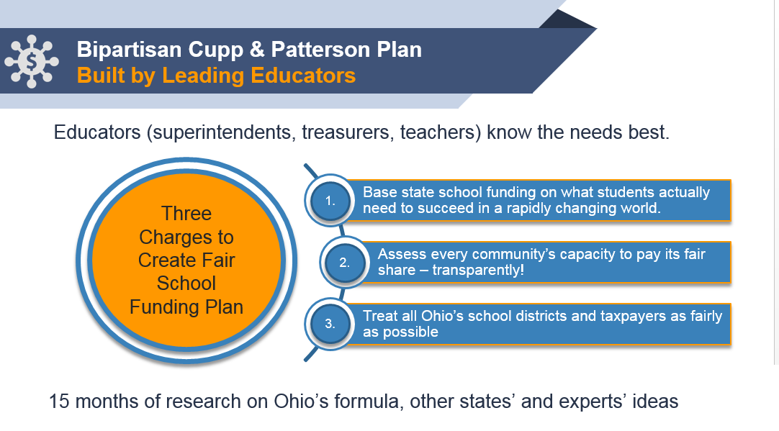
Our workgroup is incredibly busy with huge responsibilities within our districts, but twice a month for a year and a half, we showed up to design this plan. We studied school funding plans all over the country; we analyzed thousands of Ohio school district data elements to identify true costs and trends across districts; we consulted with Ohio finance experts to advise us when needed; and we met with educators across the state to listen to the unique needs of students within the wide variety of districts across Ohio. And we kept showing up. Everyone kept showing up. Let me tell you why I kept showing up.

Over the last 3 years, our district, under the leadership of our Superintendent David James and our corporate and government leaders in our city, have been rolling out the largest transformation of our cities’ talent pipeline in the history of Akron. We have aligned all of our economic development efforts, workforce development operations, employment data systems, and K-12 education and university training systems. Our 9 high schools reorganized this year into College and Career Academies where 100% of our students will be taking 4 courses in high school in one of 57 career pathways that our business community identified as high wage and high demand jobs in our region, such as, engineering, advanced manufacturing, information technology, and nursing. Our business partners, such as First Energy, Akron Children’s Hospital, Goodyear, and Firestone/Bridgestone are working side-by-side with us to create graduates with high tech digital skills, who can problem solve and will show up drug free with the professional skills needed to be successful at work.

THIS IS THE WORK OF OUR SCHOOLS TODAY. Our funding system has to reflect the needs of our students and our workforce TODAY in Ohio. Representatives Cupp and Patterson asked us to “fix our broken school funding system and build it based on the needs of students in this rapidly changing world.” And we did just that. THAT’S WHY I KEPT SHOWING UP TO THE CUPP/PATTERSON workgroup meetings. We built a transparent, rational, and justifiable school funding system. You will hear today in our testimony that the Fair School Funding Plan is built on the career advising and training needs of our students. There is inconsistency across the state regarding student’s access to technology. Our plan is built with 1:1 technology costs as a core factor in our base cost. Aligned with the Governor’s school funding priorities, our plan is built based on the wraparound supports students need, including early childhood, mental health supports, and services to address the social emotional needs of our students.

Because we based every component of our system on real data and research-based systems, we didn’t throw down random funding amounts. Where we didn’t have enough data to justify a funding amount, we recommended a study over this next year to make sure we had the data to justify the amount included in our plan. For example, we recommended studies in special education, gifted, and poverty. That’s the huge advantage of our system. You can see line by line how the funding system is built. If in a few years you want to add additional funds for districts across the state to do more, for example, with college and career advising and training, then you can go directly to that line in the base cost and add funds. You could never do that with our current system.

The current House budget contains increased education funding based on Governor DeWine’s vision to provide additional funds for the social and emotional needs of our students. This focus is to be commended and our base cost amount aligns with the Governor’s priorities. The Governor’s priorities also align with our add-on funds that we have in our plan to address poverty. Coming from a very high poverty district, it has been great to see the entire state discussing how best to provide funds for our districts with the greatest concentration of poverty. In fact, based on the Governor’s proposal, feedback from Speaker Householder, and input from rural and urban districts, you’ll hear in our testimony today that our workgroup will be releasing adjustments to our plan within this next week to drive additional funds to districts with high concentrations of poverty. The advantage of our Fair School Funding plan is that it can be easily modified as priorities arise.

Here’s the issue though that we collectively need to address. We’re going to show you examples today of just how dysfunctional our current funding system is. Districts with the same wealth have widely different per pupil amounts that can be thousands of dollars different - this makes no sense. If through this budget process we freeze our current dysfunctional system and simply add on funds to address poverty, for example, it can actually accentuate the problem.

We can continue to add funds to our current broken system, but when you’re adding to a broken system, you can inadvertently make matters worse. Some districts will get more funds per pupil than they should; others continue to get thousands of dollars less per pupil than what the formula says they should get. Every time we simply add funds to our broken system, we’re adding to the patchwork.

At some point, you need to hit the reset button. We need to stop adding to the dysfunction, press pause, and then reset. Instead of a temporary patch that currently exists in the House version of the budget bill, we could use the new education funds in the House budget bill to reset our school funding system by adopting the Cupp/Patterson Fair School Funding Plan. Our plan addresses many of the Governor’s priorities, so we can accomplish fixing our school funding system AND addressing the social emotional needs of our students living in poverty. So we ask that you consider our plan within the current budget bill - that is absolutely our top priority path. In the event that doesn’t occur, Representatives Cupp and Patterson are prepared to introduce a stand alone bill.

You’ll hear in our testimony today that our proposed funding plan positions our state to meet the demands of our rapidly changing world. After my 35 years of education and living through the patchworks of funding, this fair funding plan finally gets it right - it is modern, fair and transparent. My colleagues will testify today regarding the three key components of our fair plan: Base Cost, Add-Ons to the Base Cost, and Distribution. Tom Hosler and Ryan Pendleton will testify regarding base cost and distribution; Jenni Logan and Michael Barnes will cover add-ons to the base cost, such as, poverty, preschool, special education, transportation, and career education. Finally, Mike Sobul, will join us to answer questions regarding distribution and the recent adjustments to our plan to address high concentrations of poverty.

Thomas L. Hosler, Superintendent, Perrysburg Schools

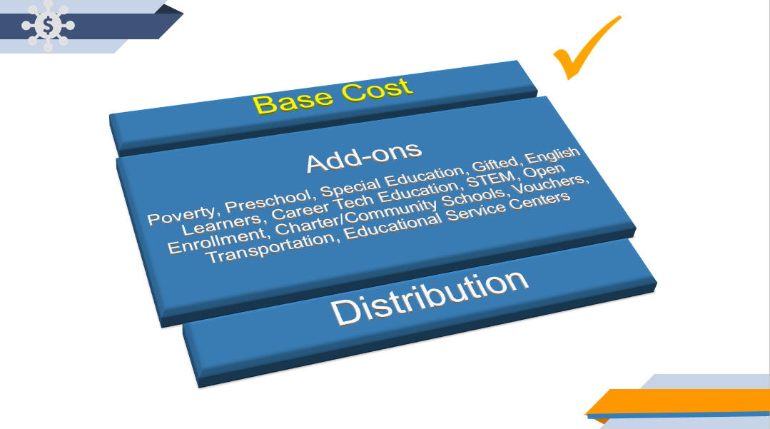
Thank you Chairmen Dolan, Vice Chair Burke, Ranking Member Sykes and members of the Senate Finance Committee. Thank you for allowing me the opportunity to testify today in favor of the proposals soon to be generated by the Cupp/Patterson School Funding Workgroup's Fair School Funding Plan and recommendations for changes to Amended Substitute House Bill (Am. Sub. HB) 166, the biennial budget bill. My name is Tom Hosler, Superintendent of Perrysburg School District. I have been a superintendent for 20 years, with 13 in my current position and 7 years prior to that in Michigan. I am currently the co-chair with Akron Public Schools CFO Ryan Pendleton for the base costs subcommittee as a member of the Cupp/Patterson Workgroup for the past 18 months. I am grateful for the opportunity to contribute in this process. I have never been more excited and hopeful about the future of Ohio’s educational system.

On Monday, March 25, 2019, Representatives Cupp and Patterson addressed the citizens of Ohio about school funding at a press conference announcing the release of the Cupp/Patterson Fair School Funding Model. As Ohio legislators, Reps. Cupp and Patterson were determined to find an education funding system for pre-K through 12 that is fair and rational and reasonable compared to what exists today which is unfair and incomprehensible. You see, for decades, Ohio leaders have tried and failed to find an equitable way to fund the most fundamental service provided by state government. No one in the state can explain why our current per pupil base cost is $6,020. Our current plan is complex, lacks transparency, and is inherently unfair. Our current system is not based on needs of students and the complexity does not permit any fundamental changes to the system.

Representatives Cupp and Patterson explained to our workgroup that as you know, every two years, the Governor presents his biennium budget proposal. With this event there is an intense push as each legislative chamber has approximately 6 to 8 weeks to analyze several thousand pages with its hundreds of funding levels and myriad of policy initiatives, hear hours and hours of testimony – my apologies by the way, debate possible changes to dozens of amendments before agreeing on a revised budget. Today, we are in the middle of this daunting task.

The challenges that this process takes to resolve complex and high stakes policy issues like school funding has led to a patchwork quilt of funding with various education-oriented representatives and school districts pushing for funding and amendments. As a result, today’s school funding model is unrecognizable, indefensible and no longer justifiable.

There are currently 610 public school districts in Ohio. Of those, 503 are funded outside the formula. In other words, 82% of all of Ohio’s school districts are either “capped,” meaning they do not receive the full funding the formula requires, or are on the “guarantee,” which means these districts receive more funding than what the formula requires.
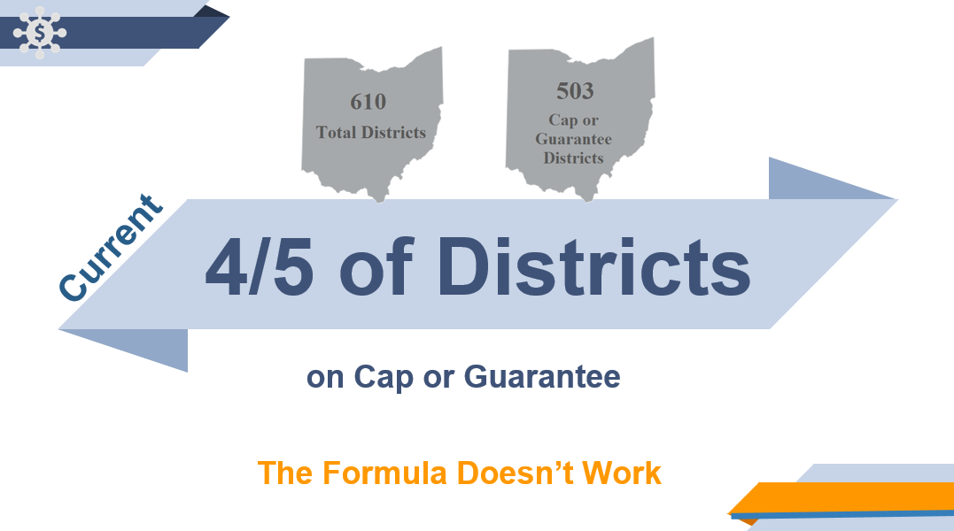
When 82% of districts don’t receive what they are supposed to based on the formula, the funding system is broken. The failures of today’s Ohio funding formula cut across school district lines; it fails children in urban, suburban, small, large and rural districts across the state.

As I stated earlier, the current “base” funding for a student in Ohio is $6,020. There is no rational way to explain how we as a state arrived at this number. And, that is wrong.

One thing we all agree on is what we have today is not working. At the end of the process we ask these questions: What about the students? What do school kids really need? Are Ohio’s young people prepared for success in a rapidly changing world?

A recent survey confirms Ohio’s voters care about the quality of education and are willing to pay more to guarantee that quality. Voters are concerned about the so called "typical" child, but they also want children with physical, mental and emotional needs, children who are high achievers or possess special talents, and children are from lower socio-economic households to receive additional assistance.

The proposed Ohio Fair School Funding Plan is based on the actual costs of an Ohio education using best practices from our state and nationally-recognized research. Also, this plan eliminates artificial caps and reduces the number of school districts on an artificial guarantee. Most importantly, it targets the most essential components in the educational process – students and the classroom.

In Ohio there are 610 unique school districts, ranging from serving as few as five students to more than 50,000. Finding a perfect funding formula to meet each of those school districts’ unique needs is a challenging feat. The Fair School Funding Plan provides a framework to address each Ohio school districts’ needs better than anything we have seen or had before. Ryan Pendleton, Treasurer/Chief Financial Officer of Akron Public Schools will introduce how we established our base cost per pupil amount and then I will step you through the key components.

Ryan Pendleton, Treasurer/Chief Financial Officer, Akron Public Schools

Chairmen Dolan, Vice Chair Burke, Ranking Member Sykes and members of the Senate Finance Committee. My name is Ryan Pendleton, Treasurer/CFO for Akron Public Schools. For the last 15 years I have served two districts with high percentages of economically disadvantaged families. School funding reform and aligning resources to improve educational outcomes is near and dear to my heart. Thank you for the opportunity to speak to you today in support of the Cupp/Patterson School Funding Workgroup's Fair School Funding Plan and recommendations for changes to Amended Substitute House Bill (Am. Sub. HB) 166, the biennial budget bill.

Ohio has tried just about every approach to funding schools. In looking at the four different available models, a hybrid of an inputs based and professional judgement produces the best alignment to Ohio’s needs. We built this model around what the student needs, so we started with the classroom. 75% of this model is tied to direct instruction or instructional supports. Another 20% is costed for school operations and finally 5% is costed for district leadership and data and accountability.

Open enrollment, community schools and vouchers allow students to choose locations other than their resident school districts for K-12 education. Under current law, these students are funded by transferring monies from the school district in which they reside to the location at which they are taught; a requirement that has generated considerable tension between educating forums. The challenge is to find a way to continue these choice programs without the tension that currently exists. The competition is causing disruption and difficulties in the districts. We propose a “fund where educated” model. A model, that in the interest of efficiency and clarity, students should be funded directly by the state at the school where they are enrolled and taught instead of their resident district. Students enrolled at a school other than the district of residence would be removed from the student count of their district of residence, and instead would be included in the count of the school they actually attend.

The Fair School Funding Plan is a scalable model. All the costed items listed in your handout can and should be revisited every biennium. Later in our testimony, you will hear how important it is to fund studies to support this concept. The current funding formula is not transparent or tied to what students need; therefore, it is difficult for educators and legislators to have meaningful conversation about targeted resources and then drive monies through the formula. In fact, most of what happens today takes place outside the formula. This is evidenced by the Governor’s budget initiatives. While we appreciate the emphasis around poverty, the education community would rather have these resources directed through a formula that is transparent, based on actual costs and respects local control. More importantly, being able to target resources in a comprehensive manner through a base cost – categorical seamless relationship is the only way to move the needle.

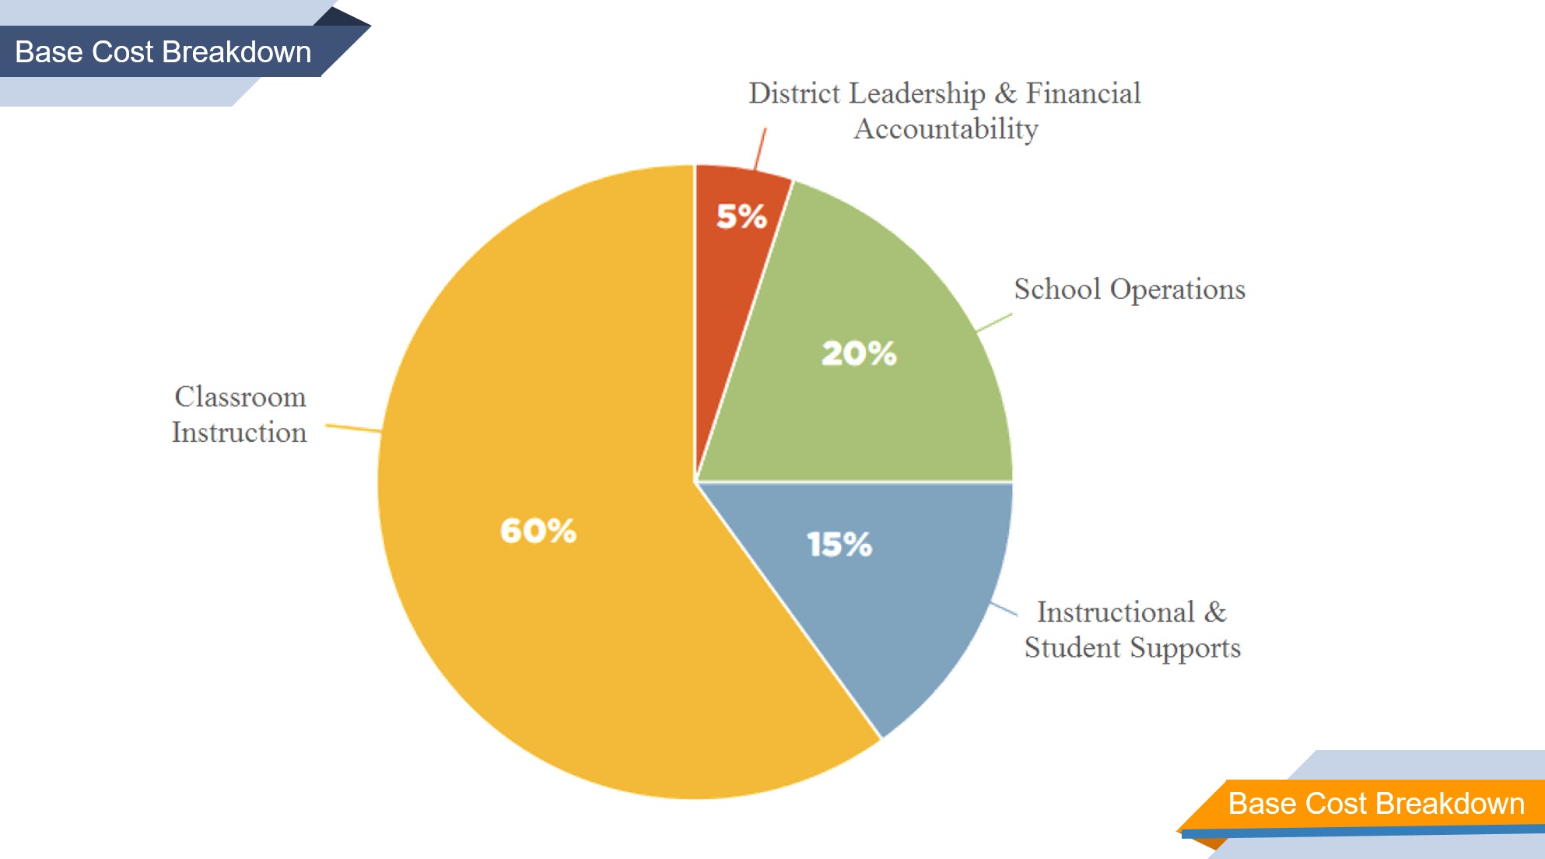

Tom Hosler will step through how the base cost works using a sample district in Ohio.
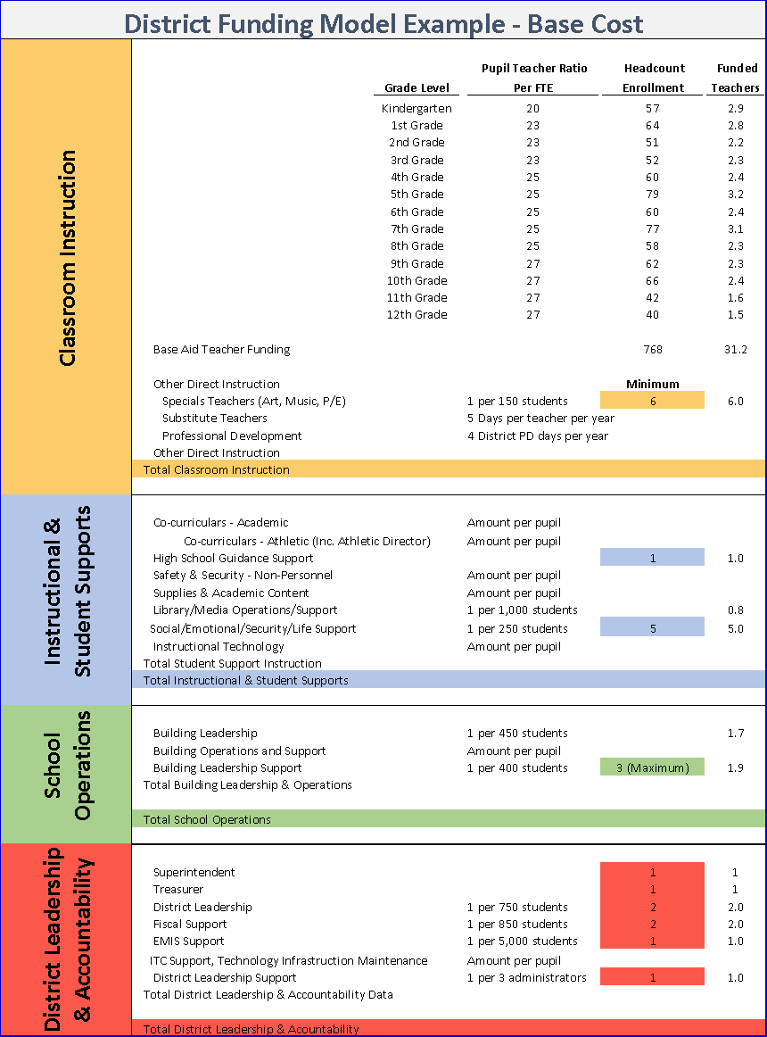
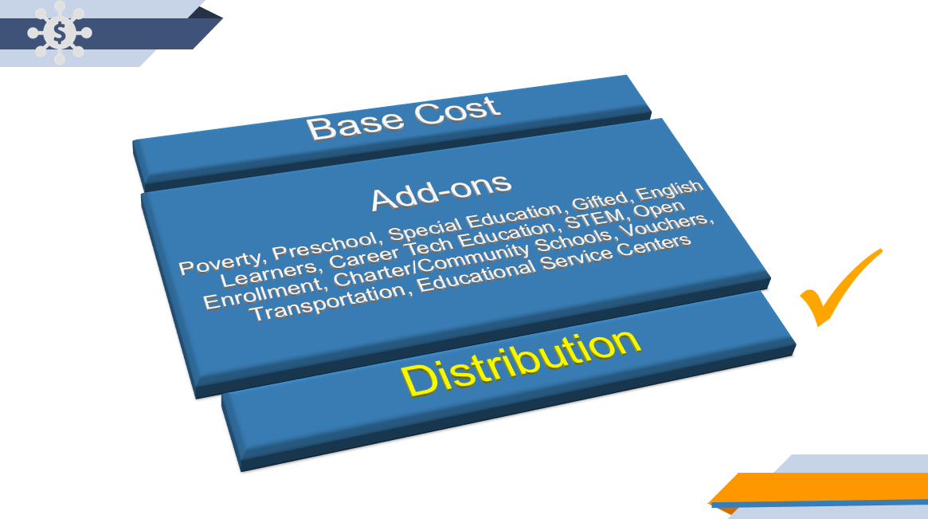
There are three components to getting a formula right. 1) base cost (what every student needs) which we covered, 2) distribution (how the State and each community share in raising resources) 3) categoricals (what special circumstances each child and district need) Jenni Logan and Michael Barnes will be talking through categoricals.

I’d like to shift my testimony now to the second key component of school funding: how the state distributes funds. This has been the most difficult component of school funding for generations. The challenge was to develop a new method for determining a district’s “capacity” – computing a district’s state/local share by using a method that is stable, reliable and based exclusively upon capacity factors within the district which include both property values and personal income.

As you have heard from the Governor’s budget initiatives, previous school funding formulas and the Fair School Funding Plan, poverty maintains a high priority. This is a significant issue that needs additional funding, but also needs to be fully studied to address poverty around such a diverse state.

Unlike the current formula, which is too dependent on property values, the new plan uses both property values and resident income to identify each community’s capacity to pay their fair share. The chart below is a result of the inequities of the current distribution formula. 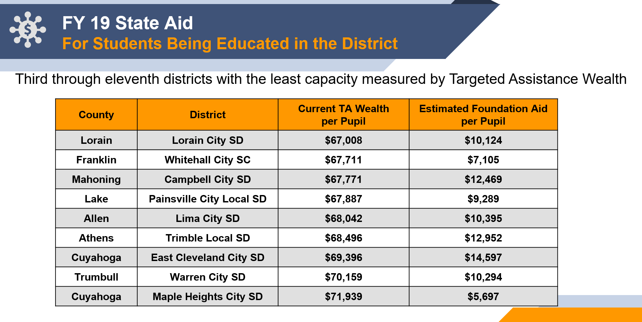
These are districts with the same wealth, but their per pupil amount varies more than $10,000. This doesn’t make sense. Examples of this are happening as large swings in agriculture and public utility values rise and fall, resulting in a broken distribution system. Freezing this broken system, as proposed in the current House version of the bill, where districts with similar wealth are receiving widely different per pupil amounts and then adding new money to this disparity, only widens the gaps and accentuates the problem.

Under the new distribution formula, a district’s state and local share will be determined by its capacity to generate local dollars. Only a change in the district’s resident income, property value or enrollment would cause a change in that district’s local capacity. This is a vastly different concept than the current distribution formula where a change in one district affects another.

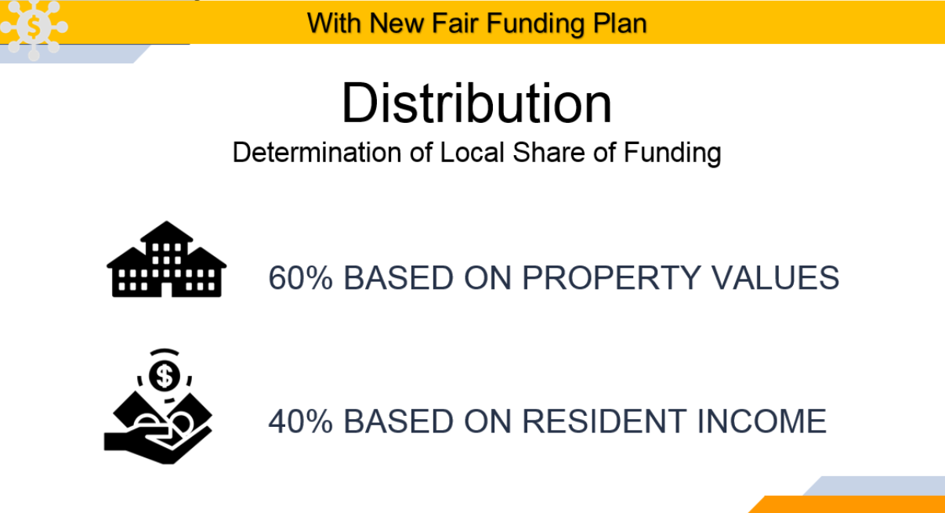

The results, when we pushed the button on simulations, were generally aligned with our values. Compared to our current broken school funding plan where 82% of districts are either on a cap or a guarantee, meaning they are not being funded by the formula, our Fair School Funding plan flips those numbers where more than 80% of districts are now funded by the formula and are no longer on a cap or a guarantee.

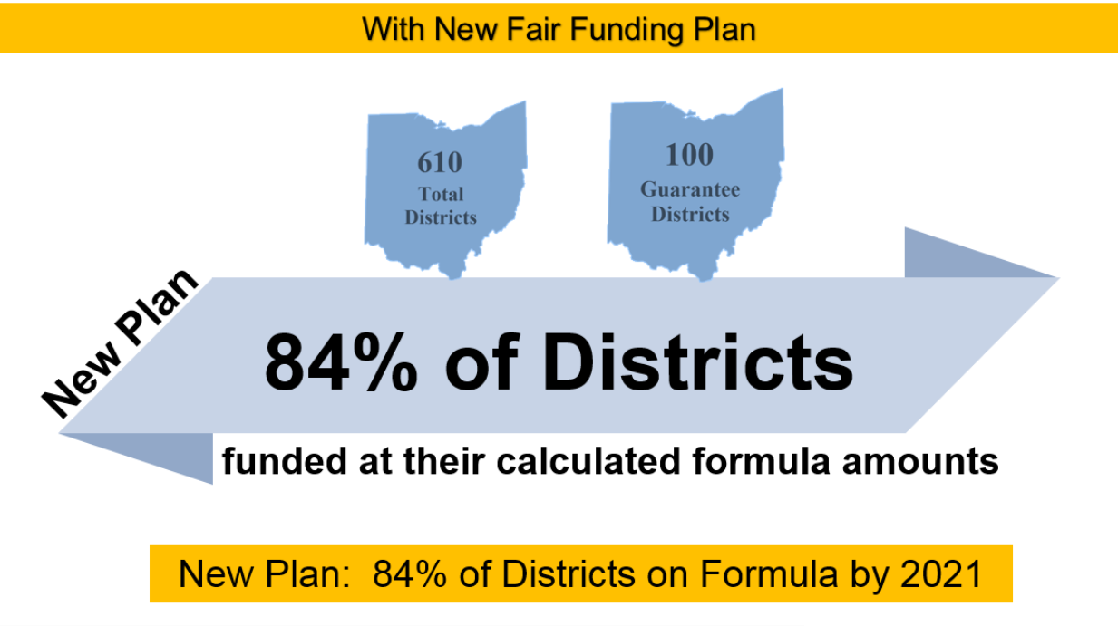

Even though our distribution system fixed the significant inequities that exist across the state, we did hear some concerns about the impact on some high poverty urban districts and rural poor districts. Our Fair School Funding Plan recommended an interim per pupil increase from $272 to $422 for students living in poverty and drove additional funds through our distribution formula to high poverty districts. In addition, we recommended a year long study to determine the exact needs of students living in poverty across all of our diverse Ohio districts. After carefully reviewing the Governor’s proposal, conducting listening tours in all regions of the state, and receiving feedback from districts and legislators with the highest concentrations of poverty, we knew we needed to make an adjustment now instead of waiting one year for the study. We have made three key adjustments to address the issues:

First, to address the urban issue, a tier of revised targeted assistance that was in the original plan has been moved from inside transitional aid to outside transitional aid. This moved additional aid to these high poverty urban districts.

Second, to address the rural and suburban issue, a change has been made to the local share percentage. In the initial work, every district had a local share equal to 2.25 percent of local capacity. The local share percentage is now variable, based on relative median income. It ranges from two percent to 2.5 percent. The impact of this is to drive additional resources to those with lower median incomes.

Third, in the original simulations, transportation aid was part of the formula inside transitional aid. The recommendation of the Transportation Subcommittee was for that funding to be outside the calculation of transitional aid. The current plan moves the transportation funding outside transitional aid.

These three changes, taken together, address the concerns we have heard without compromising the framework designed by the Cupp/Patterson Workgroup. Our base cost addresses the specific needs of all students in the state, our distribution system untangles the web of distribution that resulted in a wide variance of funding, and now we want to finish our testimony by introducing Jenni Logan, Treasurer/Chief Financial Officer for Lakota Local Schools and Michael Barnes, Superintendent from Lakewood City Schools who will testify in support of our proposals for the add-ons to base cost.

Jenni Logan, Treasurer/Chief Financial Officer, Lakota Local Schools
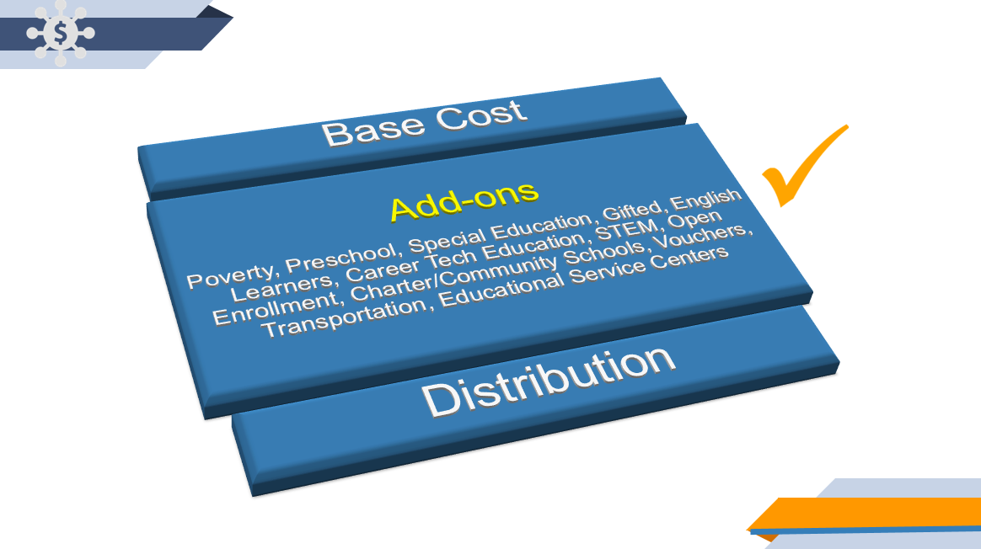
Chairman Dolan, Vice Chair Burke, Ranking Member Sykes and members of the Senate Finance Committee my name is Jenni Logan and I am the Treasurer/CFO of the Lakota Local School District in Butler County. I would like to continue our testimony by diving into the categoricals or add-on specifics of the Fair School Funding Plan. Specifically, I will cover poverty, preschool, special education and transportation. Michael Barnes, Superintendent of the Lakewood City School District, will cover gifted, English language learners, career tech and educational service centers.

Our 610 districts are unique and so are the 1.7 million students we serve. We need to align the financial resources to the student needs. We believe this approach and these recommendations do exactly that. The Fair School Funding model is a rational, understandable and transparent pathway to fund Ohio schools. This is evident not just with the base cost and distribution piece of our plan but consistent throughout. It drove our work in every sub-committee. The plan respects local control and sticks to our critical value that all students can achieve their greatest potential, regardless of their economic circumstances.

I grew up in a small rural town Latham, Ohio in Pike County. I am a proud graduate of Western Local School District, one of the first districts in the state to benefit from the Classroom facilities assistance Program in partnership with the state of Ohio. The community would never have been able to provide adequate facilities to its deserving students without the commitment from the state. Now, I am honored to serve as the Chief Financial Officer for the Lakota Local school district in Butler County,the eighth largest district in the state.

Whether a child lives amid poverty or wealth, all students deserve a quality education. To achieve this we believe the following regarding poverty, preschool and special education. In funding the whole child and meeting them where they are, and to provide more funds for our students living in poverty for their social, emotional, and mental health needs as well as the academics. Currently, the state provides an additional $272 for each economically disadvantaged student. Research suggests students in poverty need 30% more to succeed. To get it right in Ohio and determine the correct funding level, a study should be funded and completed. Until then, the per pupil funding for economically disadvantaged students should be increased by $150 on an interim basis.

A healthy start is critical for success. The Fair School Funding plan includes access to high quality preschool for every economically disadvantaged four (4) year old by 2021. Our current system is limited with providers who operate under different eligibility criteria. For example Head Start’s eligibility is 100% of the poverty level, Job & Family Services is 130% and the Ohio Department of Education’s threshold is 200%. Therefore, correctly identifying economically disadvantaged students is problematic and complex. To help coordinate efforts, the plan includes a preschool director for each educational service center. More research needs to be completed to correctly address this critical need; therefore, the funding for a study is being recommended.
Our special education students account for approximately 14-15% of the students we serve. Our current funding model is a per pupil dollar amount for six categories of disabilities. These categories range from speech only (category 1) @ $1,578, to deaf-blind, autism, and traumatic brain injury (category 6) @ $25,637. Prior to 2014 these six categories were funded based on a multiplier of the base cost instead of a stand-alone dollar amount which exists today. Since that time, we have seen changes in funding for our special education students which has not been consistent with our base aide amount. For example, during the 2016-17 biennium special education increases were at 2% while the base cost increased by 1.7%. And, conversely, the most recent biennium showed an increase in the base cost while the special education funding remained flat. To remove possible parity issues and to be fair, we recommend returning to a multiplier of the base for the six categories of special education students.

Our plan includes the funding and authorization of a special education cost study by the Ohio Department of Education to take into consideration changes in technology, remedial best practices and other advances to determine the accuracy of the funding levels for the six categories. The last complete study was done in 2001 with updates in 2006 and 2014 which were sponsored by the Ohio Coalition for the Education of Children with Disabilities.
The final recommendation for special education is full funding. Currently, this funding level is at 90% and has been since FY 2004. We recommend the additional ten percent (10%) be set-aside for catastrophic costs. Currently, if the cost for a student in category 2-5 (speech only is not eligible) exceeds a threshold amount of $27,375 or if a category six student (i.e. autism) exceeds $32,850 a district can file to receive additional monies for these more significant student needs. The current amount available state-wide is approximately $45 million. Claims for last years catastrophic expenses exceeded $116 million. That’s a coverage of less than 40%. The additional 10% being set-aside would more than double the amount available currently.

The final add-on I would like to cover is transportation. Since 2016 our transportation funding levels have been going in reverse. Dropping to 50% in 2016, 37 ½% in 2018 and currently 25% or your state share, whichever is greater. Our plan includes restoring this funding to the 60% level.

Ohio isone of the least restrictive when it comes to transporting students who choose to attend a school other than their traditional public school. Our plan includes implementing a more organized structure which would encourage synchronizing calendars. Unless funding is provided, our plan does not require public schools to transport students when the public school is not in session or outside of a 30 minute window before or after school.
We also believe efficiency should be rewarded, ridership counts should be am or pm and the bus purchase program should be re-established. And, all this should be achieved by funding transportation outside of the formula. This will avoid the impact of any cap or guarantee.
Now I would like to pass the baton to the next leg of our team, Mr. Michael Barnes.

Michael J. Barnes, Superintendent, Lakewood City Schools

Chairman Dolan, Vice Chair Burker, Ranking Member Sykes, and members of the Senate Finance Committee, I would like to begin by thanking you for the opportunity to present testimony today in support of the Fair School Funding Plan. My name is Michael Barnes, and I am the Superintendent of the Lakewood City School District in Cuyahoga County. Today, I will cover Gifted Education, English Language Learner Education, Career Technical Education and Education Service Centers.

Students in Ohio’s 610 school districts have diverse needs. Beyond what it costs to educate a typical child, the Fair School Funding Plan addresses the diverse needs of each individual learner. This plan focuses on students - each of them individually. Students who are Gifted require additional resources; this plan addresses them. Students who are English Language Learners require additional resources; this plan addresses them. Students seeking Career Technical Educational experiences require additional resources; and this plan addresses them as well.
The Ohio Education Research Center conducted a Gifted Cost Study on behalf of the Ohio Department of Education. The goal of the study was twofold: a) develop a deeper understanding of the cost of providing Gifted Education services in a manner that is compliant with the state’s Gifted Education operating standards; and b) identify the most appropriate method of funding Gifted Education.

Currently, districts received funding for Gifted Education based on three components:
1) identification, 2) coordination, and 3) intervention specialist. Under our current model, each school district is provided with a flat amount of $5.05 per student for gifted identification. For the coordination of gifted services, districts are eligible to receive funding for one gifted coordinator for each 3,300 students at a salary of $37,370. For gifted intervention specialists, districts are eligible to receive funding for one intervention specialist for each 1,100 students at a salary of $37,370.

As pointed out in the Gifted Cost Study, there are two fundamental problems with our current gifted funding formula. The first problem is that there is no clear cost basis for the current funding parameter relating to gifted education. For example, cost relating to gifted identification was increased by 1% in FY 15 to $5.05 per pupil. It has remained that amount every since. There is no explanation for how the $5 per pupil was arrived at in the first place. Similarly, the salary amount for gifted coordination and intervention was set at $37,000 in FY14 and increased by 1% in FY15 to $37,370 with no explanation. The second problem with the current funding model is that funding for gifted education is based on a district’s ADM rather than the actual number of students identified as gifted. It is not logical to fund gifted educational based on ADM especially since districts are not required to provide gifted services, they are only required to identify students who are gifted.

The Gifted Cost Study found these to be an underrepresentation of what it actually costs to provide gifted education that meets Ohio’s Gifted operating standards. Our current funding methods fails to take into consideration all of the cost drivers for Gifted Education. The Gifted Cost Study identified seven (7) Gifted Education Cost drivers. Our recommendation is to fund each of these category areas at per pupil amount.

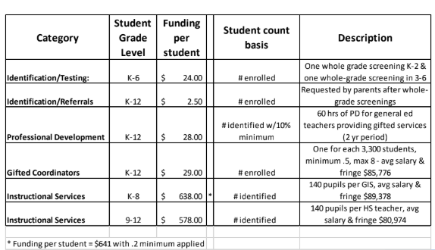

Our final recommendation related to Gifted Education is to establish an Incentive Program for rural districts. The Gifted Cost study referenced earlier, noted identification, funding and service inequities. These inequities negatively impacting students who would benefit from receiving adequate Gifted Education services. As noted by an ESC, in the Gifted Cost Study, a gifted intervention specialist is likely only to be present one or two days a week in rural districts. As a result of this, gifted services may be more disruptive, less integrated into a student’s everyday routine and, ultimately, less successful. At the extreme, students may be pulled out for extended periods of time to fulfill gifted service-hour requirements, missing instruction in areas they will ultimately be responsible for learning. While they may not have the student population or budget to fund an FTE for gifted coordination or services, smaller rural districts utilizing ESC services are doing so not as a compliment to district services but for the entirety of their gifted services. That is why we are recommending the establishment of an Incentive Program for rural districts to overcome some of these challenges.

I would like to share some personal information about English Language Learners (ELL) in my district. Lakewood City Schools doubles the state average of students who are English Language Learners. Nearly half of our ELL students are refugees, representing 24 countries. Currently we have 32 different languages spoken district-wide by students in our schools. Most of these students also have the task of translating for their parents and other relatives in the home. As you can imagine, this poses challenges for these students as they work hard to navigate through our system. We have staff who are committed to ensuring the success of this population of students. As it is with other districts with similar demographics, we are interested in a funding formula that will provide for the unique needs of these and other students.

Our first recommendation is that a multiplier be returned to the base cost. In fiscal year 2014, the weighted funding for English Language Learners was converted to per pupil amounts. In the most recent biennium, the per pupil weights for English Language Learners remained constant while the per pupil base cost increased. To avoid parity issues, the weighted funding for English Language Learners should be a multiplier of the base cost.

Our second recommendation is that the Ohio Department of Education authorize and fund a cost study. Like the results from Gifted Cost Study, it is our belief that English Language Learners Education cost drivers will be accurately identified and quantified allowing the students to receive what they need and allowing treasurers, superintendents, and school boards to more accurately plan.

Finally, recent changes at the federal level under the Every Student Succeeds Act, requires district tracking of ELL students two (2) years after exiting ELL status. We are recommending that Category 3 Funding be adjusted to satisfy this mandate. Specifically, we ask that Category 3 Funding be revised to include ELL students for the two (2) years after they have achieved proficiency. Achieving proficiency means no longer receiving services as an ELL student.

Also, we recommend that Category 2 Funding be revised to include all students enrolled more than 180 days until they achieve proficiency. In my district, we continue service for ELL students beyond the school year and into the summer because they need it. The current funding system ends at the conclusion of the 180 days school year.

Ohio is one of the few states in the nation with a comprehensive career technical education system. Career technical education in Ohio offers high school programs that meet the needs of employers in the local economy, prepares students to enter the workforce with credentials that allow them to contribute immediately to an employer, seek additional training, or go to college. Ohio career technical education providers serve over 70,000 FTE students (slightly over half in career technology centers and the remainder in comprehensives and compacts).

While many misconstrue a career technical education to be limiting, many employers want to hire workers who have basic skills then provide further training or even pay for college (and this in turn helps reduce the amount of money some may have to borrow to pay for college). A career technical education does not limit a student's potential, it only enhances it. Whether the student opts to immediately enter the workforce, seek additional training or go to a two-or four-year college, the student is prepared for any of these options and is prepared to be successful regardless of the path the student may choose.
We believe that all students should be exposed to the opportunities career technical education has to offer and make an informed decision based on short term and long term career goals, earnings potential, and other factors that provide a realistic and achievable path for career and financial success.
To this end, career development programs are extremely important for students in kindergarten through 12th grade. Exposure to various career pathways in elementary and middle school and throughout high school will allow students to be more aware of career opportunities whether they relate to attending career training at the high school level, a two year technical training program or a four-year college.
The current funding model for career technical centers is similar to that of traditional school districts including the base amount of $6,020 per pupil. In addition, districts providing approved career technical education courses receive supplemental CTE funding (also known as tiered funding or weighted funding) which allows for an additional amount to cover the additional costs of providing a career technical education (i.e. supplies, materials, equipment).
The recommendation for Career Technical Education from the School Funding Workgroup is as follows:
- Update and provide basic aid in the same manner as the proposed K-12 funding model.
- Continue to provide supplemental career technical (tiered or weighted) funding and convert the current dollar amounts to weights (or percentages).
- Fund Career Technical Planning Districts (CTPD) to deliver relevant career awareness programs to all K-12 students within the CTPD in the amount of $10/student in the CTPD.
To summarize, the overall position of the recommendation is to keep the basic aid calculation similar to that of traditional districts, maintain supplemental career technical funding, and add funding for the essential career exploration component.
Finally, relating to Educational Service Centers (ESC). Ohio has 52 ESC’s. They serve school districts and other education entities by providing a variety of educational services. No two ESC’s are alike. They serve rural, suburban and urban districts. The complexity of the districts they serve requires that ESC’s are flexible, creative, and innovative with service delivery models. The factors make the development of a single funding mechanism challenging. The current per pupil amount of $26/pupil has no discernible relationship to any cost related objective/procedure.
The State Auditor's office is in the midst of a comprehensive operational study of all ESC’s. The study is intended to provide standards and benchmarks to inform future performance audits and potentially assist the Ohio Department of Education with the development of standards. This operational study does currently include funding requirements, citing the need for more data. In the meantime, we are recommending the following interim Tiered funding allocation for ESC’s:
- First 5,000 students $32/pupil
- Next 10,000 students $30/pupil
- Next 10,000 students $28/pupil
- Over 25,000 students $26,000/pupil

Thank you for the opportunity to testify today. Ellen McWilliams-Woods has our final words for today.

Ellen McWilliams-Woods, Assistant Superintendent, Akron Public Schools - Closing
Chairman Dolan, Vice Chair Burke, Ranking Member Sykes and members of the Senate Finance, we want to thank you for the opportunity to testify today in support of the Cupp/Patterson Fair School Funding Plan.
- As you’ve heard today, Ohio’s school funding system is not tied to any type of determination of what it takes for students to succeed in the 21st century – diminishing our future workforce and economy
- The Fair School Funding Plan will allocate base costs tied to the actual needs of students, resident’s income, and its property values.
- It will help students with special needs and mental health concerns, make all students more safe and secure, update technology, provide essential services for high poverty districts, provide expanded quality preschool, and reflect the real cost of operating public schools.
- Fair School Funding will prepare our state and local workforce for the challenges ahead.

We ask our legislators and all Ohioans to consider our plan in its entirety, as an essential roadmap to guide school funding decisions. We can no longer add funds to a dysfunctional system which will only accentuate the problems. It’s time to provide a long-term fix. The Fair School Funding Plan in coordination with the Governor’s priorities is the right fix. Together, we can adopt a comprehensive, fair school funding plan that meets the needs of Ohio’s children, future workforce, and economy.

Thank you.

