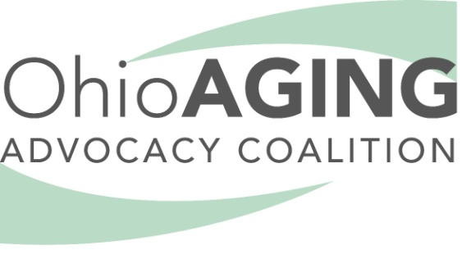

Ohio Aging Advocacy Coalition
Testimony before the Ohio Senate Finance Committee
June 5, 2019
Testimony Presented by:
Barbara Riley, Chair of the Ohio Aging Advocacy Coalitiion

Chairman Dolan, Vice Chair and Ranking Member Sykes, and members of the Ohio Senate Finance Committee, the Ohio Aging Advocacy Coalition appreciates the opportunity to testify regarding Amended Sub. HB 166, and in particular, aging related issues. The Ohio Aging Advocacy Coalition is a group of over 500 seniors and their caregivers who have come together to make certain that the voice of Ohio’s seniors is heard as aging policy is formulated and funded. Our primary goal is to enable Ohio’s older adults to age in the place they choose to call home. I am Barbara Riley, Chair of the Coalition and the former Director of the Ohio Departments of Aging and Job and Family Services. Our Coalition is supported by a wide array of aging services organizations and associations that believe it is crucial for seniors ourselves to be represented as you consider Ohio’s biennial budget.

Our focus is assuring access for all older adults to quality services at a cost we can afford and that enable us to age where we choose and are able. From a state budget perspective, that includes the Senior Community Services line item in the Department on Aging, Medicaid and departments that oversee or provide transportation, housing, and family services. Our specific concerns and/or recommendations are:

- The Senior Community Services line item in the Department of Aging funds services that allow us to remain in our own homes and can help us avoid future dependence on Medicaid. We all are familiar with things such as Meals on Wheels which these funds help support, but many other services we need are included, such as transportation, housing, health and wellness, and caregiver support. Far more than half of the caregiving in Ohio is unpaid and provided by spouses, relatives and friends of the frail older adult, but unpaid caregiving is demanding and unrelenting. Without it, Medicaid would balloon and the budget would burst.

Without assistance such as respite care, or support groups, or simply the ability to have periodic professional assistance, as unpaid caregivers we potentially will be forced to give up being part of the taxpaying paid workforce, or we will collapse under the strain, and force our loved ones to become reliant on Medicaid.

I would like to provide a perspective that I believe is crucial to understanding this line item. I was the Director at the Department on Aging when the final cuts were made to these state funds. I do not say that with pride, rather with shame; but we were facing continued decline in state revenues and as we now know, were entering a serious recession that some feared could result in a depression. This was a “discretionary line item”, and therefore prime for the picking. These services were reduced by over 50% from 2001 and although the Administration’s budget proposal does provide some additional funding, that funding is directed solely at increases in the Senior Farmers’ Market program. We certainly support those markets that assist us in securing fresh produce, but that program serves a small number of people, in only certain areas of the state. Instead, we ask that you increase that appropriation to $10 million at a minimum, and that you allow the local Area Agencies on Aging to allocate those funds to the services and individuals most in need. By doing so, you can reduce the risk of increased Medicaid reliance, you can help those at risk of self-neglect; you can provide direct services to Ohioans in financial and physical need; and you can ease the burden on unpaid family and friend caregivers so that they stay “on the job” – both their paid employment and their assistance in the home. We hope you see the financial and human wisdom in providing additional Senior Community Services dollars.

- Medicaid reimbursement for in home services is insufficient for home care agencies to offer a living wage to their personal care assistants, insufficient to allow small, (especially rural), agencies to continue to operate, and insufficient to attract and retain quality aides. This results in serious access issues as we lose the very agencies we need in underserved areas; as worker turnover results in less continuity of care and in a loss of our ability to become comfortable with the people who are performing our most intimate care; and as workers flee to McDonalds for higher wages and leave us either without care or without consistent caregivers. We request that you increase the rates paid and direct that increase to the pay of the direct care workers, at least equal to those rate increases being proposed in the Developmental Disability system.

- Also within the Medicaid budget, Ohio’s Assisted Living Waiver rates have been static for over 10 years. This has led to providers reducing the number of Medicaid eligible consumers they will serve, or dropping out of AL Waiver participation, which in turn leads to serious access issues for those of us who need such care. It is an alternative that disproportionately serves those with dementia, a growing number that threatens to overwhelm our families and our agency system of care. We ask that those rates be increased to a level that allows us to use this lower cost and more appropriate option for 24/7 care rather than creating increased reliance on higher cost skilled care which we do not yet need.

- Housing is another item that is fundamental to our ability to avoid unnecessary institutional care. The success of Ohio’s program to transition individuals from skilled nursing care back to the community is proof that if we can secure appropriate housing we can help Ohio’s seniors rejoin their friends and family, enhance their well-being, and avoid long term dependence on Medicaid. In addition, as we age we often need housing that meets our older needs, rather than our needs as a young and growing family. Affordability and availability are key. Through the Housing Trust Fund and other supported housing and low-income housing programs we can meet the needs and provide us with the choices we need and want.

- Although you have completed your work on the Transportation budget bill, we do want to point out that public transportation is often our only source of mobility for grocery shopping, doctor’s appointments, going to church or simply maintaining any sort of social contact – which is vital to our long-term well-being. In addition to public transportation, we ask you to keep in mind that both Medicaid and non-Medicaid line items covered under HB166 are used to provide this sort of assistance.

Aging is one thing to which we all aspire, but we all are clear that we would prefer to age with dignity and our health and well-being intact. You have the ability to help us all fulfill those aspirations as you consider HB 166, and we ask that you remember Ohio’s aging population, our caregivers and our needs. Once again, we appreciate your consideration of our concerns and I would be happy to discuss any of these issues in further detail. We can be reached at ohagingadvocacy@gmail.com.

