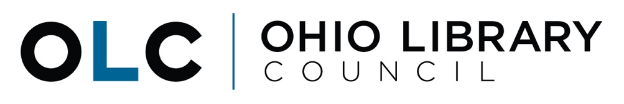

Senate Finance Committee
Sub. House Bill 166 Testimony
June 13, 2019

Good morning, Chairman Dolan, Ranking Member Sykes, and members of the Senate Finance Committee. Thank you for the opportunity to testify today on Substitute House Bill (HB) 166 and Ohio’s public libraries.

My name is Michelle Francis and I am the Director of Government and Legal Services for the Ohio Library Council (OLC). The OLC is the statewide association representing Ohio’s 251 public library systems (rural, urban and suburban) and the 8.4 million library cardholders they serve.

We are here today to formally say thank you to the Senate for making public libraries a priority in the substitute bill and for recognizing the strong partnership we have with the state in delivering services at the local level. Restoring the Public Library Fund (PLF) and increasing the percentage from 1.68% to 1.7% will help to offset any additional unintended reductions in state funding that may result from the tax reform changes included in the proposal. In addition, these funds will help libraries prepare for the online portion and demands of the 2020 census, stabilize older facilities, and ensure that essential services, such as access to computers and the internet, can continue to be provided to Ohioans statewide through their local libraries.

Our state funding through the PLF ensures there is a minimum level of services provided to Ohio residents statewide, regardless of their zip code. However, each public library system and branch is a reflection of their local community and neighborhood. The services and programs at each local location are based on the needs and requests of the local community.

We saw evidence of this most recently with the Memorial Day tornadoes where many of our libraries served as “second responders” to their communities. Libraries in Greene, Montgomery, and Mercer County in particular immediately stepped in to help tornado victims by providing a safe place to come for electricity, internet access, and clean drinking water. Now the libraries are helping storm victims apply for disaster assistance, making counselors available and collecting supplies and donations.

With almost half of our overall funding coming from the state – none of this would have been possible without the Public Library Fund.

Again, we would like to formally thank the Senate for its commitment to public libraries and to Ohio’s citizens who utilize libraries every day. We look forward to working with you, the House and the Governor as the budget bill is finalized. I would be more than happy to answer any questions at this time.

