Proponent Testimony for HB 166
Antonio Ciaccia
Director of Government & Public Affairs, Ohio Pharmacists Association
Chairman Dolan, Vice Chair Burke, Ranking Member Sykes, and members of the Senate Finance Committee, my name is Antonio Ciaccia, Director of Government & Public Affairs for the Ohio Pharmacists Association (OPA). I thank you for the opportunity to give our perspectives as interested parties on HB 166.
I would first like to applaud the Senate for keeping language in the budget that will prohibit costly pharmacy benefit manager (PBM) co-pay clawbacks and gag clauses that prohibit pharmacists from working with patients to ensure that they get the best deal possible on their prescription drugs.
While these provisions are excellent ways to protect patients from PBM-directed overcharges at the pharmacy counter, unfortunately, the budget is still lacking the necessary policy changes to get nefarious PBM drug pricing conduct under control within our Medicaid managed care program and to restore order in a pharmacy marketplace that has been pummeled by industry middlemen acting within a Medicaid program that continues to allow them to have their way with local providers and taxpayers.
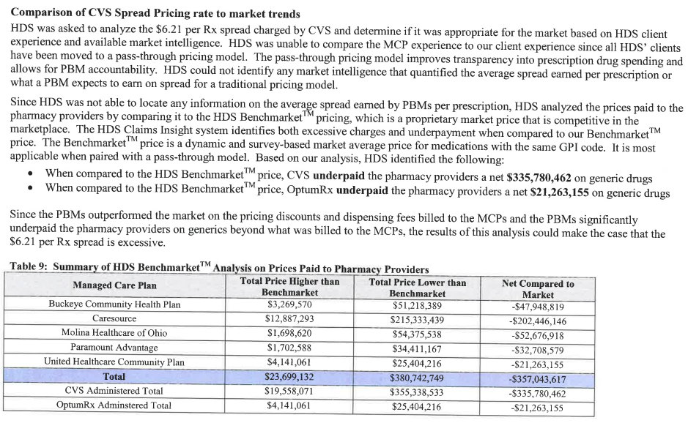
In my previous testimony to this committee, I highlighted our long journey to help provide the data and insight necessary to lead to the audit that showed PBMs sneaking $244 million out of the state Medicaid managed care program in just one year. Over the course of that journey, we learned that while PBMs were taking in more than three to six times the going rate for PBM services, pharmacies were being paid more than $350 million below typical market rates, which amounted to around $9 per prescription in underpayments. See below for the Department of Medicaid’s own commissioned report from 2018.

At this point, there is not much disagreement: PBMs took advantage of our Medicaid managed care program. But as the Department of Medicaid’s report from HealthPlan Data Solutions (HDS) demonstrates, that windfall for PBMs came largely at the expense of the local pharmacies that serve those Medicaid patients.
The Medicaid HDS report highlighted how that by moving to a pass-through pricing model, the state could take funds that were overspent on PBM services and use them to increase pharmacy reimbursements by nearly $5 per prescription and simultaneously deliver savings back to the state.
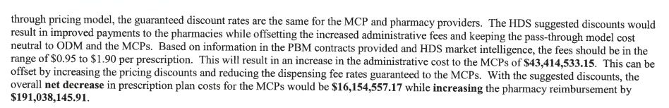
For those of you that are uninitiated, I want to better explain how pharmacists are paid in the current Medicaid managed care system. When the state has historically set rates for pharmacy spending in Medicaid managed care, they have combined the entire pharmacy benefit into the same bucket. So, the per-member-per-month rates that the state sets has included the cost of the drug, the margin for the pharmacy, and the margin for the PBM all in the same line item. And that line item has been increasing substantially in recent years, jumping by nearly 20% over a two-year period.
But while the payouts for pharmacy benefits from the state have increased in recent years, buried within that line item is the erosion of pharmacy margins by 60-80% over that same time period. As the state invests more money into prescription drug spending, the increased investment has increasingly made its way to drug manufacturers and PBMs, while the amounts retained by pharmacies that cover the costs to operate have dwindled.
As I sit in this committee, and listen to provider complaints about not having rate increases or not having enough rate increases, pharmacies have never received a set rate increase, because their rates have been sandwiched into the drug spend and cannibalized by other members of the supply chain.
The main reason that we are here today is to ask that you institute a payment methodology for the drug and a dispensing fee floor 1) To ensure that more pharmacies don’t go out of business, like the 371 that have done so in the past five years; but also 2) To ensure that the drug cost is neutralized and that that pharmacy can now have its own line item, delineated from the rest of the supply chain’s revenue, that specifically covers their costs to provide their service – which exists for nearly every other healthcare service provider in Ohio.
Here’s why that’s necessary. Every two years, the state mandates that pharmacies submit proprietary details about their business operations to the Department of Medicaid in order to determine the average cost to fill a prescription. Those survey results have typically averaged out to $9-10 as the average cost to break even after the bills, materials, service, and taxes are paid.
Publicly available data from CMS has shown that within Medicaid managed care, pharmacy margins have ranged from $2-3 over the last year, meaning that they are operating at 20-30% of the cost to balance their books.
The results speak for themselves. Pharmacies that have served their communities for decades are disappearing. Just this past month, we know of more pharmacy closures in Chillicothe, Middletown, Moraine, Kettering, and Arcanum. I can tell you that many pharmacies are hanging on for dear life, waiting for the state to deliver on its promise to fix this system. I can assure you, that if you do not address this issue now, more locally-invested providers will close their doors, and the consolidation and concentration of the pharmacy market will continue to erode access and quality across our state.
And when it comes to access, as the pharmacies get grinded down further, expect them to begin making more pragmatic decisions in order to keep their doors open. The smart business moves in climates of severe underpayments are eliminating services, no longer stocking certain medications (like they did with generic Suboxone last year), pushing Medicaid patients away, laying off employees, and hunting for margins and shortcuts. While most pharmacists will do what they can to resist these pressures, we are foolish to think that they won’t happen.
Just as the Columbus Dispatch reported in recent weeks, we have already gotten a sneak peak of what will happen if the state does not reclaim control of this program. A new PBM entrant into the Ohio Medicaid managed care program sent new terms to pharmacies that set rates at a subjective, PBM-determined allotment for the drug, plus a 15 cent dispensing fee. 15 cents doesn’t even cover the transmission fee that pharmacies are charged to submit the claim, let alone the overhead and service being rendered.
Those terms were rescinded 24 hours after they exposed and slammed in the press, but these are exactly the types of terms that will become the norm if the state does not repair this system.
OPA and our members originally brought these payment issues and spread pricing concerns to the Department of Medicaid in summer of 2016 when the first wave of PBM cuts occurred, and here we are three years later. Despite years of being told that the state would address and fix this mess, reforms have come up woefully short.
By underpaying these providers, the state is pressuring pharmacies to cut staff, cut services, cut access, and cut corners.
The budget proposal that has been submitted and recommended by Senator Dave Burke in collaboration with all relevant stakeholders achieves the necessary balance of establishing a more predictable and sustainable pharmacy payment model, curtailing PBM pricing manipulation, being responsible with state budget dollars, and positioning pharmacists to yield even greater value to the state moving forward through incentive-based payments.
Specifically, here's what the proposal would do:
- Strip PBMs of unchecked price-setting capabilities in the Medicaid program, in exchange for surveyed, reference-based prices for the drug (through a benchmark like NADAC), and transparent, set dispensing fees averaging no less than $5 per prescription, plus the ability to make an additional 50 cents per prescription through incentive-based payments.
  - Rather than allowing middlemen to set drug prices at their own whims, by using reference-based pricing benchmarks like National Average Drug Acquisition Cost, NADAC, (which is conducted through CMS and surveys pharmacies monthly on their invoice acquisition costs for prescription drugs, making it an actual reflection of market trends), the state can insulate themselves from PBM overcharges like the ones that cost the state $244 million in just one year.
  - This will provide pricing accountability not just for PBMs, but for wholesalers as well. Inserting reference-based prices better equips pharmacies with the data they need to push back on out-of-line reimbursements and purchases, which creates the supply chain accountability that the current system is lacking. Under a NADAC-based system, if a pharmacy is being underpaid, now the pharmacy knows that the wholesaler price is out of whack and can pressure them accordingly.
  - The current model, which allows PBMs to overpay on some drugs and underpay on others, begins to even out the margins and insulate the market from revenue-shifting that seems to be driving margins to drugs predominantly dispensed by PBM-owned pharmacies. Additionally, this helps prevent medication access issues like the one that dried up generic Suboxone access in 2017.
  - While $5.50 is still well below the cost to dispense, this is a reasonable middle ground to provide predictability and better sustainability than the current model, and it reestablishes a foundation to build new, innovative payment models into pharmacy.
- Create new incentive-based payments – to be developed by the Ohio Department of Medicaid and based on national pharmacy quality standards – to begin paying for more than filling prescriptions.
  - The current incentive system in pharmacy rewards pharmacies that fill more prescriptions at faster paces. By moving the focus to the overall quality of the service and outcomes of the patient, we can begin to quantify and reflect the value proposition of the pharmacist. This incentive shift should alleviate the pressures of high-speed environments in many practice settings and instead, emphasize the need for pharmacists to take time with their patients in order help them achieve positive outcomes. By pivoting the incentives, we can make pharmacy more of a true profession.
- Puts the state in greater control of their economic fate, and minimizes risks for anti-competitive behavior in the marketplace.
  - Now, rather than allowing the vendor who profits off the price to also set the price, the state now has a better grasp on what true drug costs should be. This would provide complete visibility into drug costs and reduce the chance of profiteering.
  - Furthermore, acknowledging the inherent conflict of interests that arise when PBMs get to set reimbursement rates for their own pharmacies as well as their competitors, moving to reference-based pricing removes the risk that PBMs could be leveraging their role to unfairly drive out competitors.
On behalf of the Ohio pharmacists who helped expose this $244 million problem in the first place, who continue to try to weather the economic storm, and who have been seeking a remedy to this problem for three years now, we are here to ask you not to wait for another hundred pharmacies to close. Please support Senator Burke’s proposal to fix Ohio’s PBM and pharmacy payment crisis.
Thank you for the opportunity to share our thoughts on HB 166, and I’ll happily answer any questions you may have.
Antonio Ciaccia
Ohio Pharmacists Association
aciaccia@ohiopharmacists.org

