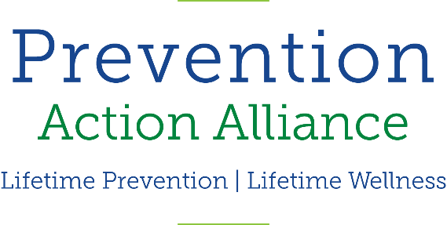


Ohio Senate Finance Committee
Prevention Action Alliance
6.17.2019
Good morning, Chairman Dolan, Vice Chairman Burke, Ranking Member Sykes, and members of the Senate Finance Committee. My name is Tyler Begley and I am the Coordinator for the Ohio College Initiative to Enhance Student Wellness (OCI), a program under Prevention Action Alliance (PAA), a certified Prevention Partner with the Ohio Department of Mental Health and Addiction Services. Established in 1996, we are a network of 54 campuses’ mental health and wellness professionals charged with addressing a wide range of issues related to mental health promotion, and prevention of substance misuse and suicide.
I am also a former AmeriCorps Member that was stationed in Toledo Public School District (TPS) with the duty of being the liaison between TPS, United Way, and the YMCA for monitoring and evaluating third-party programs, and developing and evaluating community-needs assessments. I was stationed at Leverette Elementary School, a school that has almost 90 percent minority population. Ranked 3185 out of 3,224 schools in Ohio. My office was stationed next to the associate principal’s office and often that meant that the overflow of students that were sent with a referral to the AP’s office were right outside my door. I would always welcome the students from my chess class in to talk broadly about life and learn more about what they were going through at home and the harsh realities they faced when the last school bell rang. I am not a clinician, but I know how to recognize individuals that are in a fight or flight mentality and the negative behavioral health consequences of always being in that state of mind. Every single one of those students from kindergarten to eighth grade had the cards stacked against them and had to fight through the gauntlet of adversity every single day. These are students that will find themselves on college campuses across Ohio, for some, the first generation in their families to attend college. These students will walk onto campuses with high ACE scores which indicates significant increase of likelihood for alcoholism, substance misuse, depression, suicide attempts, and many other negative health consequences.
That is why, due to the recent changes in the budget introduced last week, I am testifying today as an opponent to Substitute House Bill 166 and wish to address my concern with cutting K-12 prevention programs out of the state budget related to outcomes we are seeing in our young adult students across our campuses.
A study from the Commonwealth Fund this past week revealed rates of deaths from suicides, drug overdoses and alcohol have reached an all-time high in the United States 2. About 1 in 4 college students report academic consequences from drinking. About 20 percent of college students meet the criteria for an Alcohol Use Disorder. Young adults – including college students – reported turning to alcohol for relief from discomfort from a wide range of concerns including mental health, most commonly anxiety and depression 3.
A 2018 World Health Organization survey found that one in three college freshmen reported dealing with mental health disorders in the years leading up to college. In a 2017 survey by the American College Health Association (ACHA), students reported that anxiety and depression are among the biggest factors that negatively affect their academic performance. While the 2018 ACHA survey determined that 42% of students had felt so depressed in the past year that it was difficult for them to function, the same survey given in 2009 found 31 percent of students felt that level of depression. That’s an 11 percent increase. The number of students who had seriously considered suicide has doubled, with 6 percent in 2009 and 12 percent in 2018. 4
Our campuses are not prepared for this mental health crisis. Between 2009 and 2015, the number of students visiting counseling centers surged by about 30% on average. 5 A recent study from Ohio Alliance for Innovation in Public Health reveals there were more than 15,000 suicide deaths reported in Ohio over 10 years, an increase of nearly 24 percent. For students ages 20 to 29, suicide is up by 36 percent.6
Our campuses in Ohio are fighting an uphill battle with addressing mental health and substance misuse. They heavily rely on primary schools’ education, like Leverette, to address prevention and build up protective factors in behavioral health during those developmental years. We know we will see significant dividends from the resources we invest in our K-12 students as they transition to secondary school. We need the K-12 prevention programs now more than ever. Right now, we have an opportunity to be proactive, to invest in generations to come by giving them the tools and skills earlier in their development so they can be well-equipped to address any trauma that affects their mental health. This is a time to say we care about our future, that we care about our children to not add to the statistics. I ask that you consider restoring the funding for K-12 prevention education initiatives and statewide multi-media prevention, treatment, and stigma reduction campaigns back into the budget.
Thank you for the opportunity to provide testimony as an opponent in consideration of Sub HB 166. and I am happy to answer any questions that the committee may have.

