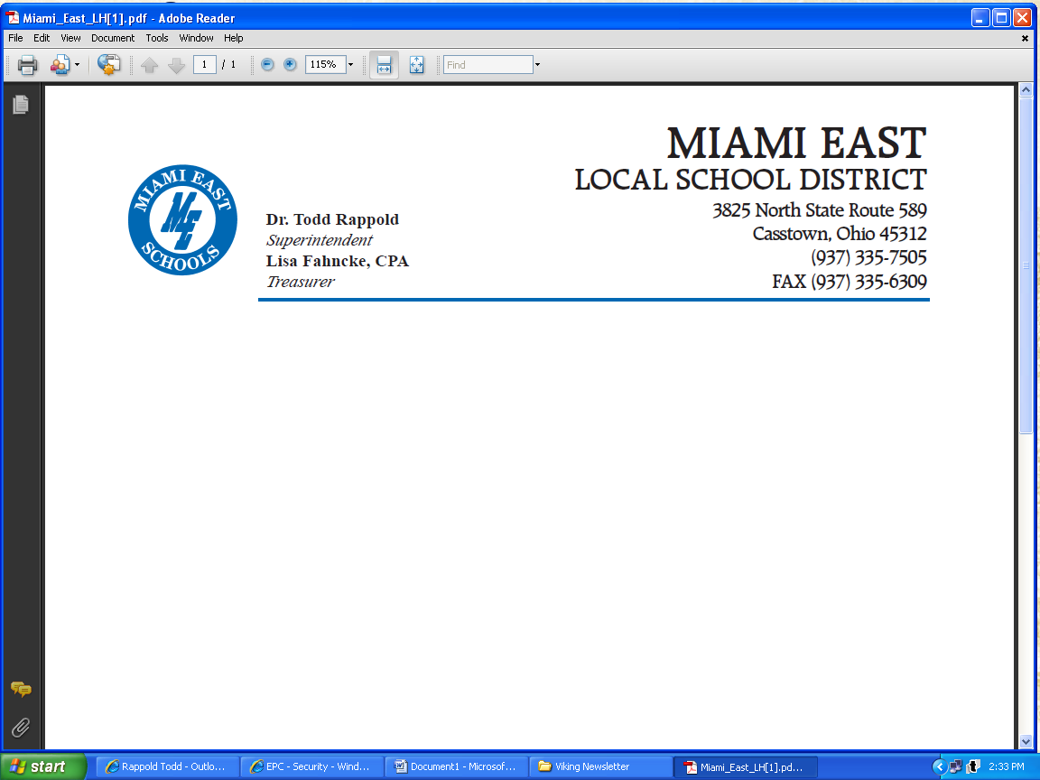
Senate Finance Committee
Substitute HB 166 Interested Party Testimony
Lisa Fahncke, Miami East Local Schools
June 17, 2019

Chairman Dolan, Vice Chair Burke, Ranking Member Sykes and members of the Senate Finance Committee. My name is Lisa Fahncke, Treasurer/CFO for the Miami East Local School District. Thank you for the opportunity to speak to you today about one specific provision that was included in the House version of the budget bill, HB 166, but is not currently in the Senate Substitute Bill.

Our school district objects to the removal of the correction that we had requested to the School District Earned Income Tax provisions.
The House included a “fix” to the school district earned income tax. When the state’s small business income tax exemption was established, the statute was amended to add the small business income back in for purposes of calculating the taxable income for a traditional school district income tax. However, we believe that amendment was inadvertently left out for the school district earned income tax. Both school district income tax statutes fall under the same section of law, but the taxable income definition is different for each version of the tax.
The earned income tax is favored by retired residents who are often on a fixed income from a pension or social security, so it makes sense that it should be the preferred tax for school districts. However, by inadvertently applying the small business income tax exemption to the school district earned income tax, districts are encouraged not to use this tax. The House version of the bill would correct this and remove the exemption and therefore making it a more viable option for districts than the traditional income tax. However, the Senate has removed the “fix” from HB 166.
Additionally, our school district has lost in excess of 1.8 million dollars. There are about 50 other school districts in the state that have also lost large amounts of funding. Our school communities passed these earned income school district tax levies for essential funding for our schools and support of our students. The reduction in collections caused by the Small Business Income Tax deduction has diminished our Districts’ funding and reduced collections of funds that were originally intended by our school districts’ communities to support our schools. Please help reinstate the language that was added by the House in HB166 to fix this issue. Please Senators, we need your help. Thank you for your consideration and attention to this matter.

Lisa Fahncke
Treasurer
Miami East Local Schools
3825 North State Route 589
Casstown, Ohio 45312

