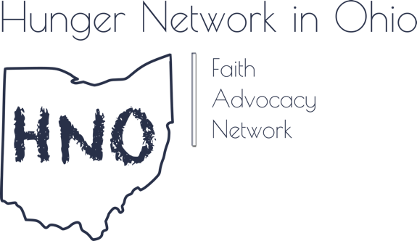
Good afternoon Chairman Schuring, Ranking member O’Brien and members of the committee,

My name is Deacon Nick Bates, I serve in the Southern Ohio Synod of the Evangelical Lutheran Church in America (ELCA) as the director of the Hunger Network in Ohio (HNO).

HNO is an ecumenical ministry that believes we can end hunger in Ohio by addressing the root causes of poverty.

People of faith are on the front lines in the battle against poverty each and every day. But we cannot do it alone. Our food pantries pale in comparison to the public investments needed in food security and the importance of the federal Supplemental Nutrition Assistance Program (SNAP). Only through collaboration and cooperation can we end hunger in our communities.

We see many people in our pantry lines with unique stories. People rise and fall out of poverty every day. Rising out of poverty doesn’t mean economic stability. Nearly 30% of Ohio Households earn less than 200% of the federal poverty level – that is around $42,600 for a family of three. Most of these families are working hard to get by, and they still question where their next meal will come from. They water down milk to make it stretch a few extra days, take advantage of free meals at local churches, and know how to scrimp and save. They still end up in our pantry lines.

It is because of the people we see in our pantry lines that we stand in opposition to SB 165. This bill will make it harder for families to put dinner on the table and increase the pressure on our local pantries even further.

I personally witness SNAP working everyday as a resident of the Hilltop here in Columbus. About 8 months ago, I was at the local drug store with my two children. We saw two kids, one was my son’s age – 9 - and the other was 11 or 12. They were using their family EBT card to buy a frozen pizza, cereal, bread, milk and peanut butter. I remembered this basket vividly, because at their age, I would have filled my basket with frozen pizza, ice cream, and fruit punch. They were more responsible than I was.

They did nothing wrong except assume more responsibility for themselves than most kids have to assume. They are examples of why the SNAP program works. This bill could prevent kids in similar situations from buying the food they are legally allowed to purchase because their picture wont be on the card.

These kids were authorized family members to use the card. Likewise, SNAP recipients can designate others as authorized users of the card. Many pastors and congregational volunteers are authorized users for individuals who are disabled or elderly. Also, especially in rural areas, an individual may authorize somebody else as a user just because the distance is too great to get to the grocery store, get the kids off the bus, and get to work on time. People struggling to make ends meet are innovative in the ways they collaborate to eat and survive.

Making grocery store runs for others is part of what communities of faith do for one another. This bill will lead to additional bureaucracy and headaches at the check-out counter. Are grocery stores expected to check everyone’s photo ID now – whether using a credit card or an EBT card? What is a grocer to do if the photo doesn’t match the shopper? What happens at self-scan lanes? Headaches for Ohio’s grocery businesses, headaches for those who want to help their neighbor, headaches for those who need food.

That is a lot of headaches caused by government bureaucracy that will not help address concerns around fraud and cost Ohioans about $15 million just to implement. Put another way, Pennsylvania found, in 2012, that photo’s on SNAP cards would increase the cost from 23 cents to 8 dollars to produce each card. We need public investments to help end hunger – not to grow administrative costs. Why would we waste our state resources by spending $8 on a card when 23 cents will suffice?

As a Christian, I pray every day the Lord’s Prayer – and there is that famous line – give us this day our daily bread. I extend my prayer today to this committee that you will reject this bill so that we do not take food off the tables of Ohioans who need it.

Thank you and I would be happy to answer any questions.

Hunger Network in Ohio
Deacon Nick Bates, J.D.
Nick@hungernetohio.com
www.hungernetohio.com

https://www.kff.org/other/state-indicator/population-up-to-200-fpl/?currentTimeframe=0&sortModel=%7B%22colId%22:%22Under%20200%25%22,%22sort%22:%22asc%22%7D
https://aspe.hhs.gov/poverty-guidelines
https://www.legislature.ohio.gov/download?key=12427&format=pdf
https://lisaopdycke.files.wordpress.com/2014/03/ebt-feasibility-in-ri1.pdf

