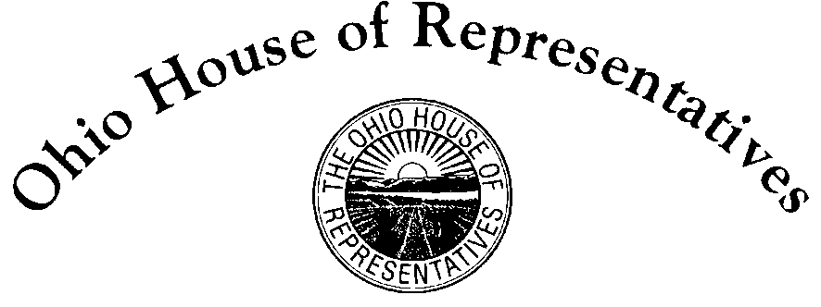

State Representative Derek Merrin
District 47
House Bill 76 – Sponsor Testimony
General Government Agency Review Committee
November 13, 2019
_____________________________________________________________________________________
Chairman Schuring, Vice-Chair Rulli, Ranking Member O’Brien, and members of the General Government Agency Review Committee thank you for the opportunity to present testimony on House Bill 76. The legislation fixes three flaws in ballot language. First, it updates antiquated ballot language by expressing millage in terms of $100,000 of market value rather than in $100 increments of tax value. Secondly, requires all tax levies list the estimated revenue they will generate annually. Third, it requires all text size and the use of bolded words be uniform.
Beginning in 1939, the Ohio Revised Code required millage expressed in a dollar amount related to $100 of property valuation. It was a great idea. This is necessary because the mills system is complicated. For example, most voters do not know what 4.5 mills or 9.9 mills levy means. Putting an actual dollar amount in ballot language expressing the fiscal impact is important. Values of homes have changed, but the law has not changed to reflect today’s home values, so the dollar amount expressed in ballot language at best is useless and at worst misleading.
To compound the problem, $100 taxable value is actually $287 market value due to property taxed at 35%. Without that knowledge, voters are automatically misled with current ballot language. Furthermore, it is standard practice by media outlets, local governments, and political advertisements to express levies in relation to $100,000 market value. House Bill 76 updates the law to reflect this standard, common-sense practice. The Ohio House approved this measure last session, and both chambers recently approved this language in HB 166, state’s operating budget, this session.
Current law requires some levies to provide the revenue amount the levy will generated annually, but not all levies. This is an inconsistency in law. County Auditors provide government entities with estimates on how much a levy will generate. This legislation requires the estimate be included in ballot language.
The third part requires ballot language text to be uniform. For some school levies and bond issues, current law mandates the purpose of a levy or issue text be bolded and the size of the surrounding text doubled. Other levies do not have this requirement. The bill removes this mandate so all levies and bond text size is uniform. Doubling the text size of certain words makes ballot language longer, and can cause extra pages to be printed. By mandating certain words be in large text and bolded, it creates controversy whether the language is unduly emphasizing one side or the other.
Ballot language should be clear and concise. Tax levies and bond issues should be transparent to voters. A calculator should not be necessary when voting. House Bill 76 seeks to update inconsistent ballot language that make it much easier for voters to ascertain the fiscal impact of levies and bonds. To conclude my testimony, I want to request committee members look at the attachments to my testimony and allow me to discuss them in further detail.

