Written Testimony to the
Senate Government Oversight and Reform Committee
regarding Senate Bill 136
November 19, 2019

Chair Coley, Vice Chairman Huffman, Ranking Member Craig and members of the Senate Government Oversight and Reform Committee, on behalf of the American Council of Engineering Companies of Ohio (ACEC Ohio) we are writing to express our support for Senate Bill 136.

ACEC Ohio is the voice of Ohio’s engineering industry, comprised of 140 companies representing over 8000 employees that provide a wide array of engineering and other professional services for all types of construction and environmental improvement projects.

This bill establishes a payment assurance program for registered design professionals which includes engineers, architects, landscape architects and surveyors. Many of the companies we represent employee all named design professionals.

Engineering, architectural and surveying firms are typically involved very early in the construction project and perform services such as survey/layout work, soil borings and testing, and preparation of construction plans and specifications. Unfortunately, some projects in Ohio fail to move to construction for various reasons after services have been completed by the design professionals or may even be constructed without payment for the services to the design professional. Under current law, a design professional has no protection as the design work does not improve the physical real estate and therefore the design professional cannot file a mechanics’ lien. The design professionals are being harmed by this situation as they have been unable to collect fees for the services they have performed.

Design professionals are not looking to get in front of any other lien claimants, but to have a place in line and the ability to recover costs for the services performed. The bill focuses on commercial property and private work and will be subordinate to any real estate mortgage filed.

We appreciate the opportunity to share our support of Senate Bill 136 with the committee.

Respectfully,

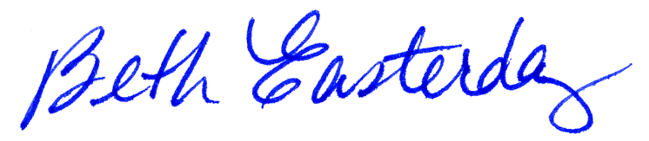

Beth Easterday
President, ACEC Ohio

