**Proponent Testimony SB 23**

House Health Committee

**February 19, 2017**

Chairman Burke, Vice-Chair Huffman, Ranking Member Antonio and Members of the Ohio Senate Health, Human Services and Medicaid Committee, it is my honor to advocate to you today as a mother, a former legislator and as a devoted proponent of The Fetal Heartbeat Protection Act. This issue remains extremely close to my heart as it has the potential to save the lives of many unborn children. During a time of substantial contrast with states like New York who are stripping the rights and protections formerly in place for unborn babies, I am so honored and thankful to call Ohio home as you consider and carry the opportunity to be a state where instead of abortion stopping a beating heart, a beating heart will stop abortion.

To be honest, it has been hard to put together testimony as an engaged citizen because I often wonder how much weight my words might carry. For the last 8 years my words were spoken on behalf of many women, many families and many unborn children who would otherwise not have had a voice in the process. I believe these individuals still need me here today, just as we need every proponent at this stand being a voice for the voiceless. I can not tell you how many people have come to me in the grocery store, while picking up our kids from the nursery at church, through a private Facebook message and nearly everywhere I go and their moment of sharing is the opposite of shouting one’s abortion but instead whispering one’s heartache and lifelong regret and heartbreaking remorse. I can’t tell you how many times I have held the hand of a woman frightened or convinced into having an abortion and left devastated by the loss of her child and the scars on her heart. These moments, their words, the untold stories of precious children who will never be here to make their mark will forever be a part of who I am. I will carry their banner everywhere I go because every person deserves a voice and every heart deserves to beat.

Day after day I read the news and I wonder how our hearts, our minds, our souls and our actions could become so calloused toward innocent unborn children. I hug my daughter closer than I ever have and I hold my babies longer and tighter asking God how any person could knowingly or purposefully choose death over life. I pray daily that God will touch every heart and change every mind when it comes to the individual’s worth and life that we are debating. My work for women and children is not to create controversy but to create hope and healing that eyes may be opened and in turn lives may be welcomed instead of destroyed and violently dismantled.

I think we all have a shared understanding that a mother’s embrace is most often a place of love, warmth and grace in our lives. When we think of babies, we often think of our greatest blessings and joy even and even more so in cases where babies have overcome great odds while battling though really challenging stays at a nicu, against cancer, or a tiny hole in a tiny heart, we seem quick to band together and all celebrate their beautiful and joyous existence because at the end of the day, they are central to who we are, who we once were and who we are meant to be, loving, responsible, committed and people who can and do overcome. I think that is why it is so heartbreaking that the safest place for a baby to be today is not in the womb, near his or her mother. Shockingly a mother’s womb has become the most dangerous place in America for a baby to be. The American womb is almost 160 times more dangerous than the most dangerous city in the world. Also, throughout the whole of U.S. history approximately 2.2% of the military personnel who actively served in wartime have been killed in the line of duty. What does all of this mean? Even if you lived in the world’s most dangerous city or engaged in the worst or most tragic American conflicts of war, your odds of survival will never be lower than they were when you lived in your mother’s womb. In terms of scale, death by abortion is unparalleled by any other atrocity in the world. The only thing that kills more people than abortion is old age. Passing the heartbeat bill allows us to overcome these odds and protect our most vulnerable citizens when they need us most.

Women have died, many women from abortion complications, botched abortions, and sadly in some cases suicide from abortion regret and at a rate 4 times higher than those who faced horrendous circumstances and chose life. But in every single case of abortion a person dies. Abortion kills a person, every single time, with few exceptions for those who live to testify against what was done to them like Gianna Jessen who was burned alive during a saline abortion, later being born against the mother and abortion provider’s will with a lifelong infringement of cerebral palsy inflicted upon her due to her vulnerable state of no protection. Like the countless victims of “Dr” Kermit Gosnell, just a few hundred miles from where we are today. Children born, unborn and mother’s alike who were subjected to brutal life ending procedures became victims while the state turned the cheek, year and year again.

Through the years, doctors, OBGYNs, pediatricians, nurses and even first responders - paramedics and EMT’s have lended both their written and verbal support to this bill with simple recognition that no one has to die for patients to be cared for and that it is a central mission to their work that hearts are to be kept beating. Unlike and harshly contrasting words of the Governor of Virginia, a pediatric neurologist who said, “The infant would be resuscitated if that’s what the mother and family desired”, after a failed abortion. That ladies and gentlemen is the ugly truth that infanticide is alive and well in our nation. We must, we should and we will stand against this tyranny being thrown against the lives of mothers and their children. Thank you sincerely for your gracious patience and consideration as we culminate years and years of testimony and hearings on this bill because of your outstanding leadership and I want to express the deepest gratitude for the fact that Governor Dewine will be remembered in History as a man who made Ohio a safer place to work, live and raise a family because of his conviction, resolve and dedication to our most vulnerable children with beating hearts.

In addition to my testimony here today I have attached my previous testimony as a resource for members of this committee and any Ohioans who may find it of use. I want to thank you for allowing me the opportunity to provide proponent testimony and I welcome any opportunity to be a resource or answer any questions that you might have as we work to defend life.

WHAT WE KNOW:

According to the World Health Organization, "In the USA, there are over 3,000 abortions per day. Twenty-two percent of all pregnancies in the USA (excluding miscarriages) end in abortion.". For each beating heart, I feel deeply convicted and called to action. If any other cause of death had numbers that were this sobering, we would halt all other activity to focus on the epidemic at hand. We know that the majority of these abortions are occurring when the unborn human individual has a beating heart.

HEART AND FETAL CIRCULATION

Heart development:

The heart raises from a little group of special cells located in the embryological region which will become the chest. During the first four weeks of pregnancy these cells grow until they form a tube called the primitive heart tube. It is constituted of four segments: the seno-atrium which forms the atria, the primitive ventricle which forms the left ventricle, the heart bulb which forms the right ventricle and the truncus arteriosus which forms the aorta and the pulmonary artery. In the primitive heart tube, the blood arrives in the seno-atrium, travels through the tube and goes out through the truncus arteriosus. (ABC- Cardiopathic Child Association)

During the next step the primitive heart tube coils up in a handle giving two atria and two ventricles. The right atrium connects to the right ventricle through the tricuspid valve, left atrium connects to the left ventricle through the mitral valve. Contemporaneously are formed the atrial and the ventricular septum. The truncus arteriosus branches into the aorta and pulmonary artery which connect respectively to the left and right ventricle. At ten weeks the heart is completely formed and functional and during the rest of the pregnancy it will grow to supply the demand of the developing fetus.

Starting at week 5 the fetal heart will accelerate at a rate of 3.3 beats per day for the next month.

The fetal heart begins to beat at approximately the same rate as the mothers, which is 80 to 85 bpm. Below illustrates the approximate fetal heart rate for weeks 5 to 9, assuming a starting rate of 80

Week 5 starts at 80 and ends at 103 bpm

Week 6 starts at 103 and ends at 126 bpm

Week 7 starts at 126 and ends at 149 bpm

Week 8 starts at 149 and ends at 172 bpm

At week 9 the fetal heartbeat tends to beat within a range of 155 to 195 bpm.

The fetal heart rate will begin to decrease and generally will fall within the range of 120 to 160 bpm by week 12.  (Resource: Article "SEX, HEART RATE, and AGE" at http://www.obgyn.net)

WHEN DOES LIFE BEGIN?

Biology is crystal clear that at the moment of conception (also known as fertilization), a unique organism comes into existence. Since this new life possesses human DNA and is the offspring of human parents, it can legitimately only be described as human life.

Since there can be no question that human zygotes, embryos and fetuses are alive, some have attempted to claim that human beings are not "persons," until some threshold is crossed, such as viability, the capacity to feel pain, birth, or even the first year after birth. The merits of such notions can be debated, but it should be clear that they are not based on science but rather on ideology, philosophy or belief.

As far as observable science is concerned, human life begins at conception.

What happens at the moment of conception?

At the moment of conception, a male sperm unites with a female ovum. The single-celled entity formed by the sperm and oocyte (egg) is known as a zygote.

At conception, the zygote has 23 pairs of chromosomes and approximately 50,000 genes from each parent, which combine to determine all of one's physical characteristics, including sex, facial features, body type, and color of hair, eyes, and skin.

In fact, as recently as this year, the U.S. Department of Health and Human Services under the Trump Administration has enhanced language about protecting Americans at every stage of life beginning at conception with language throughout the strategic plan highlighting improving healthcare outcomes for all people, including the unborn.

TODAY THE OPPOSITION WILL TRY TO REDUCE THE UNDERSTANDING OF THE CHILD IN THE WOMB TO BE THAT OF A CLUSTER OF CELLS OR "TISSUE" WE KNOW THIS TO BE SCIENTIFICALLY INADEQUATE. LET’S PREMISE THIS DISCUSSION WITH AN UNDERSTANDING OF WHAT ACTUALLY OCCURS:

What are the various stages of development in the womb?

Many stages of prenatal development can be identified, especially in the early days and weeks of life when changes take place at an extremely rapid pace. The following are the primary stages:

Zygote—A single-celled human being from the moment of conception until the first cell division

Blastocyst—A human being, possessing 40 to 150 cells in the shape of a tiny ball; the placenta will develop from the outer cells, while the body develops from the inner cells.

Embryo—A human being from the time of the first cell division up until approximately the eighth week of life

Fetus—A human being from about the eighth week of life up until birth

To this list of stages of human development, we might also add newborn, infant, toddler, child, adolescent, adult and senior—the continuum of human life which begins with conception. It is important to understand this is indeed a continuum, it is scientifically grounded that of the 45 generations of cell divisions before adulthood, 41 have already taken place in the womb.

SOME WILL SAY WE CAN NOT IDENTIFY WHEN HUMAN LIFE BEGINS IN THE WOMB, ALBEIT CONTRARY TO SCIENTIFIC EVIDENCE OF LIFE AND UNIQUE DNA BEING CREATED AT THE POINT OF CONCEPTION. WE WILL ALSO HEAR THAT WOMEN DECIDE WHEN THE CHILD IN THE WOMB BECOMES LIFE AND THAT THE STATE HAS NO BUSINESS OR NO INTEREST IN PROTECTING SUCH LIFE:

This is as ludicrous as suggesting a senior citizen is a toddler in the continuum of life because we now must care for their needs more closely, they are seniors because they are, not because we feel they are something different. It is also a State responsibility to care for its most vulnerable populations. We hear from the Governor very loudly that we need to take care of others, such as those who may suffer mental illness, or those who may need a hand up until they can stand on their own. I don’t disagree. Although, I can't think of a population of Ohioans who are more underserved than those waiting to experience their God-given life, this may just be the most important and fundamental role of Government to defend the least of thee from injustices. If you disagree that this is the role of the Government, I would ask you very directly if you believe we should go back in time and reverse decisions that were made by the very same function of our three tiered Government and the decisions at the Supreme Court, that expanded protection to the unborn - during the partial birth abortion ban? A practice that now is unthinkable by the American people yet which was occurring on demand with no ability to regulate previous to the Supreme Court agreeing that such barbaric practices of killing an unborn or half born child by stabbing an instrument inside the child's neck and suctioning out it's brains - allowing it's full-term body to go limp and head to collapse. I believe you would not want this to be legal in the United States. I would then beg the question, why is tearing a child apart outside of the womb disturbing but more acceptable when done inside the womb? I am thankful for the boldness and willingness of elected leaders like Senator Gardner, Senator Hottinger and Senator Schuring who are the reason alongside leaders like Representative Hood and many other strong legislators that Ohio was able to lead and win against this devastating act against our humanity. We now have a law to protect the unborn at the point when we understand they may experience pain, I support this whole-heartedly. However, again I believe the question remains, what if we are wrong? If we believe this child may or may not feel pain, how could we ever error on the side that they may not feel pain before such a defined point (a 20-week ban). I will tell you what we know for certain, that he/or she has a beating heart. If the unborn child has a beating heart, how can we be the ones who allow that beating heart to be stopped?  We know that a heart is pumping and we continue to pretend that this child has no independent qualities of the mother. In fact, this is not a one person plus a doctor equation. This is at very least, a two-person equation previous to ever consulting with a doctor, not even accounting for the father that may very much want to be included in such a life altering decision dictating the fate of the mother and their child. If this is about a woman and her body, then it is interesting that she only during pregnancy has 2 heads, 4 hands, 4 feet, etc., you get the picture.

"SAFE, LEGAL AND RARE.", "WE ALL WANT TO REDUCE THE NUMBER OF ABORTIONS."

I can't think of one person who disagrees with this commonly used statement. In fact, it was President Bill Clinton who coined the term "safe, legal and rare". We have clung to it ever since. I have heard my peers say to me during former testimony that, "we all want to reduce abortion" as a premise to their question in opposition of moving in that direction. So, even those who are vigorously pro-choice want to reduce this practice. If this practice of abortion is perfectly legal, safe, rare, does no harm to the woman and the unborn are not human beings then why do we want to reduce it? I too am vigorously pro-choice and pro-woman. I believe we should be able to do any job our male counterpart can do, I believe we deserve the right to choose our level of education, our marital status, what purchases we want to make, how we want to help others, if we should run for office, where we want to live, how we want to conduct ourselves, I too believe in and promote choices that lift women up. The fact is that some choices are wrong, killing human beings is wrong and in turn illegal in most circumstances. This is a serious moral wrong if they are human beings, if they are not human beings then why should the vision of all be to reduce this perfectly "safe and legal procedure"? Why should we keep it rare? The truth be told - abortion is a very skillfully marketed product sold to a very frightened person in crisis. Women buy this product because we have culturally embraced abortion as a "woman's healthcare procedure" only embracing half the story. We, us women, buy this product expecting it to fix our woes and all too many women find it incredibly defective. Women who are left medically harmed, mentally bruised or spiritually broken are seldom brought into the equation and considered when we, as the American people, continue to choose convenience and the status quo over caring for the lives of women and their children. Many female patients, female doctors and post-abortive women have testified and shared their experiences with abortion yet have had their voice silenced because they happen to be against this very life altering and ending procedure.

WHILE TESTIFYING TODAY AS A FORMER FEMALE MEMBER OF THE OHIO STATE LEGISLATURE I WANT TO ADDRESS THE SO CALLED "WAR ON WOMEN".

Myth: abortion is the leading of many women's health issues, as if similar to breast cancer and endometriosis or other challenges unique to women. Those who oppose abortion, including women like me, are now labeled as people who oppose womens’ health care. This couldn't be further from the truth. In fact, this laudable marketing could not be more insulting to women who have suffered through such occurrences and stand firmly on the pro-life side of this discussion. For pro-life people, abortion is not, first and foremost, a womens’ issue. It is a human rights issue. At stake is much more than touted in these press conferences, at stake is our commitment to cherishing and protecting human life at all stages of development. As a woman who has held the hand of her best friend during a teen pregnancy, slept in the hospital overnight with her, offered resources when necessary, as a woman who has stood with other dear friends in assisting to raise money to battle breast cancer, as a woman who has marched among the many to battle health issues like endometriosis, as the granddaughter of a woman who lost her breast to cancer and as a woman central to this particular legislation you can see that their claims are far from truthful. I can tell you that many post-abortive women have cried to me in my office, at my desk, to carry this bill for women. Many have privately witnessed to me about their life after abortion and many have publicly testified against abortion with their personal life story after having endured one. As a woman who has carried three lives to term and as a woman who has lost two lives to miscarriage, I recognize the vulnerability of the child in the womb. This bill would protect vulnerable lives and because we are willing to legislate for children with beating hearts, we are not less understanding, less compassionate or less empathetic to these issues than our pro-abortion peers. I have empathy and love for women that cannot be bullied out of their belief in the sanctity of human life by the empty campaign slogans of those who profit from this hollowing of human life. We too, are strong women who love and care for other women. I will not allow for women to be put into such disrespectful terms. It was only eight years ago, just a year before this legislation was launched in Ohio that the Economist Magazine featured a cover story in 2010 titled, "The War on Baby Girls": Gendercide. When exactly should we start caring for women? It is also important to note the disproportionate amount of abortions that occur in our minority populations in America. Alveda King, niece of Martin Luther King Jr has said that, "Abortion is the white supremacist's best friend.", pointing to the fact that Black and Latinos represent 25% of our population but account for 59% of all abortions. Abortion clinics are largely concentrated in inner-city areas where the largest numbers of minorities live. Fortunately, Pregnancy Resource Centers are wide-spread across the State. It is sadly true that through the abortion industry’s creation of smug campaigns, pitting women against life and forceful indoctrination of our culture to promote abortion while embracing death as empowerment, that through this very process, we are chipping away at our own humanity and the constitutional right of all persons to have the equal protection of the law. We are asking for the long, historic march for the rights of all to be continued and the heartbeat bill is the latest and an extremely meaningful piece of this movement- for race, gender or religious creed are all incredibly important to who we are as individuals but a heartbeat, a heartbeat reflects the humanity and rights of all people. A beating heart is our most common denominator and it unifies all persons born and unborn.

SOME MAY CLAIM THAT THE FETAL HEARTBEAT PROTECTION ACT WILL NOT BE CONSTITUTIONALLY SOUND. THANK YOU FOR ALLOWING ME TO SPEAK TO SUCH OPINIONS:

Some have printed and some have verbalized the fetal heartbeat protection act to be unconstitutional. This bill has been written by some of the most brilliant minds in the pro-life movement alongside lifelong constitutional attorneys. In fact, in "Issues in Law and Medicine" Gregory J. Roden J.D. noted a shift from Gonzales v. Carhart, he now says indicates that, "a heartbeat approach will work". He bases that opinion on the following:

GIVEN THE COURTS PREVIOUS STRICT ADHERENCE TO THE TERM "POTENTIAL LIFE" AND SYNONYMOUS EXPRESSIONS, (310) The plain language in Gonzales affirming the actual life of the unborn child is startling. So too is the declaration that this is no longer a contested issue. Said agreement was reached about in a lower court decision leading up to Gonzales, Planned Parenthood Federation v. Ashcroft. (311) There, The United States District Court for the Northern District of in its findings of fact, made this definitive statement, " The fetus may still have a detectable heartbeat or pulsating umbilical cord when the uterine evacuation begins in any D&E or induction, and may be considered a 'living fetus'"(312) The Supreme Court accepted these findings noting that the parties in Planned Parenthood Federation agreed that that conclusion. (313) Consequently, the Supreme Court has now again embraced the idea that there does exist medical evidence which allows a court to make a finding of fact that life exists in the womb. Ergo, the procedure implicit in any plea of pregnancy are no longer in conflict with the Supreme Court abortion jurisprudence.

Roden explained four decades of cases that viewed the child in the womb as "potential life"- three pages and 34 years of court citations. But in Gonzales v. Carhart, for the first time, the Supreme Court admitted as a finding of fact that not a "potentially living" fetus, but a "LIVING fetus" is recognized from the time of a, “DETECTABLE HEARTBEAT". Not only is this a finding of fact, it is an undisputed finding of fact. Even those in favor of legal abortion on demand agreed with this fact, now recognized for the first time since 1973, by the United States Supreme Court. That is why the time is right, in order to expand protection to the unborn, we must ask for it. This bill was designed specifically based off court precedence and is aimed at the court's own findings as a direct intention to change the debate based off of their own language. There has never been a better time than now to push the discussion of the State's interest to expand legal protection for the unborn child.

For those who claim this legislation will set the movement back, this piece of legislation does not make any progress vulnerable, no more so than any other pro-life measure ever has. To address such concerns this legislation has even included a severability clause to protect all other existing pro-life laws from being reversed. If we were intimidated by a challenge, we wouldn't pass any pro-life legislation since all of our gains in protecting the unborn have been challenged to some extent. As legislators we cannot act in fear or concern of what may or may not occur if our legislation reaches the courts, we must always do and enact what we know to be right. The Supreme Court in 2000 struck down the Partial Birth Abortion ban and in 2007 it upheld it, and for the first time since 1973 a brutal method of abortion was outlawed. That victory was achieved by an Ohio law that the court struck down initially. In 1995 when Ohio Passed the first ban on Partial Birth Abortion, the same arguments we are having today were had then. Legislators don't swear to an oath to uphold Roe v. Wade, we swear to uphold and defend our great Constitution. Our Constitution contains the Fourteenth Amendment which says, "nor shall any State deprive any person of life, liberty or property without due process of law; nor deny to any person within its jurisdiction the equal protections of the law.”. This bill has a chance with the current court to change the law, for it is based on current Supreme Court doctrine. There are many variables, less that are against extending protection to unborn children everyday but what is known is that we have an opportunity to expand protection of unborn life in a very meaningful way to an unborn human individual whose heart is beating and detectable.

ALL LEGISLATORS HAVE A SHARED VISION OF REDUCING ABORTIONS. THIS LEGISLATION IS THE CATALYST FOR ADVANCING THAT VERY CAUSE. IT IS NOT ONLY THE VISION OF THIS LEGISLATIVE BODY BUT THE VISION OF THE WOMEN WHO HAVE EXPERIENCED THE ACT.

Study findings indicate that most women would have preferred to have had their abortions earlier than they did; this was understandably more common for women later in pregnancy. According to the Research Division of The Guttmacher Institute in a 2006 study on timing of steps and reasons for delays in obtaining abortions in the United States, "Findings suggest that once women suspect pregnancy, most of them who seek an abortion act fairly quickly and are able to obtain an abortion in the first trimester. Most suspect that they are pregnant just a few days after missing their period. They quickly confirm their suspected pregnancies. A large majority of women report taking little time or no time between suspecting pregnancy and confirming it, between confirming the pregnancy and deciding to have an abortion and between deciding to have an abortion and beginning to seek services. The median time from suspecting pregnancy to confirming the pregnancy was 4 days; the median time from confirming the pregnancy to deciding to have an abortion was 0 days; the median time from deciding to have an abortion to first attempting to obtain abortion services was 2 days. We should stand beside women and work to reduce abortions.

In the words of many pro-choicers, abortion is a "tragic choice". I want to encourage you all to join with me in defending unborn children with beating hearts, and protecting women from the tragic choice of ending a life. It is obvious that in a culture where we move so quickly, we often make choices aimed only at our short-term gratification. We have become consumer-driven, instant gratification people. We have valued convenience over life for purposes of ease or self-centered ambitions. Our consciences have become so seared that even those of us who feel deeply convicted to the issue of defending life have dropped the torch to avoid controversy and negative public opinion, I know because I am personally guilty of need of rest from the debate for such self-preservation.

This is the human rights issue of our generation, this is not an issue meant to divide us by party affiliation but to unite us to end violence against our shared humanity. While we have done great work to improve our economic climate, we will certainly not clean out our desks and dissolve the legislature. I ask that this same act of endurance and persistence be applied to defending what you and I all have in common, life and beating hearts. I have heard the notion that we have done much and therefore should not carry forward, I charge you to apply this to any other legislative asset we have created and reevaluate this way of thinking. I encourage you to join me in this effort to defend the least of thee and in Ohio instead of "abortion stopping a beating heart," because of your vote "a beating heart will stop abortion.”. I look forward to vetting any questions that you might have.

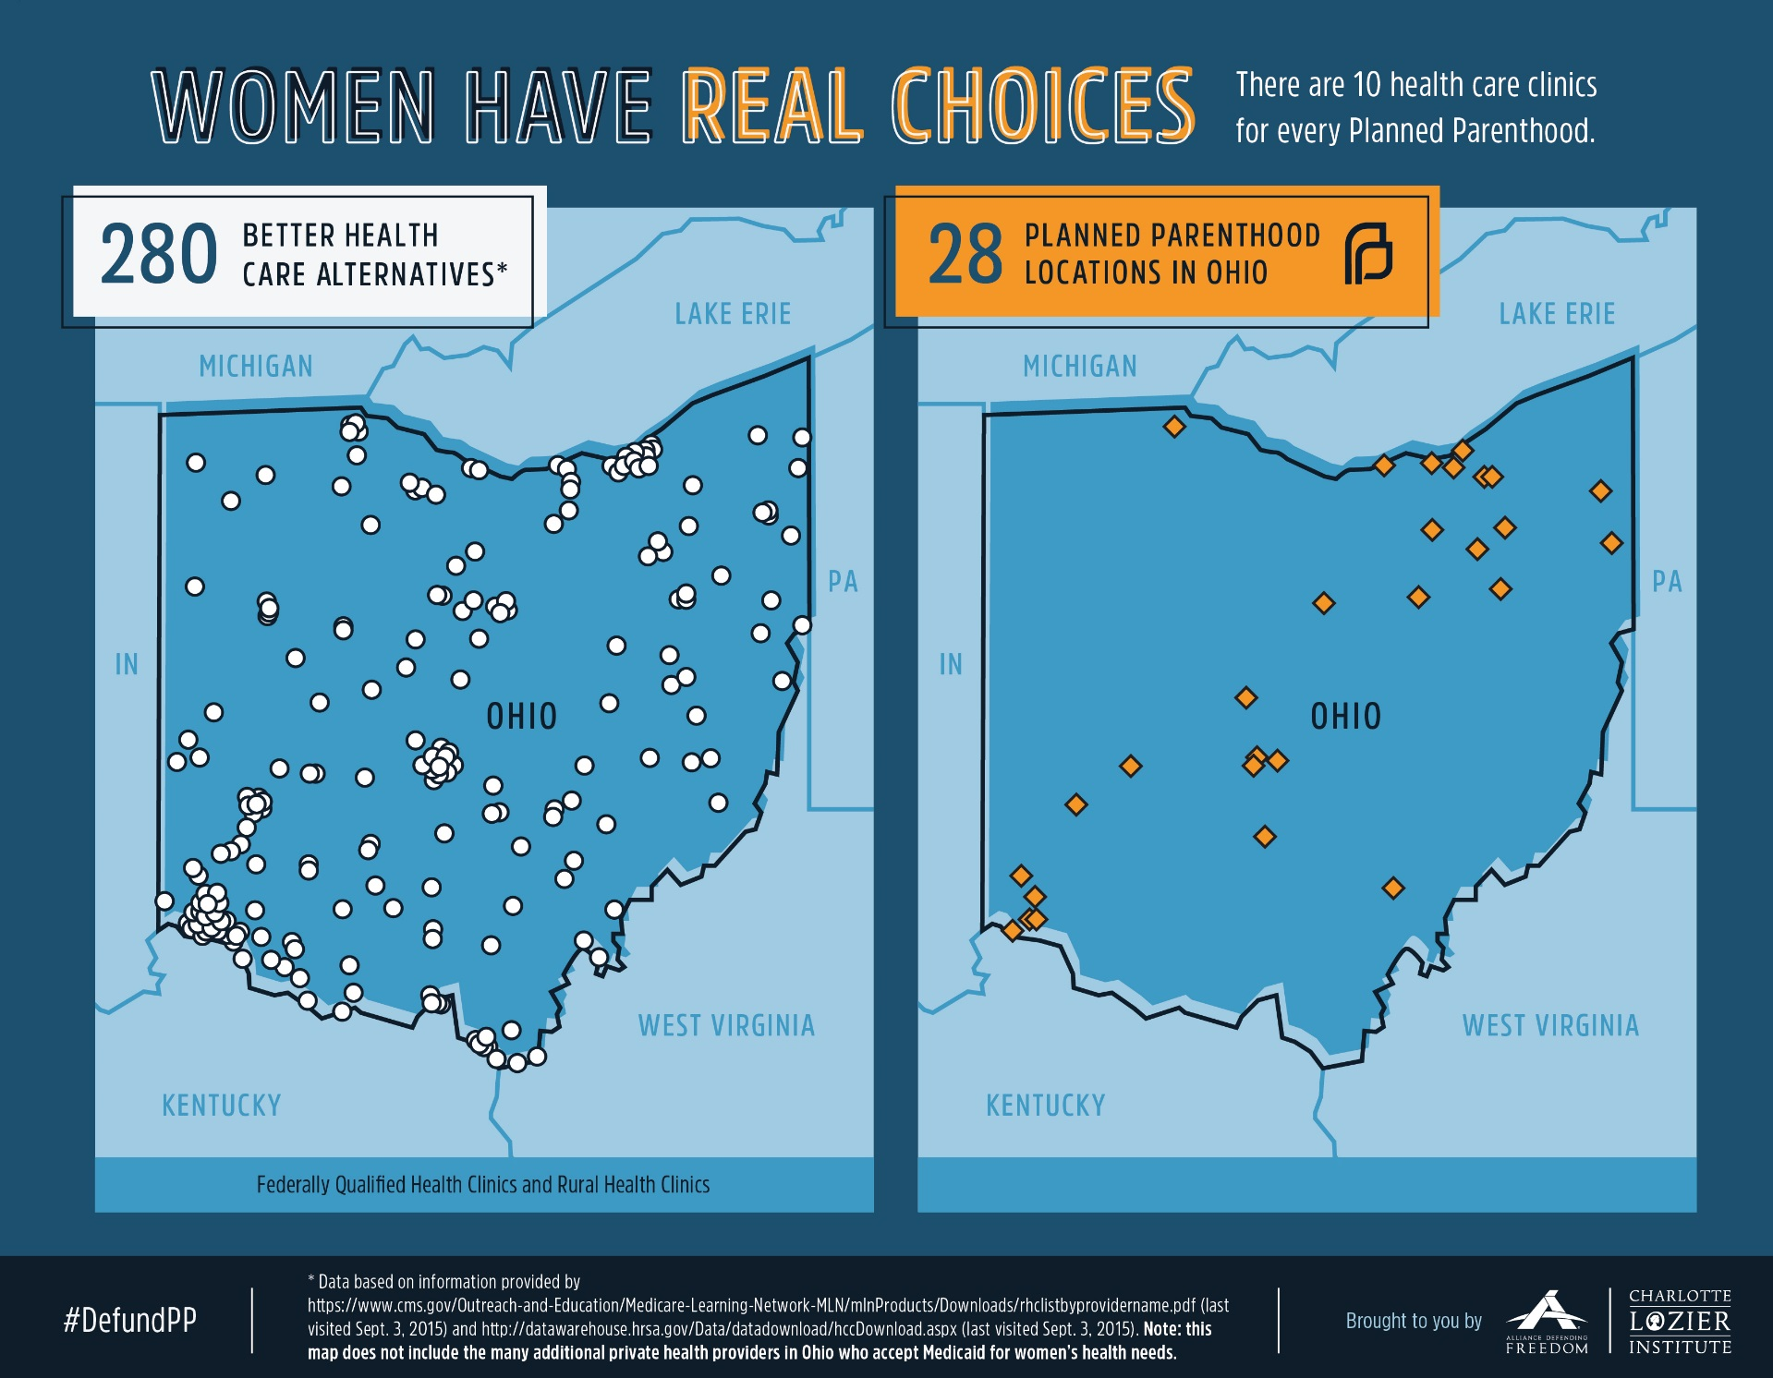

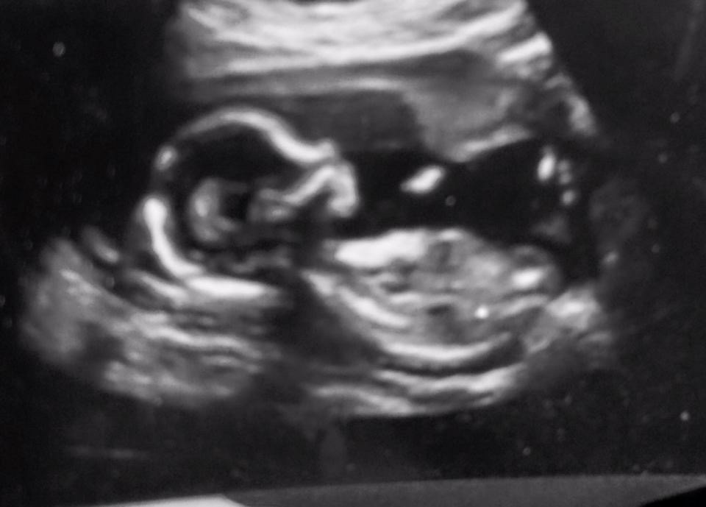

* In addition to the unborn child's heartbeat, brainwaves, fingerprints and capacity to feel pain, other important milestones include:
* At 4 weeks from conception, a baby's eye, ear, and respiratory systems begin to form.
* Thumbsucking has been documented at 7 weeks from conception.
* At 8 weeks from conception, a baby's heartbeat can be detected by ultrasonic stethoscope.
* By 9 weeks from conception, a baby is able to bend her fingers around an object in her hand.
* By 11 to 12 weeks from conception, the baby is breathing fluid steadily and continues to do so until birth.
* By 11 weeks from conception, a baby can swallow.
* Between 13 and 15 weeks from conception, a baby's taste buds are present and functioning.
* At 20 weeks, and perhaps as early as 16 weeks from conception, a baby is capable of hearing his mother's heartbeat and external noises like music.
* At 23 weeks from conception, babies have been shown to demonstrate rapid eye movements (REM), which are characteristic of active dream states.
* At six months from conception, a baby's oil and sweat glands are functioning.
* At seven months from conception, a baby frequently "exercises" in preparation for birth by stretching and kicking.
* At eight months from conception, a baby's skin begins to thicken, and swallows a gallon of amniotic fluid each day and often hiccups.
* During the ninth month from conception, a baby gains half a pound per week. Of the 45 generations of cell divisions before adulthood, 41 have already taken place.