Senate

Health and Human Services and Medicaid Committee

Ohio Commission on Minority Health

October 2, 2019

Chairman Burke, Ranking Member Antonio, Vice Chairman Huffman and members of the Health, Human Services and Medicaid committee. Thank you for the opportunity to provide proponent testimony on Senate Bill 151. Senate Bill 151 designates the month of May as “Maternal Mortality Awareness Month” to raise awareness of the high maternal mortality rate in Ohio and around the country. It is also meant to inspire the Ohio Legislature and all Ohioans to take action to decrease our maternal mortality rates.

Women in the United States are more likely to die from childbirth or pregnancy-related causes than other women in high-income countries.

Even as maternal death rates fell by more than one-third from 2000 to 2015 across the world, [outcomes for American mothers worsened](https://data.unicef.org/topic/maternal-health/maternal-mortality/), according to UNICEF.

According to the Centers for Disease Control and Prevention, African-American, Native American and Alaska Native women [die of pregnancy-related causes at a rate about three times higher than those of white women](https://www.cdc.gov/mmwr/volumes/68/wr/mm6818e1.htm?s_cid=mm6818e1_w). While 13 white women die for every 100,000 live births, the rate for Hispanic women is even lower: 11.4. The figure for African-American women is 42.8 for every 100,000 live births, and for Native American/Alaska Native women, 32.5.

The racial disparity has persisted, even grown, for years despite frequent calls to improve access to medical care for women of color. Of the 700 to 900 maternal deaths each year in America, the [CDC Foundation](https://www.cdcfoundation.org/building-us-capacity-review-and-prevent-maternal-deaths) estimates that 60 percent are preventable. This is largely due to the prioritization of infant survival over maternal care. The research has also indicated that pregnancy-related deaths can be prevented with better health care to include clinical protocols, communication and support, as well as access to stable housing and transportation.

Health issues of pregnancy do not just end after delivery. A pregnancy-related death can happen during pregnancy, at delivery, and even up to a year afterward (postpartum).

In May of 2019, The American College of Obstetricians and Gynecologists (ACOG) released [new guidelines for treating heart disease during pregnancy](https://www.acog.org/About-ACOG/News-Room/News-Releases/2019/ACOG-Releases-Comprehensive-Guidance-on-How-to-Treat-Heart-Disease-in-Pregnancy).

The standard postpartum doctor visit for new mothers is typically scheduled for six weeks after delivery. The ACOG now says that postpartum care should be an ongoing process, rather than a single appointment, and that services and support should be tailored to a woman’s individual needs.

Historic concern about high pregnancy-related death rates among black women has already resulted in some changes in policy in other states.

California has made significant strides in reducing maternal mortality by incorporating a data driven lens. As such, California leads the nation through the development of the California Maternal Quality Care Collaborative. Their efforts have been focused on the regular examination of data to drive informed strategies. This data analysis has resulted in the implementation of basic standardization to pregnancy emergencies, regular drill training and the development of toolkits to address hemorrhaging and preeclampsia – two common causes of maternal death.

Data driven decisions are key in making progress toward disparity elimination and the achievement of health equity. Population health management must start with data. According to the Robert Wood Johnson Foundation, unless specifically measured, racial and ethnic disparities in health care can go unnoticed by public health and health care organizations, even as these organizations seek to improve care. Stratifying quality data by patient race, ethnicity, and language is an important tool for uncovering and responding to health care disparities. Using race, ethnicity, and language data strategically allows public health and health organizations to:

* Discover and prioritize differences in care, outcomes, and/or experience across population groups;
* Plan equity-focused quality improvement efforts and measure their impact; and
* Share the story of how patients are experiencing health care.

While we are aware of the impact, nationally, regarding maternal mortality, we must obtain state level data to understand the overall impact in Ohio as well within population groups.

In Ohio, there has been continual concern voiced regarding the lack of pregnancy associated mortality data and related reports. It is further important that the reports provide disaggregated data by race, ethnicity and language.

Since there is clearly a correlation between infant mortality and maternal mortality, we suspect that Ohio has a high black maternal mortality rate; given that our black infant mortality rate is the second highest in the US based on 2017 data. However, we are limited in demonstrating the need for targeted population-based interventions for maternal mortality due to the unavailability of state reports.

When we are unable to ascertain the specific impact of maternal mortality within this state, we are challenged to reach our goal of disparity elimination. Data provides us with the tools we need to implement both broad based and population-based solutions.

The Commission supported efforts to place the PAMR language which was previously in rule, into law within HB 166. This codified language requires the establishment in the Department of Health a Pregnancy Associated Mortality Review (PAMR) board with the purpose to identify and review all pregnancy associated deaths for the purpose of reducing the incidence of those deaths. This language also requires the PAMR board to: appoint board members that represent all regions of the state and multiple areas of expertise and constituencies concerned with the care of pregnant and postpartum women.

In addition, the PAMR board shall seek to reduce the incidence of pregnancy-associated deaths in this state by doing all of the following: (A) Promoting cooperation, collaboration, and communication between all groups, professions, agencies, and entities that serve pregnant and

postpartum women and families; (B) Recommending and developing plans for implementing service and program changes, as well as changes to the groups, professions, agencies, and entities that serve pregnant and postpartum women and families; (C) Providing the department of health with aggregate data, trends, and patterns regarding pregnancy-associated deaths using data and other relevant information specified in rules adopted under section 3738.09 of the Revised

Code; (D) Developing effective interventions to reduce the mortality of pregnant and postpartum women.

Further, to ensure the availability of pregnancy associated mortality review data, the PAMR board shall prepare a biennial report that does all of the following: (1) Summarizes the board's findings from the reviews completed in the immediately preceding two calendar years, including any trends or patterns 2) Makes recommendations on how pregnancy-associated deaths may be prevented, including changes that should be made to policies and laws. The law requires the initial report shall be submitted not later than March 1, 2020, with subsequent reports submitted not later than March 1 every two years thereafter and shall make each report available on the department of health's web site.

A new federal law, the Preventing Maternal Deaths Act, ensured the provision of grants to states that investigate pregnancy-related deaths, including deaths occurring up to a year after the birth.

The Commission extended congratulations to the Ohio Department of Health, on their receipt of two recent grant awards to combat maternal mortality and morbidity. In August 2019, the Centers for Disease Control and Prevention (CDC) awarded Ohio with a $2,250,000 five-year grant to continue their work with the Pregnancy-Associated Mortality Review (PAMR). The money will support existing work, increase the frequency of publishing data reports, and improve Ohio’s ability to adopt the PAMR committee’s recommendations including implementing maternal safety bundles statewide. In addition, they received The Health Resources and Services Administration (HRSA) five-year grant, totaling roughly $10 million. The money will support: (a) the establishment of a statewide Maternal Health Task Force to create and implement a strategic plan to prevent and reduce preventable maternal deaths and reduce health inequities and (b) promoting and executing innovation in maternal health service delivery (e.g., widespread implementation of maternal safety efforts, assuring risk appropriate care, etc.).

The availability of this funding provides Ohio with the unique opportunity to implement an overarching plan that can address maternal mortality, reduce population disparities and drive health equity.

In summary, too many women are dying of largely preventable deaths associated with their pregnancy and the racial and ethnic disparities are significant and persistent. It is important that we work hard to seamlessly transition women from postpartum to well women care. Raising the awareness on the issue of maternal mortality is a key mechanism to inform, educate and empower communities, health systems and policy makers. Ohio’s future efforts must ensure the access to high quality clinical care, adoption of standardized protocols, address social determinant of health barriers and increasing the availability of stratified data to drive interventions. In Ohio, we have the means to identify and close gaps in the care they receive and achieve equity.

I would like to inform you that I have profound bilateral hearing loss, which will likely require me to ask you to repeat your questions. Thank you in advance for your accommodation. I will be happy to answer any questions you may have at this time.

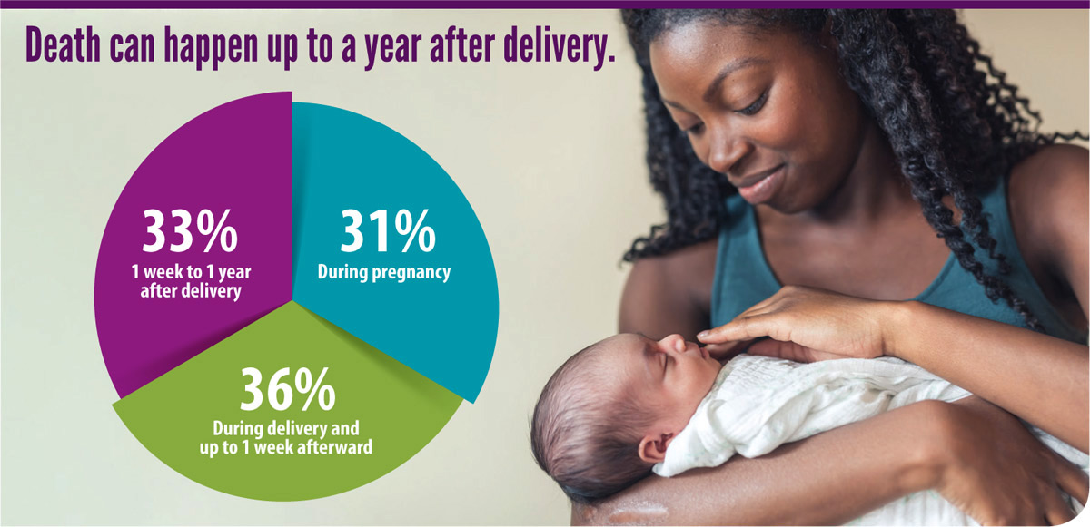

SOURCE: CDC Vital Signs, May 2019