

305 West Nationwide Blvd
Columbus, OH 43215
888.292.6582
www.OLTA.org

February 5, 2020

Testimony in Support of House Bill 209

Chairman Eklund, Ranking Member Thomas, Vice Chair Manning, and Members of the Senate Judiciary Committee. Thank you for the opportunity to present proponent testimony on House Bill 209.

My name is Charles “Chip” Brigham. I am an attorney at law and licensed title agent with my law practice, Brigham and Brigham, and my title agency, Buckeye Land Title Company, located in Cincinnati, Ohio. I am the current President of the Ohio Land Title Association (i.e. OLTA) and I am testifying on OLTA’s behalf in support of the passage of House Bill 209.

OLTA is a trade association representing licensed title insurance agents, underwriters, abstractors and real estate / title attorneys operating in all 88 Ohio counties. Our members perform examinations of the public record, conduct the closings, disburse funds, and insure title to real property.

Ohio’s dower statute is found in Revised Code Section 2103.02. In summary, dower is the old inchoate right of a spouse to claim a life estate in one third of the real property owned by other spouse.

Why is it called the inchoate right of dower?

Dower is referred to as inchoate meaning it is uncertain and unvested and that it can only be claimed, if at all, at some time in the distant future. To illustrate briefly, if a spouse transfers real estate during the marriage, the non-owning spouse must wait until the death of the owning spouse (possibly decades later) before dower, the right to only a life estate in only one-third of all real estate, can be claimed. And, the non-owning spouse must survive the owning spouse, must not have divorced the owning spouse, and must not have committed adultery during the marriage. That is dower in the state of Ohio.

The elimination of this legal relic would not repeal, change, amend, or modify any other provision of Ohio law including any law relating to probate or domestic relations matters.

Key reasons to abolish dower:

- Dower applies to real estate only and was established as an inchoate right during a time when real estate comprised a significantly beneficial asset and when widows would have no other means of security and support after the death of their husbands
- Dower does not protect against the disposition, conveyance, or transfer of any other significant marital assets including liquidating cash accounts (even when the other spouse is a co-owner), changing beneficiaries on life insurance policies, or cashing out or leveraging retirement plans (with the exception of 401k accounts governed by federal law) and investment accounts
- Many states “cover” legitimate dower issues by provisions relating to elective shares such as Ohio’s elective share statute found in Revised Code Section 2106.01
- The repeal of dower would have no adverse affect on the rights of parties to a divorce or dissolution to include all real estate owned by a spouse in the disposition of assets after the termination of marriage
- Ohio domestic relations law provides that any property acquired during the marriage is a “marital asset” subject to equitable division during a divorce or dissolution regardless of which spouse holds title
- Dower is easily defeated by conveyances to trust and other similar probate avoidance vehicles such as Ohio limited liability companies
- Many Ohio titles are needlessly defective by failures to properly reference or release dower
- Defects caused by dower omissions are not “cured” until the expiration of 50 years!

Repeal of dower would benefit Ohio landowners, lenders, and all real estate professionals

Dower is an archaic reminder of our agrarian past. It has little present substantive value. Dower baffles Ohio homeowners. It remains a bane to real estate professionals and imposes unnecessary time, cost, and expense on those homeowners who must either comply with these baffling rules or who are left to resolve clouds on title created by an inadvertent failure to properly reference or release dower.

It’s time to give dower a well-deserved demise.

Respectfully submitted,
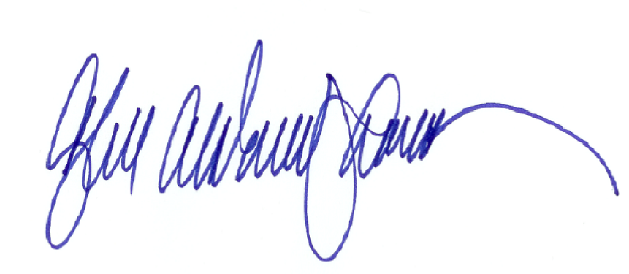
Charles A. Brigham, III
President, Ohio Land Title Association

