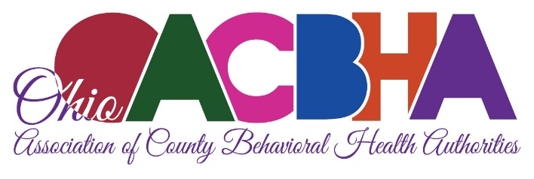

Ohio Association of County Behavioral Health Authorities
Written Testimony of Cheri L. Walter, CEO
HB 535

Chairman Ginter, Vice Chair LaTourette, Ranking Member Boyd, and members of the House Community and Advancement Committee, my name is Cheri Walter and I am submitting this testimony today on HB 535, on behalf of the Ohio Association of County Behavioral Health Authorities which represents Ohio’s Alcohol, Drug Addiction and Mental Health Boards.

Thank you for the opportunity to submit testimony. Should you have any questions or concerns please feel free to contact me at 614-224-1111 or Cwalter@oacbha.org.

As our Opioid Committee met and discussed HB 535 it was clear that having better data on the number of individuals who are overdosing is an important tool as we all work to address Ohio’s opiate epidemic.

Knowing the number of individuals brought to hospital emergency departments (ED) for a drug overdose, including the number of individuals who are saved, and the number whose overdose results in death, will help us get a better handle on the number of individuals that are overdosing, and accessing ED treatment either voluntarily or via emergency transport.

Additionally, having information from EMS/Firefighters on where naloxone is administered down to the zip code plus four, the date of administration, the number of doses being administered, who is administering the naloxone, and whether the overdose was reversed will also be extremely helpful.

The more information local boards have access to and the more specific the information, the better they will be able to fulfill their role as the County Hub to combat opiate addiction, respond to crisis, and to plan for and administer their local system of care. This bill will also help us have more real time data and enable us to better understand the realities of the number of overdoses that are happening locally; moving us from anecdotal information to hard data. This may also help us begin to get a better handle on where across the state the gaps in services exist, particularly withdrawal management/detox and Medication Assisted Treatment programs.

Again, thank you for the opportunity to provide these comments. Should you have any questions please do not hesitate to contact me.

