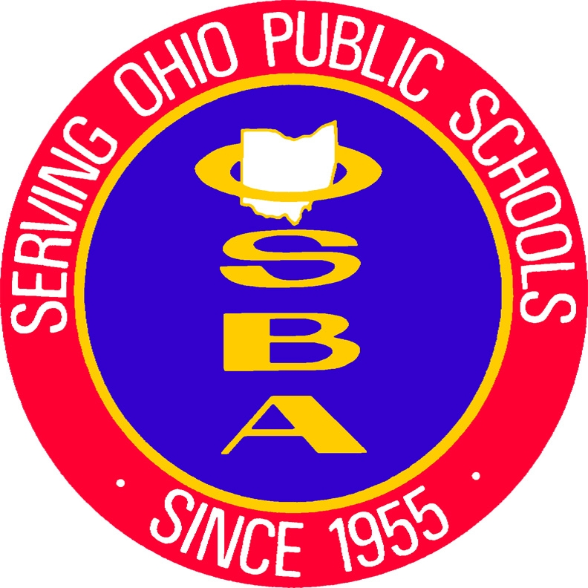
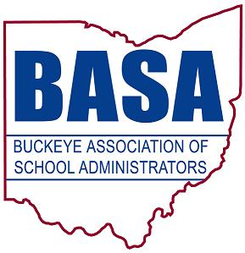

March 20, 2017

The Honorable Louis W. Blessing III, Chair
House Government Accountability and Oversight Committee
Ohio House of Representatives
Riffe Center – 13th Floor
Columbus, OH 43215

Dear Representative Blessing:

On behalf of our organizations, we are writing to express our support for House Bill 8.

As we understand the bill, it would exempt the name, address, contact information, and other personal information of a person who is under age 18 (a minor) from the Public Records Law under certain conditions. A minor's personal information would be exempt if it is included in the record of a school vehicle traffic accident and the minor was in the vehicle at the time of the accident.

Quite frankly, we can see no public purpose to include the identifying information of any student who was the occupant of a school vehicle at the time of any accident.

After all, law enforcement would still have access to this information necessary for any necessary investigation.

Furthermore, releasing such information as a public record only invites additional inquiries to those students and families at a time when they may already be experiencing trauma from an accident.

We respectfully offer our support for House Bill 8 and request that the committee favorably reports House Bill 8 to the Rules and Reference Committee.

Respectfully submitted,

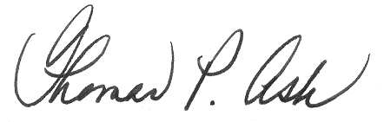
Thomas P. Ash
BASA Director of Governmental Relations

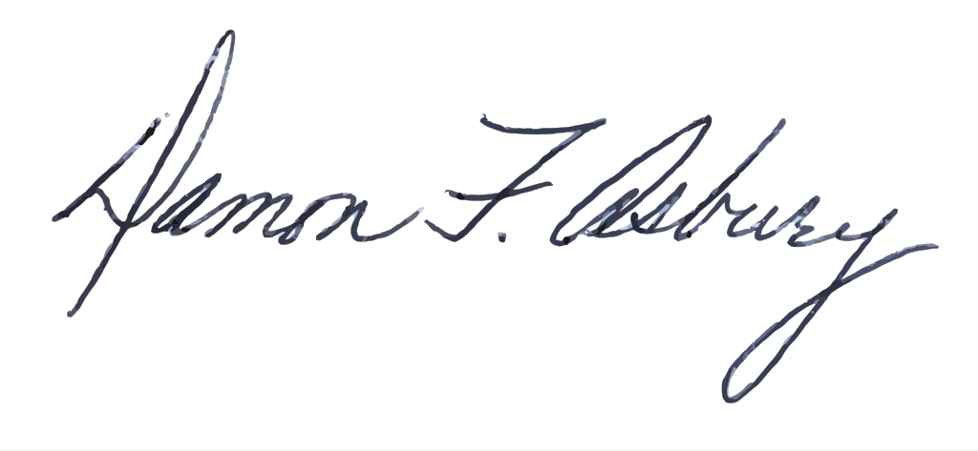
Damon Asbury
OSBA Director of Legislative Services

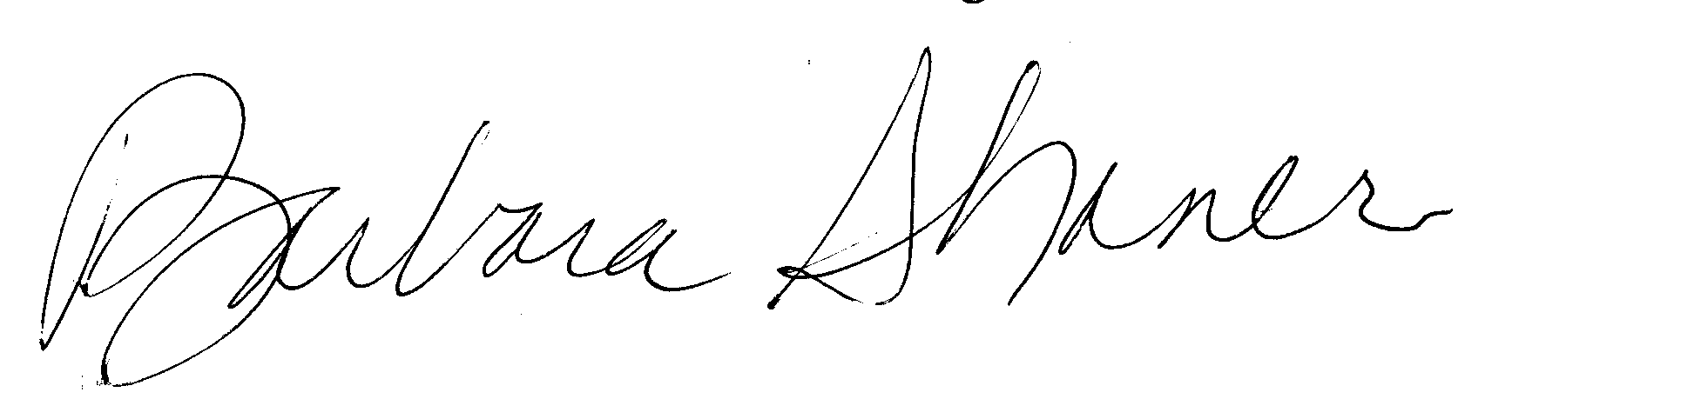
Barbara Shaner
OASBO Associate Executive Director

