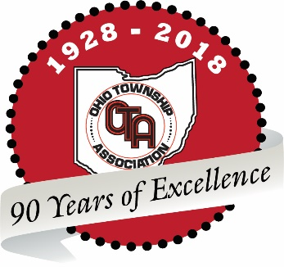

HOUSE HIGHER EDUCATION AND WORKFORCE DEVELOPMENT COMMITTEE
JOINT WRITTEN PROPONENT TESTIMONY
HOUSE BILL 668

NOVEMBER 28, 2018

Chairman Duffey, Vice Chair Antani, Ranking Member Ramos, and members of the House Higher Education and Workforce Development Committee, on behalf of our respected organizations, we write in support of House Bill 668, which authorizes municipalities and townships to enter into public-private initiatives regarding public facilities.

This permissive authority allows local governments to enter into public-private partnerships to renovate or construct buildings within their jurisdictions. Many cities, townships and villages have much-needed infrastructure projects that they are unable to accomplish because they lack the funding to do so. This bill provides another option for municipalities and townships to procure the requisite funding to not only invest in safe and sustainable infrastructure, but to invest in the local economy.
Infrastructure is a key component of economic development for political subdivisions. Crumbling, unsafe infrastructure can deter businesses from choosing to locate a new or relocate an existing business. When a municipality or a township can initiate capital improvement projects, there is an immediate and sustained impact on the local economy beyond the initial creation of jobs during construction. Additionally, public-private partnerships create “one stop shops” for local governments, relieving a municipality or township from having to manage multiple contracts, vendors and consultants.
The language in HB 668 allows local governments, through the public-private agreement, to retain ownership of a building while the private sector builds, repairs and maintains the building for up to 40 years. The private sector manages the risks and will be financially responsible for any subpar construction.
Investment in Ohio’s infrastructure is imperative, and that investment starts at the local level. House Bill 668 simply creates another tool municipalities and townships may use to finance crucial capital improvements and foster economic development. The Ohio Municipal League and the Ohio Township Association urge for the favorable passage of House Bill 668. Thank you for your consideration.
Sincerely,
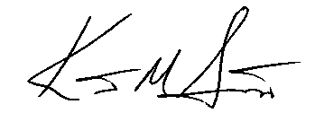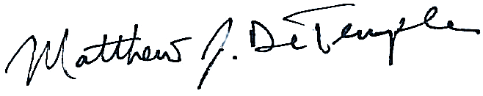

Kent Scarrett Matthew J. DeTemple
Executive Director Executive Director
Ohio Municipal League Ohio Township Association

