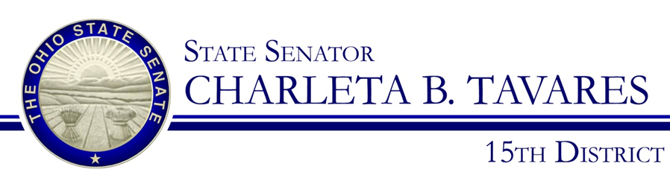
Sponsor Testimony
Presented by: Senator Charleta B. Tavares
Senate Bill 105
Education Committee
Chair, Senator Peggy Lehner
Wednesday, September 20, 2017

Good morning, Chairwoman Lehner, Ranking Member Sykes and members of the Education Committee. Thank you for the opportunity to present Senate Bill 105 which will designate October as Ohio Principals Month. This legislation will honor the service of all elementary, middle, and high school principals and will recognize the importance of school leadership in ensuring that every child has access to a high-quality education.
The Ohio Association of Elementary School Administrators and the Ohio Association of Secondary School Administrators have declared the month of October to be ‘Principals Month’ in coordination with the efforts of the National Association of Elementary School Principals and the National Association of Secondary School Principals. There are over 3,000 principals in the state of Ohio and all play a crucial role in molding our future leaders. Principals are often the role models for both students and teachers and they are entrusted with providing a learning environment that nurtures and develops Ohio’s most important resource; our children. Resolutions have been introduced at the federal level and states such as Alabama, Alaska, California, Illinois, Iowa, Oklahoma, Pennsylvania, and Texas have each issued their own proclamations but Ohio should take the next step and permanently designate October as “Ohio Principals Month”.

Chairwoman Lehner and members of the Committee, I appreciate your attention to this important issue and I respectfully request your favorable consideration and passage of Senate Bill 105. Thank you and I am happy to respond to questions from the committee.

