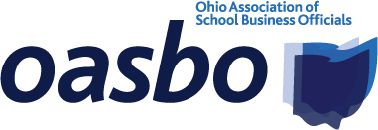
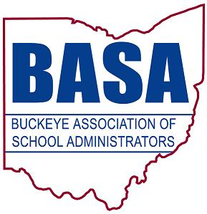

House Education Committee
Senate Bill 39 Testimony
Ohio School Boards Association
Buckeye Association of School Administrators
Ohio Association of School Business Officials
September 27, 2017

Good afternoon, Chair Lehner, Vice Chair Huffman, Ranking Member Sykes, and members of the Senate Education Committee. Thank you for the opportunity to speak to you today regarding our support for Senate Bill 39. My name is Thomas Ash, and I am the Director of Governmental Relations for the Buckeye Association of School Administrators (BASA). Joining me today for this testimony and in answering your questions is Jay Smith, Deputy Director of Legislative Services for the Ohio School Boards Association. We are also speaking on behalf of Ohio Association of School Business Officials advocate Barbara Shaner, who is unable to attend in person today.

Our organizations represent public school district boards of education, superintendents, treasurers/ CFOs, business managers, and other school business officials from around the state. We are here today as proponents for SB 39, which would enact a number of provisions that would expand the legislative oversight of electronic schools as initiated in House Bill 2 of the 131st General Assembly.

First, we support the bill’s focus on students and their achievement. E-schools would be required to submit a monthly report on participation in learning opportunities to the Ohio Department of Education. These schools would also need to notify the student’s parent, ODE, and the school district of residence if a student would fail to participate in learning opportunities for ten consecutive days. In addition, representatives of the e-school would be required to confer with a student’s parents if the student’s performance declines.

We further believe that the calculation of the percentage of full-time equivalency will motivate e-schools to monitor student participation even more closely. For a student to count as a full-time equivalency of 1.0, the percentage of learning opportunities provided by the e-school to that student must be equal to the amount of time that the student is actively engaged in learning opportunities. Nothing precludes the student from participation in additional learning opportunities and added time.

Second, we support the intent of SB 39 to elevate transparency in e-school operation. For example, certain school report card elements would be reported on promotional materials. Public meetings of the governing board would be streamed online as the meetings occurred. Sponsors would be required to report to ODE if the e-school fails to comply with the required International Association for K-12 Online Learning (INACOL) standards.

Finally, we believe that the legislation clarifies other issues. Contracts between school operators and the governing authority would be limited to a term of three years, and subsequent agreements would be required to reflect any applicable modifications made prior to renewal. Attendance requirements and rules would be strengthened by inclusion in the contracts between the sponsor and the e-school’s governing authority. The bill would also provide clarification with regard to the issue of “providing” learning opportunities as opposed to merely “offering” learning opportunities.

Finally, SB 39 would codify the distribution of money returned to the state from an e-school as a result of a finding for recovery issued by the Auditor of State based on the reason for the finding.

Chair Lehner, thank you for this opportunity to express our support for Senate Bill 39, and we will be happy to address any questions at the pleasure of the chair.

