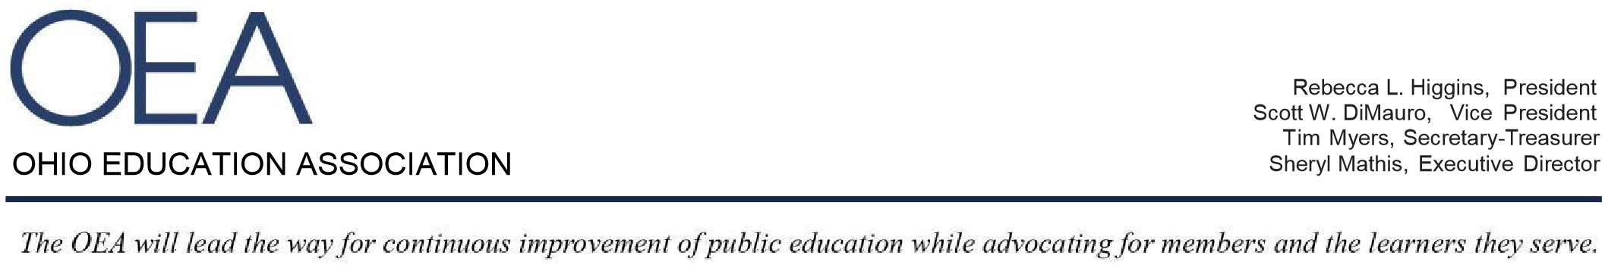
OHIO EDUCATION ASSOCIATION

September 27, 2017
Senate Education Committee
Senate Bill 39 - Proponent Testimony

Chair Lehner, Ranking Member Sykes and members of the Senate Education Committee, I am Matthew Dotson with the Ohio Education Association’s (OEA) Government Relations Division. On behalf of the OEA’s 124,000 members, thank you for this opportunity to provide proponent testimony in support of Senate Bill 39.

The bill addresses a number of important accountability and transparency mechanisms to ensure they are aligned with the unique aspects of the virtual education model. Students engaged in virtual learning can be more effectively supported by customizing certain methods of data collection, record-keeping and reporting.

Senate Bill 39 seeks to support parents and students by helping to ensure each child receives the education to which they are entitled.

Provisions in the bill address student attendance, parental engagement, student mobility data and live-streaming of public meetings.

The bill also specifies how the Ohio Department of Education is to distribute public funds that are otherwise returned to the state when there is a finding for recovery issued by the Auditor of State as a result of a charter school audit.

The audit provisions are similar to those in House Bill 87, introduced by Rep. Kristina Roegner (R-Hudson). If the finding for recovery resulted from an audit of enrollment records, the public funds must be credited to the school district from which the money was originally deducted. If the finding for recovery resulted from any other type of community school audit, the public funds must be redistributed to the school districts of the students enrolled in the charter school at the time the finding was issued, in an amount proportional to each district's share of the community school's total enrollment at that time.

In closing, Senate Bill 39 reflects ongoing efforts to make sure all publicly funded education programs in Ohio have a fair, but rigorous, system of accountability and transparency that adequately protects students, parents and taxpayers.

