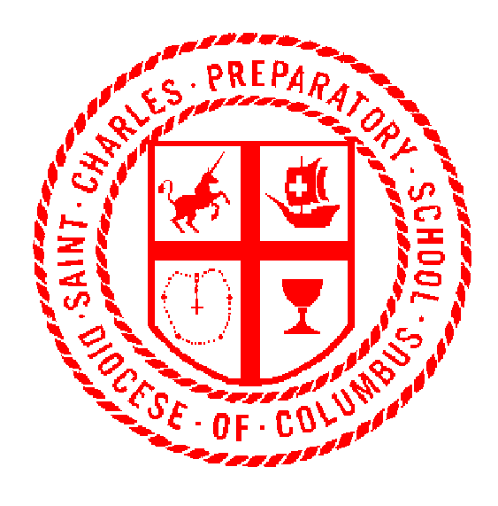
The Distinctive
Leader in
Catholic Education

May 14, 2018

Dear Senator Terhar and other committee members,

I write you today to voice my opposition to SB 241 and hope you will consider my position as a Catholic school principal. I believe that all schools, both public and non-public schools should be held accountable to comply with minimum standards established by the Ohio Department of Education and the Ohio State Board of Education. The oversight and standards are healthy for our schools and create opportunity for growth and improvement. It is my understanding that SB 241, if approved, would permit a select group of schools, ones that are part of ISACS (Independent Schools Association of Central States) a waiver so that they would not have to participate in an accreditation process, like the other schools in the state.

This waiver would give the public the perception that these schools were superior, that they did not have to be evaluated or participate in the process. I believe it is law that the Department of Education is not permitted to create a rating or any type of report card for non-public schools. By excluding these schools from an accreditation process, there is an implied message that they are superior or their overall rating is better than ones that follow an accreditation plan.

ISACS counsel describes that its member schools have attained high scores in the national assessments like ACT, SAT, PSAT, and Advanced Placement tests. They cite low remediation rates as their graduates enter college. St. Charles Preparatory School and other non-public/charter schools have comparable, it not better scores than many of these schools. Approving SB 241 would provide a message that the ISACS schools were better, even if these national tests scores may tell a different story.

Finally, the accreditation process provides teachers and administrators the opportunity to self-evaluate and determine goals and plans for improvement. Collaboration and hard work are elements of a good accreditation plan and process. Passing SB 241 may eliminate that incentive to grow and improve. The oversight and regulation from a higher authority is best practice in most industries. The Ohio Department of Education and the Ohio State Board of Education should have this authority over all schools. I strongly encourage that this bill be re-evaluated as you move forward.

Respectfully submitted,

James R. Lower, Principal
St. Charles Preparatory School

2010 East Broad Street Columbus, Ohio 43209-1665 Phone: (614) 252-6714

