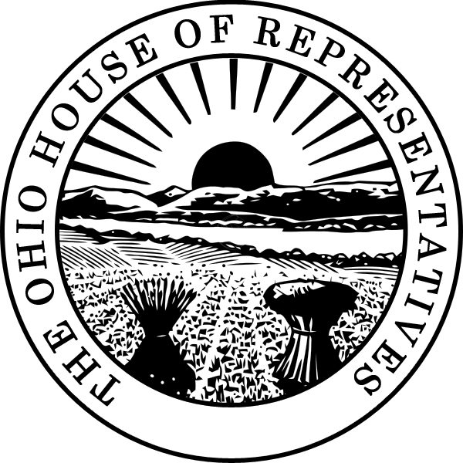

Ohio General Assembly
House of Representatives
Columbus

Sponsor Testimony of Representatives Jonathan Dever and Robert McColley
Regarding Substitute House Bill 132
Before the Senate Finance Committee
Tuesday, September 12, 2017

Chairman Oelslager, Vice Chair Manning, Ranking Member Skindell, and members of the Senate Finance Committee, thank you for the opportunity to offer sponsor testimony on behalf of Substitute House Bill 132, which regulates fantasy contests in Ohio.

With over 55 million Americans participating in some form of fantasy sports across the country, including 1.9 million Ohioans, there is a need to clarify regulations in an industry that generates such high revenue, while also emerging as a large employer in the state of Ohio.

This past summer, Attorney General DeWine released an opinion that stated the statute is not clear with regard to this industry and the General Assembly should better define their business in the revised code. Substitute House Bill 132 was developed and drafted in coordination with the Attorney General, the Ohio Casino Control Commission, and stakeholders from the fantasy sports industry.

The substitute bill updates state laws to clarify fantasy sports are legal in Ohio and add necessary consumer protections. The legislation defines a “fantasy sports contest” by using guidelines already defined in federal law in The Unlawful Internet Gambling Enforcement Act of 2006, which specifically excludes providers from the act’s provisions. The bill also makes clear that all rules must be established and enforced by the Ohio Casino Control Commission.

Other essential provisions include:
- Ensuring players are 18 or older
- Requiring all fantasy game operators to be licensed by the state
- Offering introductory on-boarding for new players
- Prohibiting any contest based on a collegiate or high school sport or athletic event
- Restricting employees of fantasy sports contest companies from playing
- Requiring “highly experienced players” to be clearly identified for all users to see
- Disclosing the number of entries a player may submit to each contest and the number of total entries allowed for each contest
- Taking measures to protect the privacy and online security of players and their accounts
- Keeping player funds separate from operating funds, ensuring player money is accessible at all times

In addition, Substitute House Bill 132 requires an annual independent audit to ensure all providers are complying with the requirements specified in the legislation. These audits will be submitted to an appropriate state agency, reassuring consumers that the games they enjoy will continue to operate at the highest standards.

Eleven other states have recently passed similar legislation, and dozens of other states around the country are moving in the same direction. This bill will allow Ohio to regulate a quickly growing industry, ensuring the rights of consumers and providers alike are protected.

Thank you, again, for allowing us the opportunity to offer testimony on Substitute House Bill 132 and for allowing for a hearing on this legislation so soon after the summer recess. We would be happy to answer any questions at this time.

