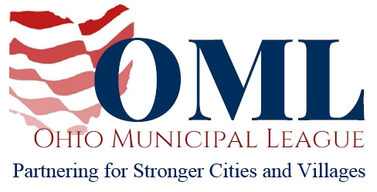

Chairman Oelslager, Vice Chair Manning, Ranking Member Skindell, and members of the Senate Finance Committee, thank you for taking into consideration our written testimony in support of HB 54.

HB 54 will create a state bond bank under the authority of the Ohio State Treasurer for the purpose of financing permanent improvement projects for qualifying local governments. The Ohio Municipal League, on behalf of our 733 members, offers our enthusiastic support of this legislation.

Ohio municipalities face many financial barriers when it comes to financing capital improvement projects. One of the most prominent issues is that of providing the requisite matching funds when applying for grants for permanent improvement projects. HB 54 offers a financing option that effectively removes that barrier, allowing our most financially-challenged municipalities the opportunity to make much-needed infrastructure improvements to their communities.

Since the reduction in the Local Government Fund and the elimination of several key revenues sources, municipalities across the state have experienced severe revenue shortfalls. As a result, many crucial capital improvement projects have been neglected for years due to the lack of requisite funding. HB 54 recognizes the challenges our municipalities face and seeks to create a means by which our cities and villages can secure the necessary revenue and begin to once again invest in the local communities where many Ohioans live and work.

Permanent improvement projects are a vital aspect of the services offered that make cities and villages such an attractive place for Ohioans to live and work. Cities across the state fighting crumbling infrastructure are struggling to provide the services their communities both expect and deserve.

OML often describes municipalities as the economic engines of our state, and considering 80% of businesses choosing to locate in a municipality, that has never been more true. The quality of our local communities attracts businesses, which in turn brings jobs to Ohio. Economic prosperity in Ohio is directly linked to the health and well-being of our cities and villages.

We appreciate Representative Blessing and Representative Gaverone for recognizing the crucial role local governments play in the success of our state, and we thank them for drafting legislation that, if enacted, will serve as another tool municipalities can use to make our local communities safer, healthier, and more prosperous.

We urge the unanimous passage of HB 54, and we thank you for your consideration.

Yours sincerely,
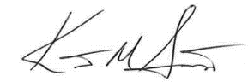

Kent Scarrett
Executive Director
The Ohio Municipal League

