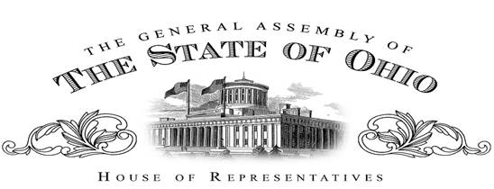

Sponsor Testimony
Representative Dave Greenspan
House Bill 251
Chair Oelslager, Vice Chair Manning, Ranking Member Skindell and the Senate Finance Committee I extend my gratitude to each one of you for the opportunity to testify today as the sponsor for House Bill 251 – which extends, on a permissive basis, the current 5-year limit on political subdivisions investment ability to a limit of 10 years.
Currently, a political subdivision has the ability to do two things. First, purchase the debt of another subdivision and secondly, use of current investment funds to internally-finance projects. This bill will provide greater opportunities to realize savings and garner greater investment income. This can be achieved by providing for longer periods of time than is currently prescribed in the ORC.
In the first opportunity – there are distinct advantages for both the purchaser and seller. Those political subdivisions purchasing the debt may have an opportunity to earn more investment income than on their traditional or current investments. And for the political subdivisions selling their debt may pay less interest expense, thus resulting in savings to taxpayers. As previously indicated, both the seller and purchaser under the proposed extended investment protocol, stand to mutually benefit. As an example, two of the five cities I proudly represent, have utilized the current 5-year investment protocol. City officials have on multiple occasions expressed to me the benefit of utilizing this financing/investment vehicle – but believe that having a greater investment window of 10 years instead of 5 could prove more beneficial. To put this into perspective, Cuyahoga County has dedicated almost $100 million dollars for this purpose. Unfortunately, the county has no takers – primarily because as we all know, when you look at an amortization schedule – there is not a lot of interest paid in the last 5 years of a debt instrument. If we extend the term to 10 years – especially in the example of a 20 year school bond issue – there is a greater opportunity to realize both savings (i.e., paying less interest expense) for the seller of the debt and an opportunity for the buyer to earn more interest income than they are currently realizing.
In the second opportunity – political subdivisions may maximize greater opportunities in utilizing underperforming investments to internally finance projects. A direct example of the benefits of this bill is Cuyahoga County – currently Cuyahoga County is internally financing a $22 million dollar capital project with investment dollars. In so doing, the county is saving hundreds of thousands of dollars in bond origination costs, legal fees and interest expense that would be paid if the project was funded through traditional bonds. The issue is that under current law they must, every 5 years refinance, internally, their own debt. This is administratively unnecessary and costly and can be avoided by extending the limit to 10 years.
House Bill 251 is a common sense, permissive piece of legislation that affirms a responsive and responsible form of government.
Chair Oelslager, Vice Chair Manning, Ranking Member Skindell and the Senate Finance Committee I appreciate the opportunity today to present House Bill 251 for your consideration.
I am available and pleased to answer questions from the committee.

