Testimony of Kevin Miller, Executive Director
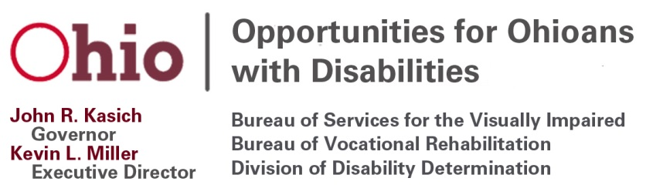
Opportunities for Ohioans with Disabilities

Chairman Coley, Vice-Chair Uecker and distinguished committee members, my name is Kevin Miller and I am the Executive Director of Opportunities for Ohioans with Disabilities (OOD). Senate Bill 144 will enhance the ability of Ohioans with disabilities to more effectively engage with and advise on the vocational rehabilitation (VR) programs provided through OOD.

Currently, OOD has three separate entities that represent individuals with disabilities in Ohio and provide feedback to the agency:

- The seven-member OOD Commission approves the state Vocational Rehabilitation portion of the Combined State Workforce Plan, jointly approves the state plan for independent living with the Ohio State Independent Living Council and serves as an advisory body on the effectiveness of, and consumer satisfaction with, the vocational rehabilitation programs of OOD.

- The Commission appoints the seventeen-member Consumer Advisory Committee (CAC) which also advises OOD on its vocational rehabilitation programs. This volunteer body is comprised of individuals who have successfully attained or retained a job with the help of OOD.

- In addition, Ohio has a twenty-one member Governor’s Council on People with Disabilities (GCPD) charged with providing input and guidance to the Governor and members of the General Assembly on policy and legislation as it pertains to laws in Ohio that affect the disability community.

Currently we have 45 representatives on three separate bodies representing individuals with disabilities. Despite significant changes in the operation of the vocational rehabilitation program and our agency, the nature and operation of the Commission, the CAC and the GCPD have remained virtually unchanged for decades. With the implementation of the Workforce Innovation and Opportunity Act (WIOA) and OOD’s inclusion as a cabinet level agency in the Governor’s Administration, we believe a clearer and more effective streamlined approach is needed.

We would propose integrating all of the aforementioned advisory entities into an Opportunities for Ohioans with Disabilities Council that would consist of 15 members. This structure, recognized under federal law, would require that all members be appointed by the Governor. Individuals with disabilities who do not work for OOD, who represent a cross section of disabilities and including those who have difficulty representing themselves, would make up a majority of the members, but membership would also include representatives from business and industry, partner agencies and programs, a full-time employee of the state’s Client Assistance Program (CAP), and a VR counselor.

Disability Rights Ohio (DRO), a non-profit that advocates for the human, civil and legal rights of people with disabilities in Ohio, is supportive of moving to this model and approached us to discuss this option.

It is also worth noting that we are the only state in the country still using the commission structure.

Besides providing for a more unified and effective process for feedback and engagement, adopting the OOD Council would involve significant savings in reimbursement and travel costs alone. The current structure allows for as many as 45 members while OOD Council would only require 15 members. The current structure at full participation, 45 members requires $49,950 (based on average costs), while 15 members would require only $16,650; a cost savings of $33,300. There will also be no extra cost to staff the OOD Council. OOD will provide internal staff to exercise the necessary functions, as we have previously done with the OOD Commissioners, CAC and GCPD.

Modernizing how Ohio serves individuals with disabilities has been a priority for OOD and Governor Kasich. This proposed change would allow for greater access, greater awareness and follow a model that has been adopted across the country all while saving taxpayer dollars.

Thank you for allowing me to provide testimony on SB 144, and I am more than happy to answer any questions you may have.

