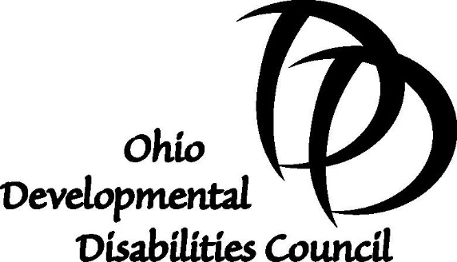

Senate Bill 144 – Proponent Testimony
Tuesday, September 5, 2017
Senate Government Oversight and Reform Committee

Mr. Chairman, Ranking Member and members of the Committee, my name is Carolyn Knight and I am the executive director of the Ohio Developmental Disabilities Council.

On behalf of the Ohio Developmental Disabilities Council, I am testifying in support of Senate Bill 144. As you know, the bill would make structural changes to the makeup of the state body responsible for oversight and implementation of our vocational rehabilitation programs.

As an entity that is also comprised of a majority of individuals with developmental disabilities and family members, the Ohio Developmental Disabilities Council supports any effort that will increase the opportunity for individuals with disabilities to be heard and to participate in the design of and have access to needed community services, individualized supports, and other forms of assistance that promote self-determination, independence, productivity, and integration and inclusion in all facets of community life.

It may come as a surprise to this committee that the current Opportunity for Ohioans with Disabilities Commission is comprised of only two of the seven members needed and that neither of the two members are individuals with disabilities. Having just undergone interviews with Ohioans seeking an appointment to the DD Council, I can tell you there is no lack of qualified and interested individuals seeking to participate in the design, oversight and implementation of programs for people with disabilities.

While we support this change, which more closely follows the federal statute for vocational rehabilitation programs, I do want to make one clarification about the differences between the DD Council and the newly created Opportunities for Ohioans with Disabilities Council that is created by the bill.

The Ohio DD Council, created by the Developmental Disabilities Assistance and Bill of Rights Act, develops a 5-Year Plan on Developmental Disabilities, which includes a comprehensive review and analysis of programs and services available to individuals with developmental disabilities. Unlike the Opportunity for Ohioans with Disabilities Agency, whose mission and purpose is to provide employment training and placement for all individuals with disabilities, the DD Council must focus on a more broad set of issues, which includes housing, transportation, early intervention services, education, and self-determination to name a few, and focused specifically on individuals with developmental disabilities.

Through the work of our grants, the Ohio DD Council has supported unique approaches to employment for people with developmental disabilities that are now being incorporated into the work of OOD. Our Council advocated for and supported the state’s effort to move to an Employment First model for young adults with developmental disabilities. Employment First is now a program that is supported by the work of OOD and the Ohio Department of Developmental Disabilities.

The Ohio DD Council supports the changes made by Senate Bill 144 because we believe that having a single governing body comprised of a majority of individuals with disabilities is consistent with the intent of federal law related to vocational habilitation and rehabilitation programs. The Ohio DD Council views the work of OOD and its governing body as vital to ensuring individuals with disabilities have access to services and supports that promote independence, productivity and integration and inclusion in community life.

I thank you for your consideration and would be happy to answer any questions you have.

