WRITTEN TESTIMONY TO THE SENATE GOVERNMENT OVERSIGHT AND REFORM COMMITTEE

HB 425
November 27, 2018

Chair Coley, Vice Chair Uecker, Ranking Member Schiavoni and all members of the Senate Government Reform and Oversight Committee, thank you for the opportunity to provide written testimony today in support of HB 425.
HB 425 provides policies for police departments using body cameras by supplying specific guidelines on when to either restrict or make recorded footage public. The proposed policies would not allow certain portions of body camera recordings that depict violent or disturbing content and/or violate someone’s privacy to be subject to public records law.
We appreciate the time Rep. Antani and Rep. Craig took to ensure input from the bill’s many interested parties was heard and the effort they made to achieve a balance of public transparency and the protection of privacy within the legislation. While the bill clarifies that the recordings are generally public record, it also carves out very specific exceptions to protect people’s privacy.
The Ohio Municipal League and its members are especially supportive of the provision in the bill that protects local control by specifying that in no way does the bill mandate that police departments have to implement body camera programs if they are not currently using one.
We support the creation of guidelines that will protect privacy while preserving public records, and we support the preservation of local control. For these reasons, we urge your support of HB 425. Thank you for your consideration.
Sincerely,
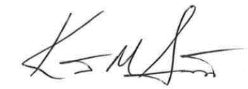

Kent Scarrett
Executive Director
Ohio Municipal League

