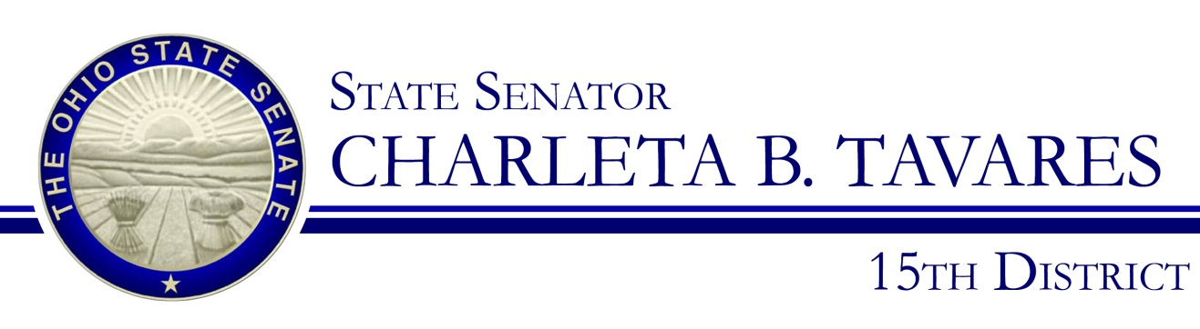

Sponsor Testimony Senate Bill 192
Presented by: Senator Charleta B. Tavares
Senate Health, Human Services and Medicaid Committee
Senator Dave Burke, Chair
January 23, 2018

Chairman Burke and members of the committee, thank you for the opportunity to provide sponsor testimony on Senate Bill 192. This bill will designate the final week of September as Diaper Need Awareness Week in Ohio. This week is meant to raise awareness of the need by low-income families of diapers for their babies and toddlers, and to rally sustainable support for diaper bank programs in Ohio.
Diaper need is the lack of a sufficient supply of diapers to keep an infant or toddler clean, dry, and healthy. Diapers are essential to a baby’s healthy development. Keeping infants and toddlers clean and dry is essential to baby’s health and longevity. Unfortunately, many babies don’t have the clean diapers they need.
Children in low-income families are at the greatest risk of suffering the effects of diaper need because many families cannot afford diapers. Current public support programs help some, but young children have additional needs necessary to build a strong foundation for healthy growth. More awareness needs to be brought to such a critical but oftentimes overlooked necessity for Ohio families.
Data recently compiled by the National Diaper Bank Network, who began this initiative, reports that 25% of Ohio families earn less than 100 % of the Federal Poverty Level. On average, diapers cost about $80.00 a month per infant or toddler, with TANF as the only federal assistance program that can be used to cover the cost. But that doesn’t account for the many other monthly expenses that TANF covers, including heat, electric, water, rent, clothing, and transportation. For a struggling family or single-parent household, that could mean the choice between buying fresh diapers or reusing old diapers to cut costs. No parent or infant deserves to have to face that choice.
Ohio currently has 14 NDBN-member diaper banks distributing a total of 1,026,110 diapers annually. Diaper banks continue to help meet the diaper need for low income families. Support for these programs is essential for ensuring all Ohio infants have a healthy start to life.
This bill is simply meant to bring attention to this important need and to encourage those of us with a little extra to donate to the Diaper Banks in our communities or to start them. Members of the Health, Human Services and Medicaid Committee, I ask for your favorable passage of SB 192 and I would be happy to answer any questions you have at this time.

