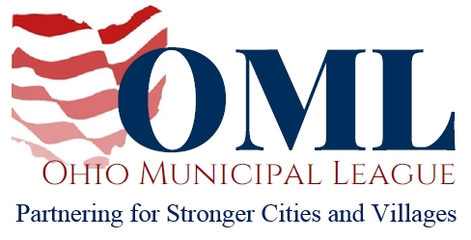

WRITTEN TESTIMONY TO THE SENATE HEALTH, HUMAN SERVICES AND MEDICAID COMMITTEE
SB 210
May 15, 2018
Chair Burke, Vice Chair Beagle, Ranking Member Tavaras, and members of the Senate Health, Human Services and Medicaid Committee, thank you for the opportunity to write in opposition to SB 210.
SB 210 would prohibit a municipality from taxing or levying a fee against any auxiliary container. The definition of “auxiliary container” in the bill extends to items such as plastic and paper bags, aluminum cans, glass bottles, Styrofoam cups and carry-out food containers.
This legislation would be another preemption against the constitutional authorities granted to Ohio’s cities and villages and we believe it violates Article XVIII of the Ohio Constitution providing municipalities with Home Rule authority.
For any who may be concerned by the fact that Home Rule authority grants the legislative authority of a municipality to theoretically place a tax or a fee on “auxiliary containers” such as plastic bags, it is important to know that the status quo has proven this need not be a concern. No municipality in Ohio has passed legislation to tax auxiliary containers of any variety. In our view, this bill poses a solution looking for a problem.
The Ohio Municipal League respectfully requests your opposition to SB 210.
Thank you for your consideration.
Sincerely,
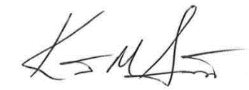

Kent Scarrett
Executive Director
Ohio Municipal League

