Senate Health, Human Services, & Medicaid Committee
Proponent Testimony – Dining with Dogs, House Bill 263
May 21, 2018
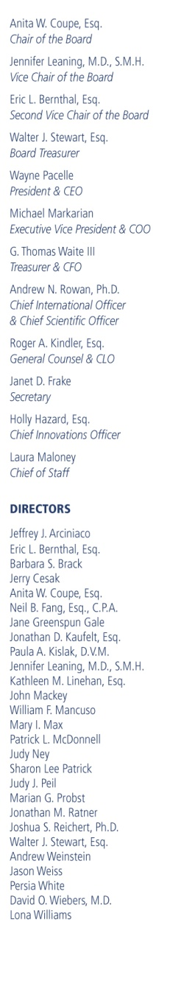

Chairman and distinguished members of the committee, my name is Corey Roscoe and I am
the State Director for the Humane Society of the United States (HSUS) the nation’s largest and most effective animal protection organization. On behalf of the HSUS and our Ohio members and supporters, I offer Proponent testimony on House Bill 263: Allow dogs in restaurant outdoor dining areas in accordance with the bill.

Dogs (and cats) share the homes of 65% of U.S. households, providing many benefits to their families such as love, loyalty and an improved sense of well-being. People consider dogs and other animals to be just another member of the family. When you sit down to eat, it’s most often with your husband, your partner, your wife, your kids and your dog. Yet many people are surprised to learn that dogs are not already allowed into outdoor eating areas given the dog-friendly attitude many establishments in Ohio take.

Making dining with dogs on patios permissible allows restaurants to be responsive to their customer base. Many eating establishments with patios host fundraisers for local animal shelters and have other fun family themed events. Restaurant owners can benefit financially on all the doting dog owners throughout our state. Now that word is spreading that dining with your dog on patios is not allowed, many people may be opting to stay home just to be with their pup.

This change could increase revenue for restaurant businesses and do wonders for pets and their people, like preventing dogs from being left in hot cars and promoting family outings. One of the great things about the bill is that it’s not a mandate. Establishments don’t have to do it. They can choose to do it.

With the passage of this bill, no longer will our beloved companion animals be relegated to staying at home while we enjoy outdoor dining. Now they can simply come with us, like any other family member. Please pass this legislation to emphasize the importance of the human-animal bond and to allow for economic success to pet-friendly restaurants in Ohio.

Thank you for your consideration.

Corey Roscoe
Ohio Director, State Affairs

