Testimony of Lori Viars
Ohio Senate Health Committee 12/4/18
Proponent of H.B.258 – Heartbeat Bill

Thank you, Chairman, Vice Chairman & members of the Health Committee.

I’m Lori Viars from Lebanon, OH & I’m Vice Pres. of Warren Co. Right To Life.

I’ll be brief. I just want to draw your attention to a few ultrasound pictures of babies to show what we are actually discussing here today.

This ultrasound is of a baby girl from S.W. Ohio when she was 18 weeks’ gestation. Baby N. could be legally aborted in Ohio at this stage.
Does that seem right to you?

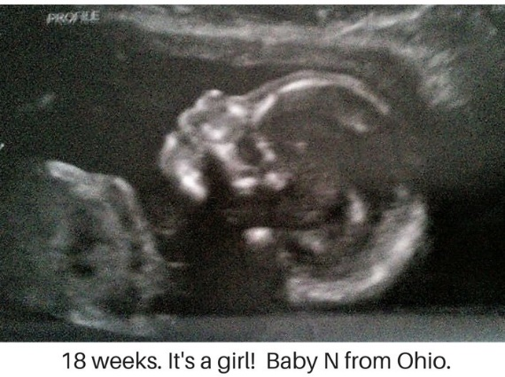

Next is Baby Boy L. at 19 weeks. He, too, could’ve been aborted at this stage. You can see his cute nose & his little lips. Should he be protected?
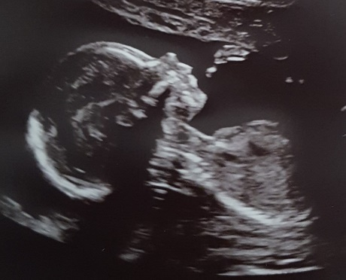

This 3rd ultrasound is the grandson of a pastor from S.W. Ohio. He’s 13 weeks & 5 days’ gestation here.
He’s still “in the oven” as of today.

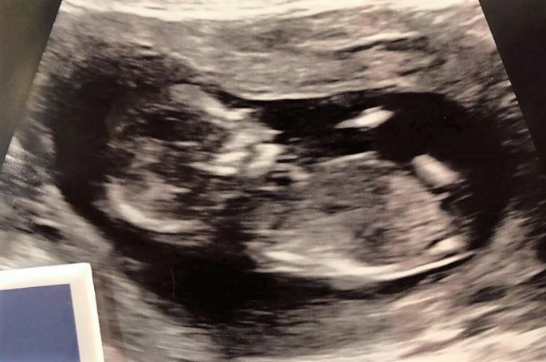

Fourth is another little boy, Baby R, from the Dayton area. He’s 11 weeks & 2 days’ gestation in this sonogram picture. He looks like a “Teddy Graham” but you can clearly see his leg, foot & hand, along with some details of his face. He too could’ve been legally aborted at this stage.

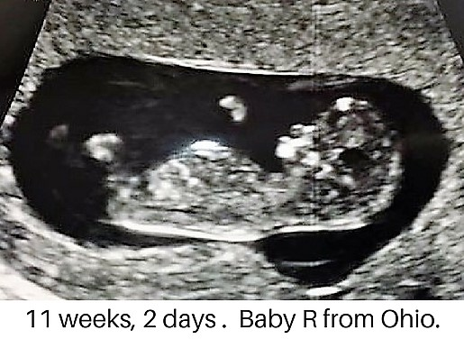

My question to you is: Shouldn’t we be compassionate & protect unborn babies just like these shown here? Please pass H.B. 258, the Heartbeat Bill. Thank you.

