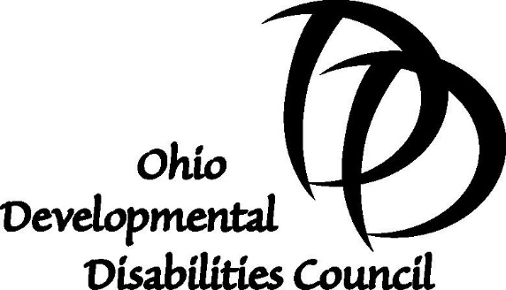

Monday, March 13, 2017

The Honorable Kevin Bacon
Chairman, Ohio Senate Judiciary Committee
Ohio Senate Building, Room 035
Columbus, OH 43215

Dear Chairman Bacon,

As you know, the Ohio Developmental Disabilities Council is an advocacy and capacity building organization created by federal law and dedicated to improving the lives of individuals with developmental disabilities. The Council has reviewed Senate Bill 20 and voted to actively support passage of this bill.

According to the federal Developmental Disabilities Assistance and Bill of Rights Act of 2000 (DD Act), state councils on developmental disabilities are to undertake advocacy, capacity building, and systems change activities related to wide variety of issues, including prevention activities. In fact, the DD Act states that Councils should conduct prevention activities that, “address the causes of developmental disabilities and the exacerbation of functional limitation (emphasis added).” The Ohio DD Council believes criminal acts that result in permanent disabilities of individuals qualifies under this provision of the law.

Based on the testimony provided by Senator Hackett and other witnesses, the Ohio DD Council believes any effort to deter criminal behavior that results in a permanent disability is an appropriate and necessary as a prevention activity. We hope the Senate Judiciary Committee will act accordingly and pass this important legislation.

Thank you for your consideration.

Sincerely,
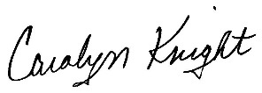
Carolyn Knight
Executive Director

