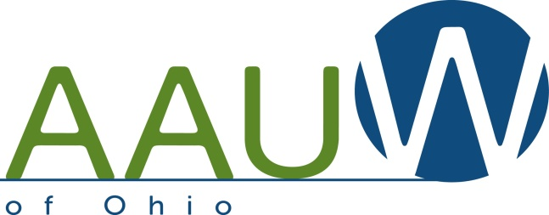
Testimony on Senate Bill 4
Before the Senate Judiciary Committee
The Hon. Kevin Bacon, Chair
By Rush Rogers, AAUW/Ohio Advocate
May 2, 2017

Chairman Bacon, Vice Chair Dolan and members of the committee:
My name is Rush Rogers, and I am speaking for AAUW/Ohio, representing 1,500 members in branches throughout Ohio. Since 1881, AAUW (formerly known as the American Association of University Women) has been one of the nation’s leading voices promoting education and equity for women and girls. AAUW’s members-adopted public policy program supports national and international policies against human trafficking; AAUW of Ohio has added its support for laws against human trafficking since becoming aware of the issue’s impact in our state several years ago.
Our policy includes support for statutes that address protection of victims, prosecution, and prevention. The protection of victims must include the ability to vacate convictions for survivors, which is why we are advocating for the passage of Senate Bill 4 and the expungement of criminal records of victims of trafficking whose crimes were committed as a result of being trafficked.
We have evidence now that given the right services and support, survivors of trafficking can go on and rebuild their lives. They can become good, productive members of our communities. We believe this bill will have a positive impact on the lives of survivors of trafficking in Ohio. We urge the enactment of this legislation as quickly as possible.
Thank you for your time.

AAUW advances equity for women and girls through advocacy, education, philanthropy and research. AAUW, founded in 1881, is open to all graduates who hold an associate or higher degree from a regionally accredited college or university. In principle and practice, AAUW values and seeks a diverse membership.

