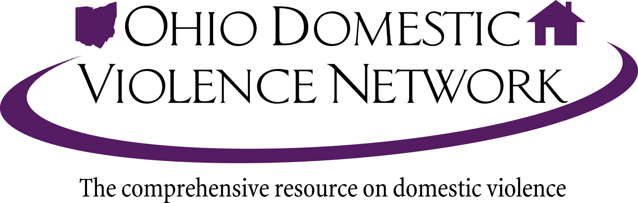

Proponent Testimony House Bill 63
Nancy Neylon, Executive Director
Ohio Domestic Violence Network

Chairman Bacon, Vice-Chair Dolan, Ranking Member Thomas, and members of the Senate Judiciary Committee, thank you for allowing me to provide proponent testimony for House Bill 63. I am the Executive Director of the Ohio Domestic Violence Network, Ohio’s statewide domestic violence coalition. The Ohio Domestic Violence Network, Ohio’s federally recognized statewide domestic violence coalition, serves as a critical resource for professional training, resources, public education and advocacy for Ohio’s domestic violence agencies and other allied organizations.
I would like to express my support of House Bill 63. House Bill 63 would allow judges to add a sliding scale specification of five to twenty years to enhance felonious assault sentences for defendants whose victims suffer a permanent disfigurement or substantial incapacity from the attack.
Because Ohio merges sentences for charges that result from one act, many abusers do not receive sentences that are consistent with the magnitude of the harm caused by their crimes. This bill specifically targets defendants whose victims have suffered permanent, serious disfigurement, or substantial incapacity at the hands of the defendant.
House Bill 63 recognizes the seriousness of the violence exhibited by some of the worst perpetrators of domestic violence, and allows the trier of the fact to add an additional term of years to the sentence when it is warranted.
Both research and practice experience have demonstrated that intimate partner violence is one of the most critical public health problems today. The consequences of exposure to violence may temporarily or permanently affect an individual’s capacity to cope and result in a reduced quality of life with long reaching health impacts. For example attempted strangulation may result in traumatic brain injury. Further, research shows that post –traumatic stress disorder is a common result of violence.
However, the level of violence and resulting repercussions addressed in Judy’s Law goes far beyond this usual impact. In these rare cases, victims who survive have their lives and the lives of their children and family members altered forever. Certainly, here in central Ohio the circumstances of Judy Malinowski are indescribably tragic. Judy, a Gahanna woman was doused in gasoline and set on fire in 2015. She remains hospitalized with horrific burns. Her ex-boyfriend, Michael Slager, is serving eleven years in prison for aggravated arson, the most serious count he faced. In other cases, I have known women who have been confined to wheelchairs or had unborn children so damaged in the womb that they were physical disabled for life.
We are outraged by the continuing homicides resulting from intimate partner violence. As advocates we continue to strive to provide support and services to victims and their children. And we believe justice is served when convicted felons are held accountable for the behaviors this legislation addresses.
These crimes are truly heinous, and the victims’ entire lives are changed as a result of the violence exhibited by the defendants. ODVN is supportive of Representative Hughes’ effort to allow the judge and jury the ability to give the defendant a sentence that is more consistent with the harm they have caused. Thank you for the opportunity to offer testimony in support of House Bill 63.

