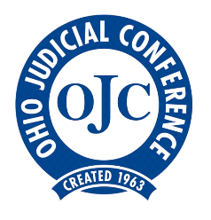

Ohio Judicial Conference

The Voice of Ohio Judges

Senate Judiciary Committee
Ohio Judicial Conference
Proponent Testimony on House Bill 366

Chair Bacon, Vice Chair Dolan, Ranking Member Thomas, and members of the Senate Judiciary Committee, we thank you for this opportunity to testify on behalf of the Ohio Judicial Conference in support of Amended House Bill 366.
The Ohio Judicial Conference previously testified on H.B. 366 as an interested party. The OJC raised concerns with the “dollars for days” provisions in the previous versions of the bill. Our concern was that these provisions would become a catalyst for parental conflict.
We appreciate that our concerns were considered and addressed, and appreciate the opportunity to give feedback throughout the redrafting process. Recently, we had the opportunity to review the AM2128 amendment draft, and believe this compromise language addresses our concerns while maintaining the goals of the bills’ sponsors and proponents. The improved language defuses the conflict points in the R.C. 3119.231 while allowing judicial discretion for courts to consider appropriate deviations.
We thank the sponsors, Representative Gavarone, S.B. 125 sponsor Senator Beagle, their legislative aides, Senate staff, as well as the members of this Committee, along with representatives from the Child Support Enforcement Agency, Ohio CSEA Directors’ Association, Ohio Department of Job and Family Services, and everyone else who helped to improve the bill with the amended language.
We thank you for your time and consideration of this testimony and would be happy to answer any questions you may have.

Judge David Lewandowski
Lucas County Court of Common Pleas, Domestic Relations Division

Paul Pfeifer
OJC Executive Director

