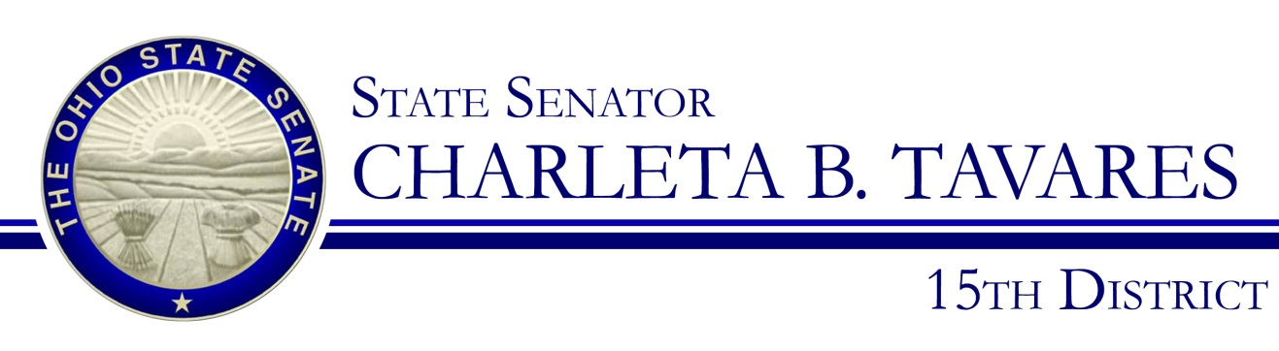

Sponsor Testimony
Senator Charleta B. Tavares
Senate Bill 11
Ohio Senate Local Government, Public Safety, and Veterans Affairs Committee
November 14, 2017

Good morning Chairman Uecker, Ranking member Thomas, and members of the Local Government, Public Safety, and Veterans Affairs Committee. I am here to give testimony on Senate Bill 11 which will designate March 31st as “Cesar E. Chavez Day” in Ohio. SB 11 will honor the humanitarian contributions that Cesar E. Chavez made to this nation by organizing farm workers to campaign for safe and fair working conditions, reasonable wages, decent housing, and the outlawing of child labor.

Cesar Chavez was born in Yuma, Arizona in 1927 to immigrant parents. In 1937, Chavez and his family would move briefly to California to find work after losing their family farm. The Chavez family would return permanently to California in 1939, where they would spend the next decade as migrant workers. Cesar Chavez would start working in the fields at just ten years old and dropped out of school after the eighth grade in order to help support his family. Cesar Chavez’s life would forever change in 1952 when he met Father Donald McDonell, an activist priest and Fred Ross, an organizer for the Community Service Organization (CSO). Chavez would join CSO as an organizer in 1952. He would make an immediate impact by fighting for the civil rights of Latinos through voter registration drives and through campaigns against racial and economic disparity. By 1958, Cesar Chavez was the national director of CSO; however, after being in this position Chavez decided he wanted to have a greater impact specifically on farmers to help end the deplorable conditions he had experienced as a child.

Thus after resigning from the CSO in 1962, he co-founded the National Farm Workers Association, which is known today as the United Farm Workers (UFW). Chavez's use of nonviolent tactics that mirrored the civil rights movement helped UFW draw national attention to their causes. In 1966, he led the Delano grape strike in which more than 5,000 workers walked off their jobs. Chavez also led a 340 mile march from Delano to Sacramento in 1966 to demand that the state legislature permit farm works to unionize. Chavez also led a nationwide boycott of grapes in 1968 to support the strike. The boycott would prove to be a success when grape growers began to accept union contracts in 1970. Chavez and UFW would find legislative success in 1975 when California passed the Agricultural Labor Relations Act which was the first law governing farm labor organizing in the United States.

Cesar Chavez dedicated his life to protecting the rights of farm workers and improving their labor conditions with new laws and regulations. The work that he achieved during his lifetime drastically changed the safety and welfare of farm workers. In 1973, he was awarded the Jefferson Award for Greatest Public Service Benefiting the Disadvantaged for his efforts and in 1994 President Bill Clinton posthumously awarded him the Presidential Medal of Freedom

While there is no federal holiday, in 2014 and each subsequent year, President Obama has issued a proclamation declaring Cesar Chavez’s birthday to be “Cesar Chavez Day”. California, Arizona, Colorado, Michigan, New Mexico, Texas, Utah and Wisconsin all observe Cesar Chavez Day. It is time for Ohio to join these states and recognize an American icon that fought tirelessly for the rights of the underprivileged and less fortunate. Chairman Uecker and member of the committee, I ask for the favorable passage of SB 11 and I would be happy to answer any questions you have at this time.

