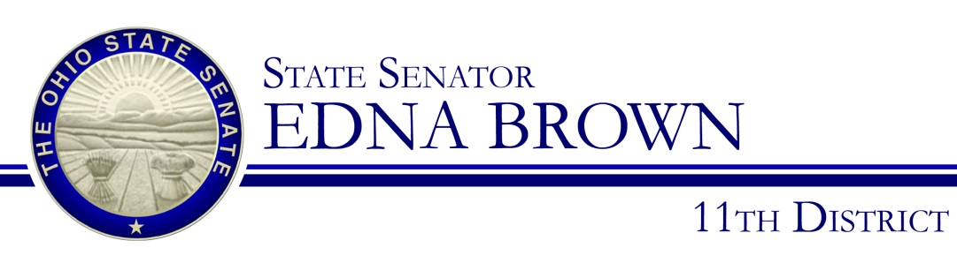

Sponsor Testimony
Senator Edna Brown
Senate Ways and Means Committee
March 1, 2017

Chairman Eklund, Vice Chair Terhar, Ranking Member Williams, and members of the Senate Ways and Means Committee, thank you for the opportunity to provide sponsor testimony on Senate Bill 65.

This bill will create a sales tax holiday in Ohio for qualifying Energy Star products on the first Friday through Sunday in April. The purpose of the sales tax holiday created in this bill is to encourage a boost in commercial activity surrounding these energy star products. This boost in sales is not only good for businesses; it is also good for consumers.

Some of the products covered include air conditioning units, furnaces, heat pumps, water heaters, refrigerators, freezers, air purifiers, and dehumidifiers. All of these items represent large purchases for households. Establishing this sales tax holiday would create significant savings for buyers.

In addition to a reduction in the final purchase price, replacing old and outdated appliances with new Energy Star-qualified products creates long-term savings for consumers thanks to their decreased energy usage and the resulting reduction in utility bills.

In addition to cost considerations, I think it is important to note that these products help meet some of the most basic needs of families. From the health and financial benefits of safe food storage, to relief from severe allergies, to heating and cooling during extreme temperatures, these products ensure the health, safety, and comfort of Ohioans.

Encouraging the usage of Energy Star appliances has far-reaching implications. Energy Star is a voluntary program to identify and promote energy-efficient products. The goal of the program is to reduce energy consumption, improve energy security, and reduce pollution through products that meet the highest energy-efficiency standards.

Currently, Alabama, Florida, Georgia, Louisiana, Maryland, Missouri, North Carolina, Texas, and Virginia have created similar sales-tax holidays for Energy Star products. I hope you will consider adding Ohio to that list by supporting Senate Bill 65.

I believe creating this sales-tax holiday and encouraging the increased purchase and use of these Energy Star products is good for business, good for consumers, and good for Ohio.

Chairman Eklund, members of the committee, thank you again for allowing me to provide sponsor testimony today. I’d be happy to answer any questions.

