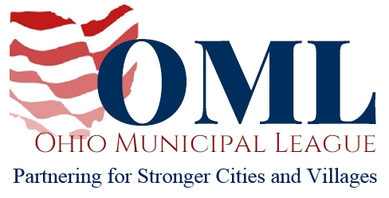
WRITTEN TESTIMONY TO THE HOUSE ECONOMIC DEVELOPMENT COMMITTEE

KENT SCARRETT
EXECUTIVE DIRECTOR
OHIO MUNICIPAL LEAGUE

SB 8

May 8, 2019

Chair Zeltwanger, Vice Chair Powell, Ranking Member Sobecki, and members of the House Economic and Workforce Development Committee, thank you for the opportunity to write in support of SB 8.
Many of Ohio legacy cities and small rural villages are struggling to pay for the basic services Ohioans expect and deserve. Financially-challenged municipalities across the state are unable to properly maintain safe infrastructure or fully staff their police and fire departments.
When a municipality cannot finance the delivery of these basic services, businesses are disincentivized from staying in or moving to those communities. Jobs dry up and the local economy suffers, while the younger incoming workforce leaves the community for an education or a career and never returns.
There are hundreds of such communities across Ohio, and the state’s economy can never be strong or vital until those cities and villages receive adequate investment. Sen. Schuring has recognized the need to incentivize investment in these struggling communities. SB 8 builds upon the foundation laid by the federal Tax Cuts and Jobs Act of 2017, creating an opportunity for investors to receive a 1% tax credit on project investments that exceed $250,000. The bill creates further incentives by offering an additional 2% tax credit if the Development Services Agency (DSA) can prove the project created net tax revenue gains for the both the state and local governments.
The League and its members appreciate Sen. Schuring’s recognition of the need to invest in Ohio’s distressed local governments. SB 8 can serve Ohio’s municipalities as well by creating jobs, growing the local economy and generating much-needed additional local tax revenues. As municipalities are the economic engines of the state, the investment SB8 would make in our cities and villages would be an investment in Ohio’s collective economic health.
Thank you for your consideration, and we urge for your favorable passage of this bill.
Sincerely,
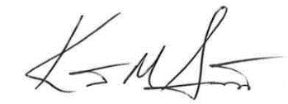
Kent Scarrett
Executive Director
Ohio Municipal League

