Testimony to the House Health Committee
House Bill 385 <> February 11, 2020
Beth Liston, MD PhD.

Chairman Lipps, Ranking member Boyd, and members of the Health Committee, thank you for allowing me to provide sponsor testimony on House Bill 385. This bill requires the Attorney General to investigate the pricing of prescription drugs containing insulin. The investigation’s purpose is to ensure adequate consumer protections in the pricing and sale of insulin used to treat diabetes and to determine if additional protections are needed. As part of the required investigation, the Attorney General must compile and analyze information from companies engaged in the manufacture or sale of prescription insulin drugs. The bill authorizes the Attorney General to issue investigative demands to obtain information from state departments, health plan issuers, pharmacy benefit managers, drug manufacturers and pharmacies. Not later than 18 months after the bill’s effective date, the Attorney General must prepare and submit a report of the findings which must include all of the following: A summary of current insulin pricing practices and variables that contribute to insulin pricing by drug manufacturers, health plan issuers, pharmacy benefit managers, and pharmacies; Recommendations for controlling and preventing the overpricing of prescription insulin; Recommendations for improving Ohio’s consumer protection laws to prevent deceptive sales practices involving the pricing and sale of prescription insulin. While the investigation remains confidential and not part of public record, the bill requires the Attorney General to submit the report to the Governor, Superintendent of Insurance, and the chairpersons and ranking minority members of the Health, Civil Justice, and Criminal Justice committees of the Ohio General Assembly.
Committee, as I have testified in past hearings, insulin prices have been rising at incredible rates despite the fact that insulin has been around for 100 years. One vial of insulin lispro, which used to cost $21 in 1999, costs $332 in 2019, reflecting a price increase of more than 1000% while insulin costs in other countries remained the same. The original patent was sold for one single dollar by those that discovered this life-saving drug – so that it could be a public good. One in 8 people have diabetes and in Ohio 1 in 4 people are rationing prescription drugs. While not all of these individuals require insulin, those that do are either young people that have Type 1 diabetes which is the autoimmune form of diabetes, or people who have more advanced disease with high risks of complications. Millions of Ohioans are impacted by this high prices of insulin – and rationing insulin means people die.
However, as clear as that statement is – the mechanism by which the price of insulin has been rising for people is a very muddied picture. Insulin is manufactured and sold by three companies across the globe controlling 99% of the total insulin by value, 96% by total market volume, and 88% of global product registrations. The published data suggest that when one insulin manufacturer increases the price for a given insulin formulation, the other insulin manufacturers often increase their prices by a similar amount shortly thereafter. Barriers to entry into the insulin manufacturing market are quite high, particularly as the practice of ‘patent evergreening’ appears rampant.
However, list prices are only part of the story and the flow of money in drug pricing is very complicated involving rebates, negotiated prices, wholesalers, health insurers and pharmacy benefit managers. I have included a schematic of the stakeholders involved from the American Diabetes Association white paper “Insulin Access and Affordability Working Group: Conclusions and Recommendations” – and have attached the white paper itself to this testimony.
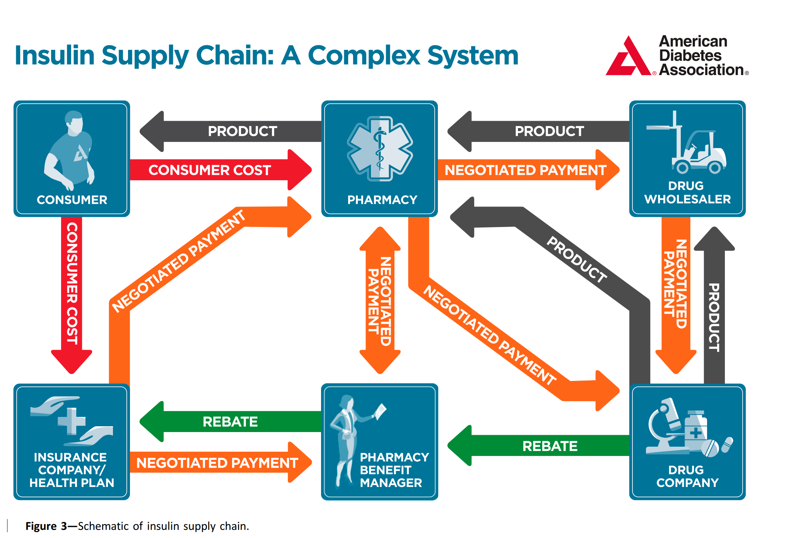

While the list price set by the manufactures are rising, the net price they receive in some cases is going down due to this complicated system of negotiations and rebates. There is no transparency around how this money flows federally or in our state. For the uninsured, or the under-insured with high co-pay and co-insurance they ultimately must pay the list price without benefit of these rebates/negotiations.
The intent of HB 385 is to investigate this complex drug pricing system for insulin for people in Ohio and ensure adequate consumer protections are in place. People need this medication to live and must pay any price in order to survive. With only 3 manufactures, high barriers to market entry, multiple middle men and little transparency, it is our role as representatives of the people to investigate and ensure the pricing is fair.

