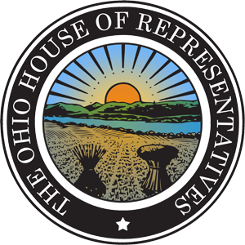
Committees:
- Finance
- State and Local Government
- Civil Justice
- Economic and Workforce Development
- Finance – Sub. Committee on Transportation – Ranking Minority Member
- Joint Committee on Agency Rule Review

Ohio House of Representatives
Vern Riffe Center
77 S High Street
Columbus, Ohio 43215
(614) 466-5921
Rep13@ohiohouse.gov

Michael J. Skindell
State Representative
13th District

Before the House State and Local Government Committee
House Bill 96 – Ohio Public Lands Day
Sponsor Testimony by Representative Michael J. Skindell
Wednesday, March 27th 2019

Chairman Wiggam, Vice Chair Ginter, Ranking Member Kelly and members of the House State and Local Government Committee, thank you for the opportunity to provide sponsor testimony on HB 96, which designates the third Saturday in May as Ohio Public Lands Day. In 2015, the Ohio House passed House Resolution 120 recognizing the 2015 National Public Lands Day. Celebrating Ohio’s public lands should be a reoccurring event in our state.

Currently National Public Lands Day is a tool used to rally volunteers for land conservation. Other states such as Colorado, Washington, and New Mexico have honored in their state legislatures the benefits of their public lands. Ohio deserves its own Public Lands Day to celebrate and conserve the natural treasures of our state, such as state forests, wildlife areas, reservoirs, and boating areas. Whether it is for recreation, exercise, fishing, hunting, education, or family bonding, our public lands provide value to all Ohioans.

Ohio has 421,700 acres of public land (1.6% of Ohio) owned by the states, and additionally 256,960 (.98% of Ohio) owned by the Feds. Establishing an Ohio Public Lands Day would invite all to enjoy the great outdoors and celebrate the lands that give us so much.

Chairman Wiggam, Vice Chair Ginter, Ranking Member Kelly and members of the House Energy and Natural Resources Committee, I would be happy to answer any questions relating to this matter.

