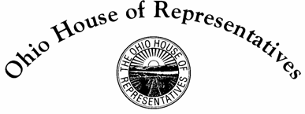

**Representative Bill Roemer**

**38th House District**

**Sponsor Testimony HB 115**

Good morning to Chairman Wiggam, Vice Chair Ginter, Ranking Member Kelly and members of the House State and Local Government Committee. I want to thank you, Mr. Chairman, for giving HB 115, or the Regulatory Reform Bill, time in this committee for sponsor testimony. As Representative Riedel has indicated, HB 115 serves as companion legislation to Senate Bill 1 sponsored by Senators Kristina Roegner and Rob McColley.

My colleague, Representative Riedel, has taken the route of exploring this legislation’s history and why it is imperative that we act. I will be addressing the mechanics of the bill, and how it interacts with the Ohio Administrative Code.

House Bill 115 will require our cabinet level agencies, executive statewide elected officials and four additional commissions to establish a base inventory of their regulatory restrictions. They will review their rules thoroughly, and then reduce them by 30% in three years, with benchmarks of 10% each year. If these agencies fail to meet this goal, for every additional regulation they propose to add in the future, two must be removed. Our bill also establishes a statewide regulatory cap beginning January 1st, 2023: the State as a whole cannot have more regulations than 70% of the original statewide base inventory. The Joint Committee on Agency Rule Review will be given a larger role in reviewing agencies. We have included an appeals process in the bill, so that agencies facing a real prospect of failing to meet the reduction target can go to JCARR and petition for a lesser reduction goal. In addition to this, if JCARR determines that a rule should not have been rescinded, they can restore it. The agencies and JCARR under this bill are also required to annually produce historical reports of the progress in reducing regulatory restriction in the preceding year.

I feel it is important to note that these regulatory requirements are being placed at the cabinet level, as opposed to agencies directly, to alleviate the burden on smaller entities and to widen the focus on overall regulatory reduction. A website will be created so that individuals and businesses can directly report to JCARR on what regulations create the biggest burdens, limitations and general struggles for them. This legislation is pro-business, and in the last General Assembly it received support from both the Ohio Chamber of Commerce and the National Federation of Independent Business.

House Bill 115 takes an important step in reducing the government’s impact on the lives of Ohioans and their businesses. Indeed, a state that prides itself as the crossroads of America’s heartland should not restrict its population with 246,852 regulations, the likes of which can only be found in the states of New York (308K) and Illinois (260k). If we are to be the most welcoming, business friendly state in our region, we must keep a constant count on our restrictions, systematically review them, and remove those that are unnecessary. 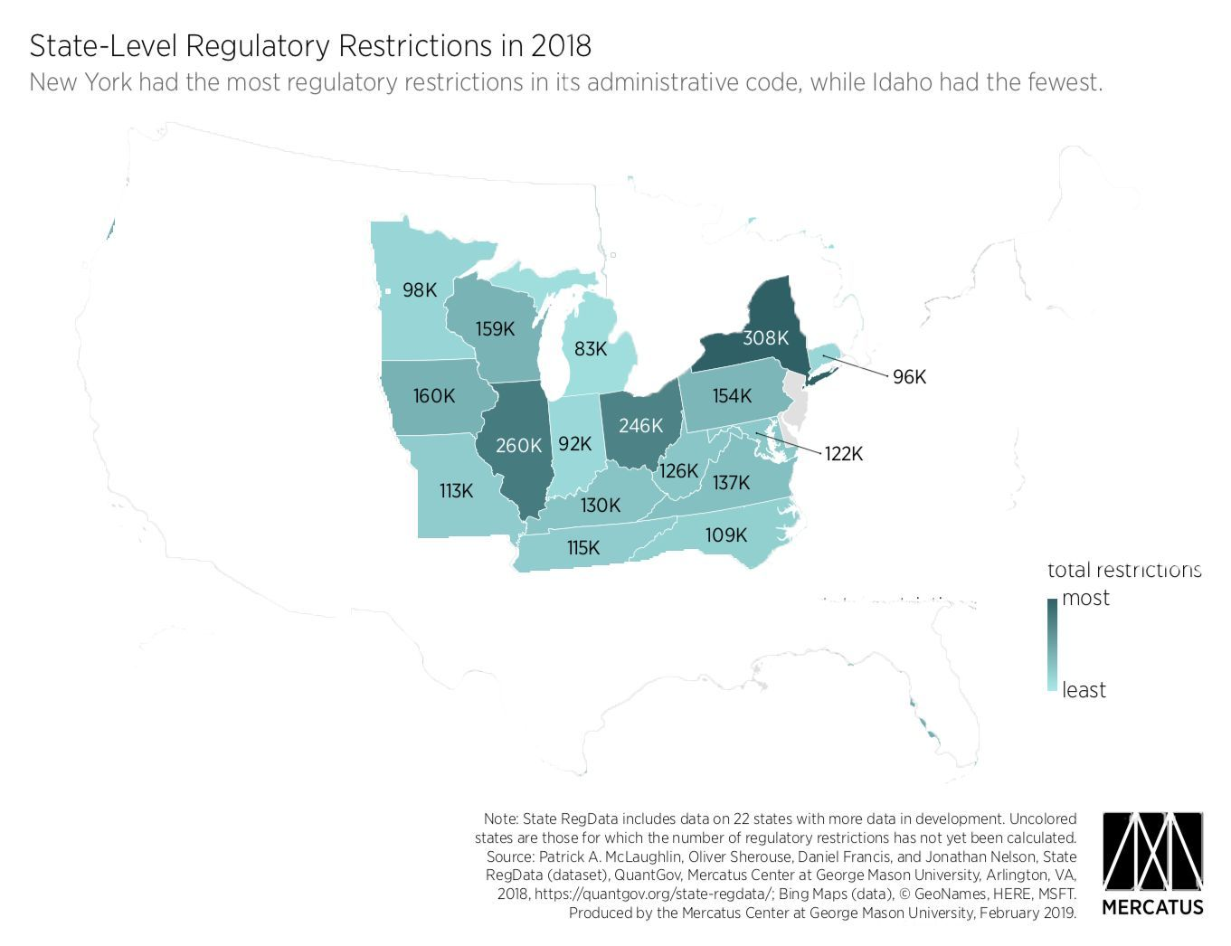

Finally, I would like to thank Representative Riedel for his hard work and dedication on this legislation as a joint sponsor. I have appreciated the opportunity to champion this important matter before the entire committee, and look forward to your careful consideration. We are happy to answer any questions you may have.